Sector Area

Area using Degrees =

Area using Radians =

Segment Area
Recall that the area of a triangle is $\frac{1}{2}ab\sin{C}$ where $C$ is the ‘included angle’ (i.e. between $a$ and $b$)

Area using radians:

Examples
- In the diagram, the area of the minor sector $AOB$ is 28.9 cm². Given that $∠AOB=0.8$ radians, calculate the value of $r$.

- A plot of land is in the shape of a sector of a circle of radius 55 m. The length of fencing that is erected along the edge of the plot to enclose the land is 176 m. Calculate the area of the plot of land.

- In the diagram above, $OAB$ is a sector of a circle, radius 4m. The chord $AB$ is 5m long. Find the area of the shaded segment.

- In the diagram, $AB$ is the diameter of a circle of radius $r$cm, and $∠BOC=θ$ radians. Given that the area of $ΔAOC$ is three times that of the shaded segment, show that
$3θ-4\sin{θ}=0$.

Test Your Understanding

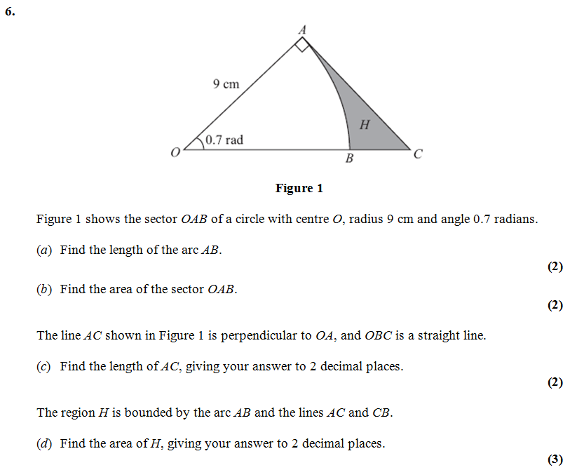

Extension
[MAT 2012 1J]
If two chords $QP$ and $RP$ on a circle of radius 1 meet in an angle $θ$ at $P$, for example as drawn in the diagram on the left, then find the largest possible area of the shaded region $RPQ$, giving your answer in terms of $θ$.
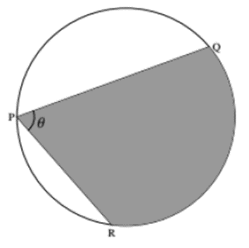

Ex 5D Page 125 - 128

