5C Arc Length
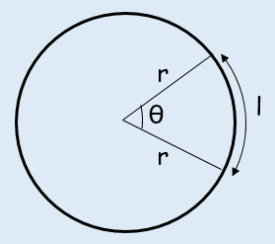

- Find the length of the arc of a circle of radius 5.2cm. The arc subtends an angle of 0.8^{c} at the centre of the circle.

- Arc AB of a circle, with centre O and radius r, subtends an angle of θ radians at O. The Perimeter of sector AOB is P cm. Express r in terms of P and θ.

- The border of a garden pond consists of a straight edge AB of length 2.4m, and a curved part C, as shown in the diagram below. The curved part is an arc of a circle, centre O and radius 2m. Find the length of C.
