Arc length
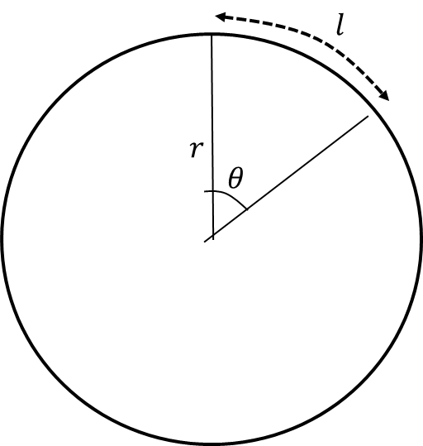
Arc length in degrees =

Arc length in radians =

Examples
- Find the length of the arc of a circle of radius 5.2 cm, given that the arc subtends an angle of 0.8 radians at the centre of the circle.

- An arc $AB$ of a circle with radius 7 cm and centre $O$ has a length of 2.45 cm. Find the angle $∠AOB$ subtended by the arc at the centre of the circle

- An arc $AB$ of a circle, with centre $O$ and radius $r$ cm, subtends an angle of $θ$ radians at $O$. The perimeter of the sector $AOB$ is $P$ cm. Express $r$ in terms of $P$ and $θ.$

- The border of a garden pond consists of a straight edge $AB$ of length 2.4m, and a curved part $C$, as shown in the diagram. The curve part is an arc of a circle, centre $O$ and radius 2m.
Find the length of $C$.

Test Your Understanding

Figure 1 shows the triangle $ABC$, with $AB=8 cm$, $AC=11 cm$ and $∠BAC=0.7$ radians. The arc $BD$, where $D$ lies on $AC$, is an arc of a circle with centre $A$ and radius 8 cm. The region $R$, shown shaded in Figure 1, is bounded by the straight lines $BC$ and $CD$ and the arc $BD$.
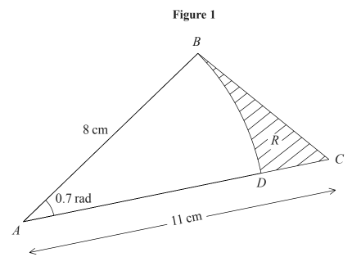
Find
(a) The length of the arc $BD$.
(b) The perimeter of $R$, giving your answer to 3 significant figures.

Ex 5C Page 120

