5B Trig Key Values as Radians
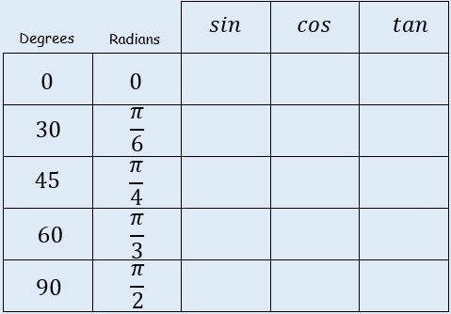

- Find the exact value of:
$$cos\frac{4π}{3}$$

- Find the exact value of:
$$sin\left(-\frac{7π}{6}\right)$$

