Sin, cos, tan of angles in radians
Reminder of laws from Year 1:
- $\sin\left(x\right)=\sin\left(180-x\right)$
- $\cos\left(x\right)=\cos\left(360-x\right)$
- $sin,cos$ repeat every $360°$ but $tan$ every $180°$

In terms of radians:
- $\sin\left(x\right)=$
- $\cos\left(x\right)=$
- $sin,cos$ repeat every _______ but $tan$ every _____.

To find sin/cos/tan of a ‘common’ angle in radians without using a calculator, it is easiest to just convert to degrees first.

Examples
- $\cos\left(\frac{4π}{3}\right)=$

- $\sin\left(-\frac{7π}{6}\right)=$

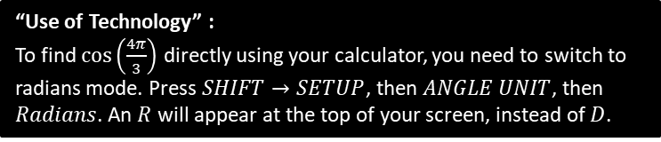

Page 116/118 Ex 5a/ 5b

