5A Converting Between Radians & Degrees

- Convert the following angle to degrees
- $\frac{7π}{8} rad$

- $\frac{4π}{15} rad$

- Convert the following angle to degrees
- $150°$

- $110°$

Equivalence relationships

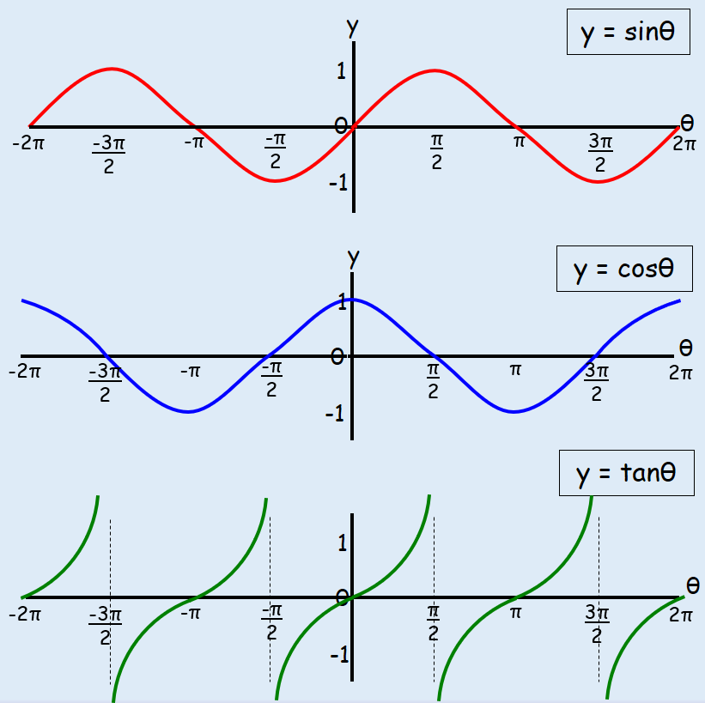
- Sketch the graph of $y=cos\left(x+π\right)$ for $0≤x≤2π$.

