U6 Pure Chapter 5
Radians

Course Structure
1: Converting between degrees and radians.
2: Find arc length and sector area (when using radians)
3: Solve trig equations in radians.
4: Small angle approximations

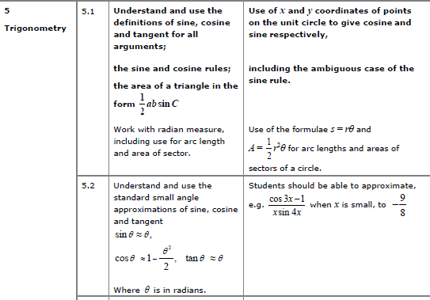

Radians

Converting between radians and degrees

$90°=$

$\frac{π}{3}=$

$45°=$

$\frac{π}{6}=$

$135°=$

$\frac{3}{2}π=$

$72°=$

$\frac{5π}{6}=$

It is useful to remember the standard angle conversions….

$45°=$

$60°=$

$270°=$

$120°=$
$30°=$

$135°=$

$90°=$

Graph Sketching with Radians

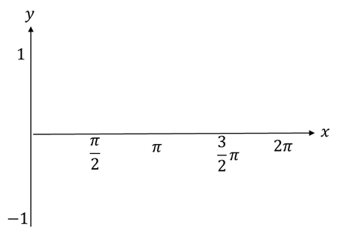
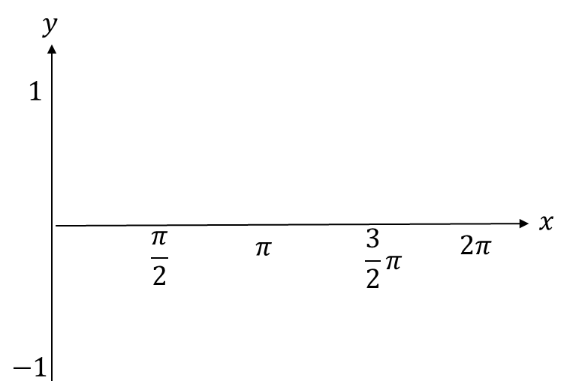

Test Your Understanding
Sketch the graph of $y=\cos\left(x+\frac{π}{2}\right)$ for $0≤x<2π$

