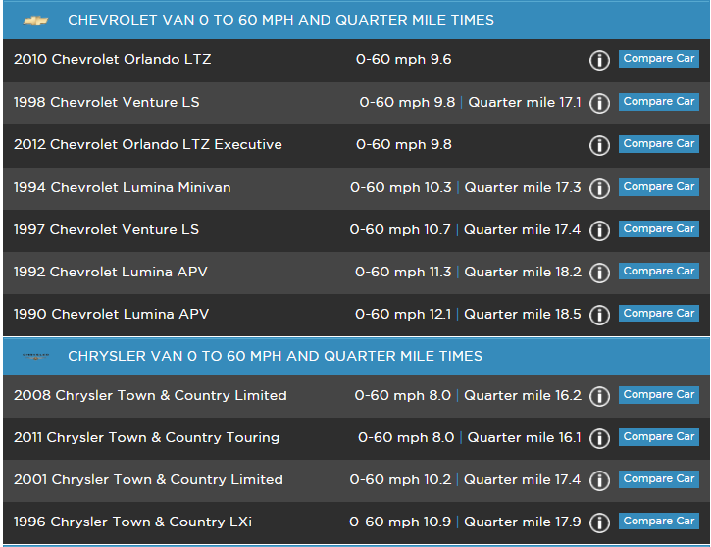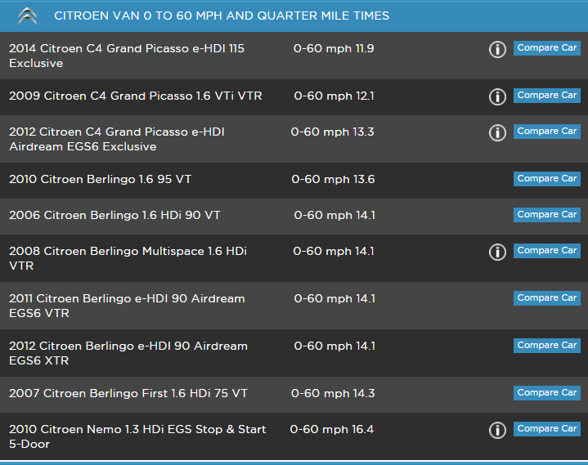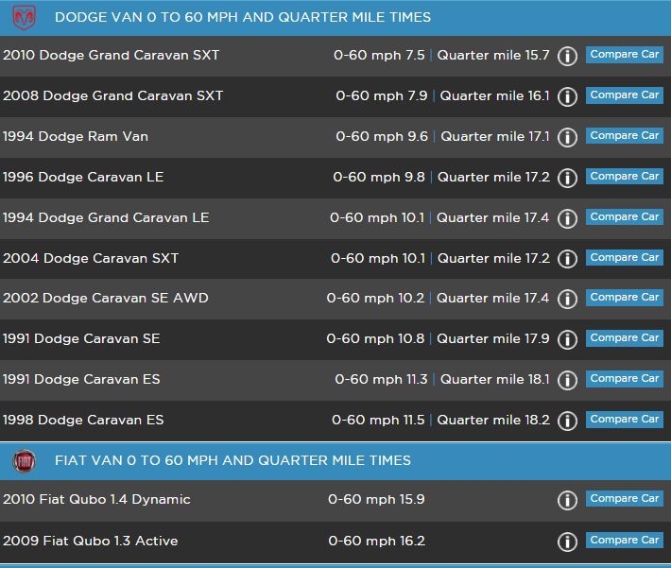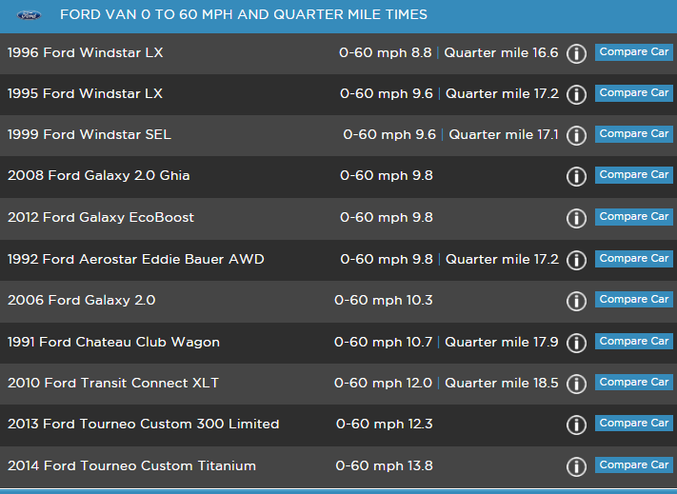

**Braking Distance**

33.2

33.2

33.2

34.8

34.8

33.2

33.2

34.8

35.8

35.8

35.8

33.2

33.2

35.6

35.6

34.6

34.6

34.5

35.8

35.8

34.5

34.5

34.5

36.5

36.5

36.5

36.5

36.5

36.5

36.5

36.5

**Braking Distance**

35.1

35.1

35.0

36.2

36.2

36.2

35.0

33.5

35.0

33.5

33.5

35.0

35.0

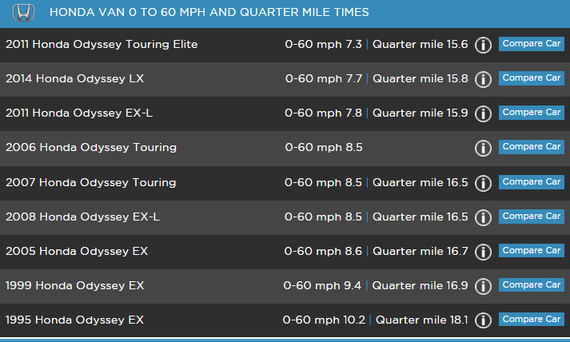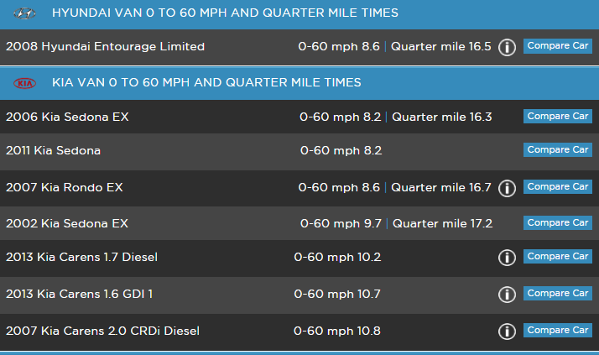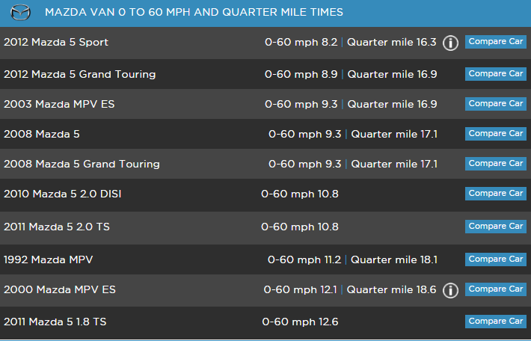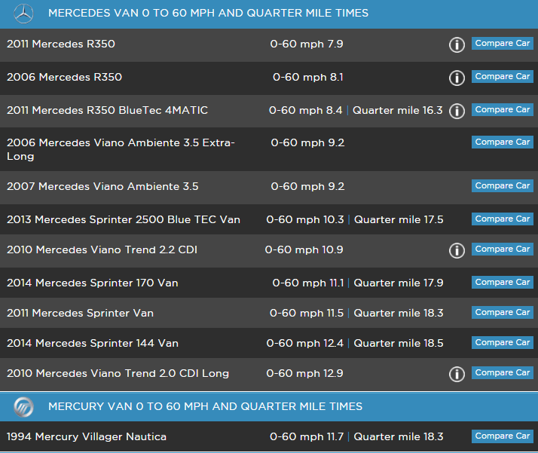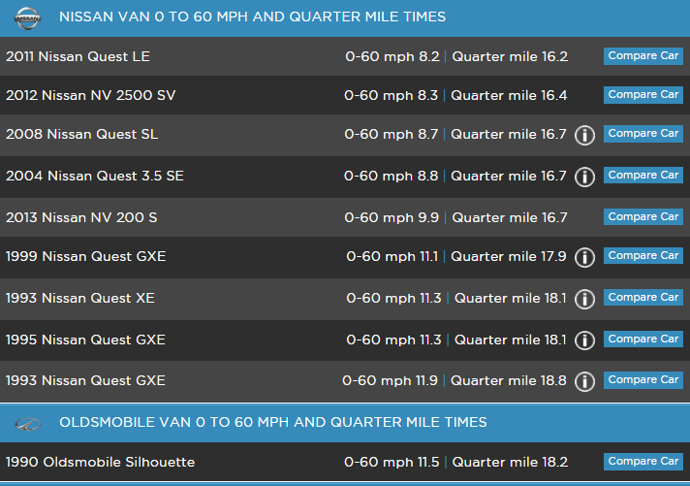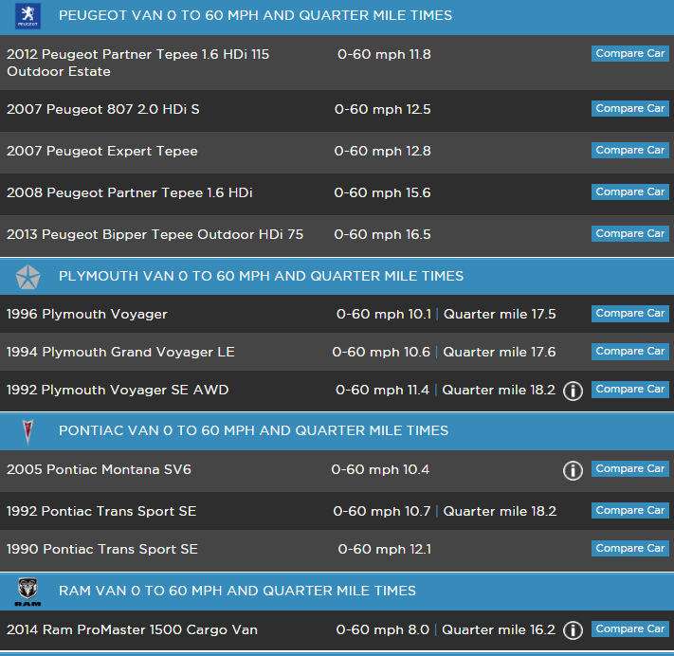

34.9

33.2

34.9

33.2

33.2

34.9

33.2

33.7

34.5

34.5

34.5

34.5

34.5

34.5

34.5

34.5

32.1

**Braking Distance**

33.5

34.8

35.5

33.5

33.5

34.8

34.8

34.8

33.5

33.0

0

**Braking Distance**

35.1

33.9

33.2

33.9

33.2

33.9

33.9

33.9

33.9

33.9

33.9

33.9

36.2

35.1

35.1

35.1

33.3

33.3

33.3

**Braking Distance**

33.3

35.1

35.1

34.9

33.5

35.6

35.6

34.9

34.1

34.1

34.1

34.1

34.9

34.1

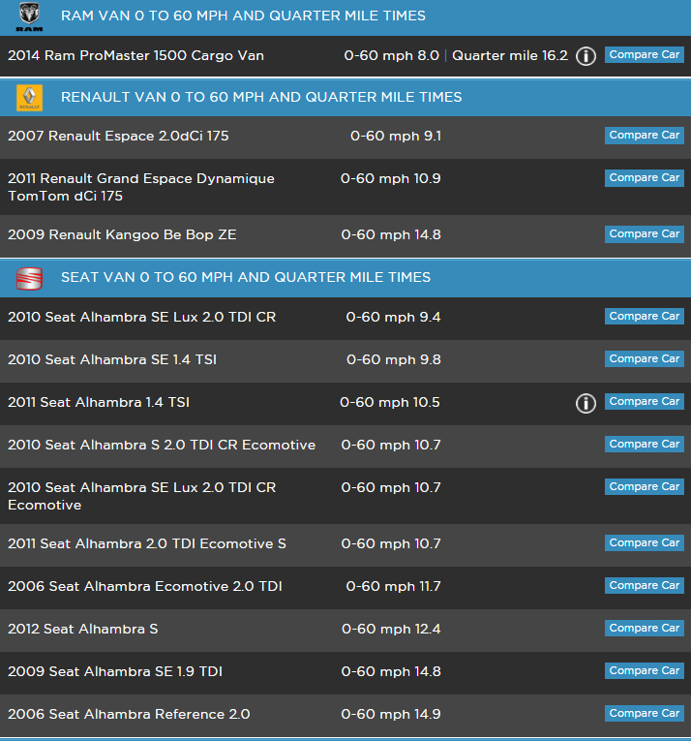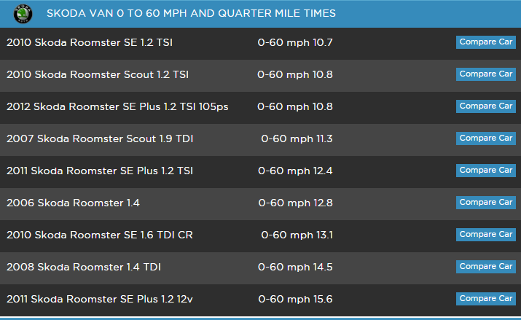

34.2

35.2

34.2

35.2

34.2

35.2

34.2

34.2

34.2

35.2

33.7

33.7

35.2

33.7

33.7

33.7

33.7

33.7

33.7

33.2

33.2

**Braking Distance**

32.5

33.2

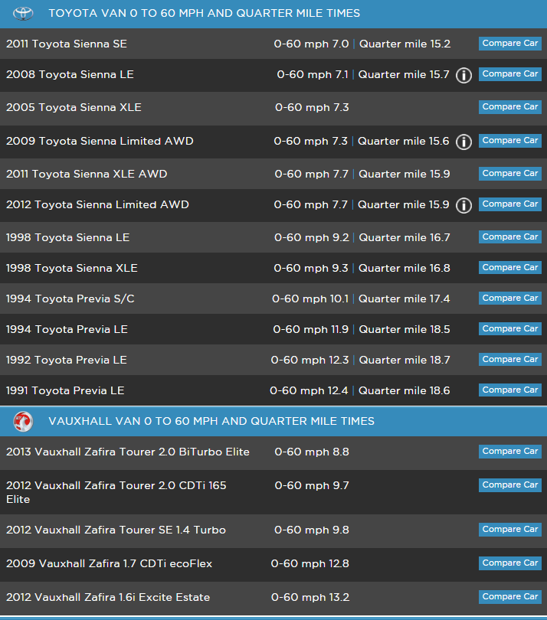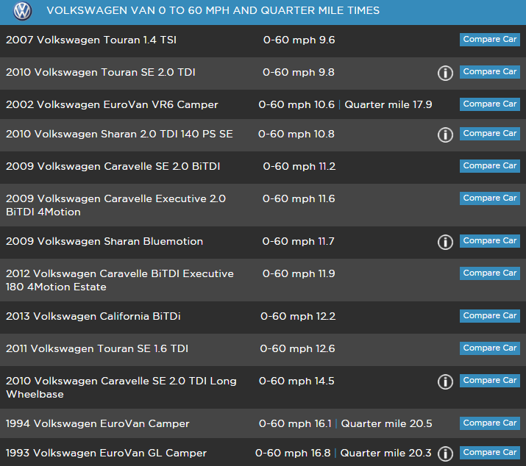

34.8

34.8

34.8

33.8

33.8

36.2

36.2

36.2

36.2

36.2

36.2

35.1

35.1

35.1

36.2

35.1

**Braking Distance**

35.1

35.7

35.7

34.2

34.2

33.9

34.2

34.2

34.2

34.2

34.2

**Braking Distance**

34.2

34.2

35.7