2/12/2018

Since 1980

YOUR DAILY FAVOURITE NEWSPAPER

**THE DAILY NEWS**

**Crown Jewel thief still at large**

***Calling card.*** The Robin Hood statue had been decorated with items from the royal collection on the evening of the robbery.

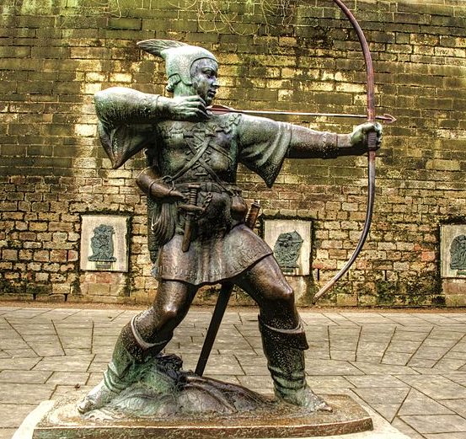

a passer by witnessed the large cases containing crowns, rings and other items being transferred below deck by two individuals in what they described as a frantic manner from a large white van. Unfortunately, the other member of the duo, and mastermind beind the heist, referred to as ‘Robin Hood’ remains at large.

**Continued below…**

**A breakthrough** in the case surrounding the heist of the crown jewels was made last night when one member of the duo known as ‘the Robin Hood bandits’ was captured. Harry Striker, also known as ‘Little John’ was found trying to flee the country via a sailing boat when coastguards recovered roughly a third of the stolen royal jewels which were stolen in the early hours of Saturday morning.

The breakthrough came when a passer by witnessed the large cases

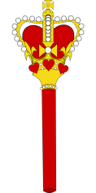

***The pair have been referred to as the Robin Hood bandits due to their tactics of sharing their loot with members of the public.******A stategy to reduce inteligence directed towards the police.***

With everyone blaming each other, the police were called to sort out the mess. A Suffolk police spokesman said: “It was certainly an unusual call from one of the locals in the pub. By the time we got there it had all calmed down, and both sides realised how the mistake had been made. “

In fact they had made up and were all enjoying a drink together, although a couple were still being patched up by the landlord’s wife. “We took no further action, but recommended that the morris men did not use bells on their uniforms when the blind footballers were playing nearby.”

bells for the one in the ball. He promptly kicked one of the dancers in the shin, sending him flying over a table and crashing into a flower pot. A hanging basket then fell on his head. More blind footballers then joined the melee, kicking out at the bells and then being surprised when they were punched by furious morris men. The brawl was only stopped when the referee caught up and blew his whistle loudly. Three morris men suffered severely bruised legs, while one of the footballers had a cut caused by being hit on the head with a morris dancer’s stick.

# Morris dancers and blind footballers in mass brawl

# ****Police were called after a mass brawl broke out in a pub car park between a group of morris dancers and a blind football team.**** The footballers were enjoying a match on the village green at Rattlesden, near Stowmarket, using a ball with a bell in it so they could keep up with play. But all hell broke out when the morris dancers began performing at a nearby pub.

A player kicked the ball off the pitch towards the Brewers Arms, and then mistook the morris dancers’ uniform

custody by Scotland Yard for further questioning, with a deal believed to be on the table to drastically reduce jail time for information that could lead to the capture of ‘Robin Hood’. It is understood that despite working together, the pair managed to keep their identities secret from each other, a measure Robin had devised in the event one was captured and offered such a deal.

**Continued from above…** The pair broke into the tower in the same van, travelling at 60 miles per hour through the gates by ‘the bloody tower’, before scaling the famous white tower, where the jewels had been moved for a special weekend event. The pair then left through the same gates only 3 minutes after first breaking through.

Harry Striker has been kept in custody by Scotland Yard for further questioning, with a deal believed to be on the table to drastically reduce jail time for information that could lead to the capture of Robin Hood. It is understood

