14H Exponentials in Data

$$y={ax}^{n}$$

$$y={ab}^{x}$$

- The data shows the rank (by size) and population of some UK cities.
The relationship between $P$ and $R$ can be modelled by the formula:
$$P=aR^{n}$$
Where $a$ and $n$ are constants.

- Draw a table giving values of $logR$ and $logP$ to 2 decimal places
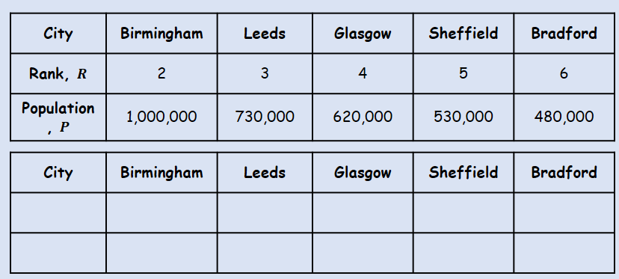
- Plot a graph of $logR$ against $logP$ using the values from your table, and draw a line of best fit

- Use your graph to estimate the values of $a$ and $n$ to two significant figures

- The graph shown represents the growth of a population of bacteria, $P$ over a period of $t$ hours. The graph has a gradient of 0.6 and meets the vertical axis at (0,2) as shown.
A scientist suggests that this growth can be modelled by the equation $P={ab}^{t}$, where a and b are constants to be found.
- Write down an equation for the line
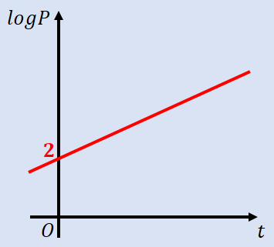

- Using your answer to part a or otherwise, find the values of $a$ and $b$, giving them to 3sf where necessary

- Interpret the meaning of the constant $a$ in this model

