Graphs for Exponential Data
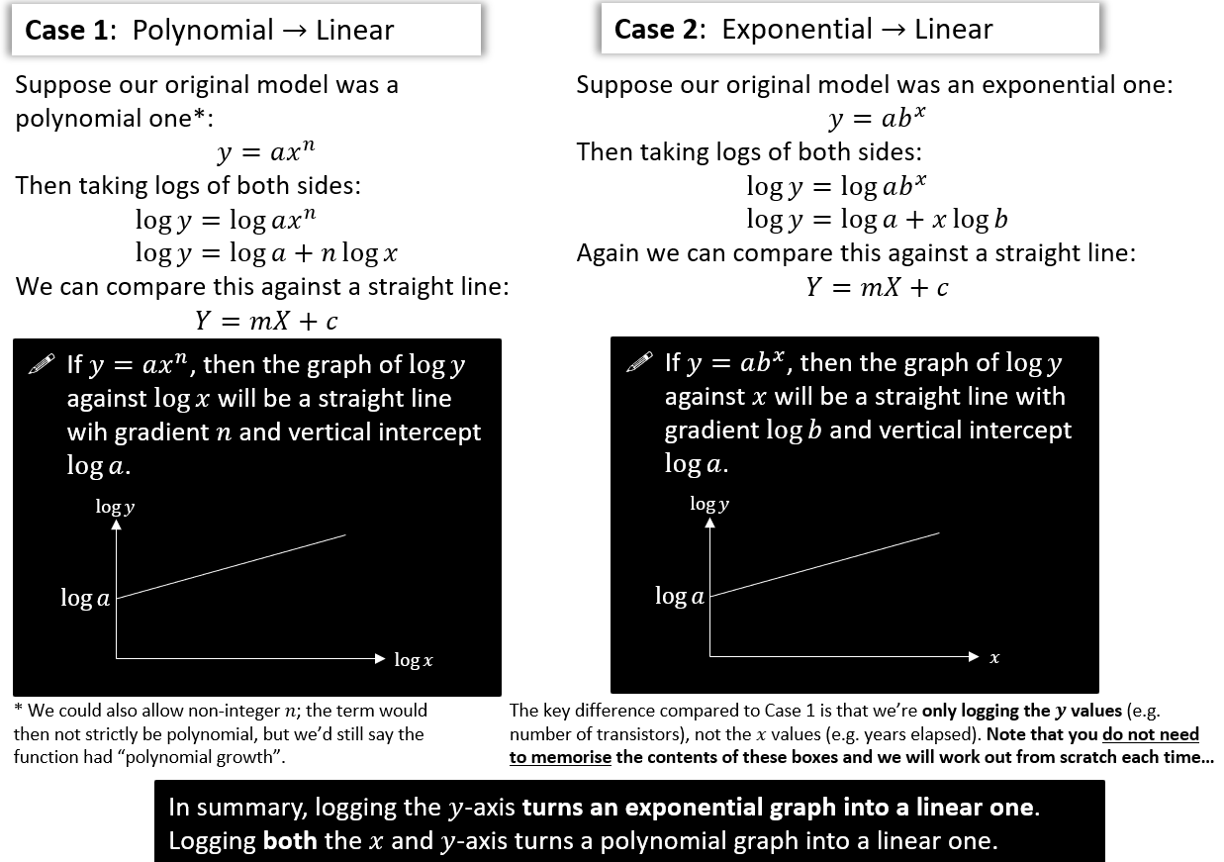
Turning non-linear graphs into linear ones

[Textbook] The graph represents the growth of a population of bacteria, $P$, over $t$ hours. The graph has a gradient of 0.6 and meets the vertical axis at $\left(0,2\right)$ as shown.
A scientist suggests that this growth can be modelled by the equation $P=ab^{t}$, where $a$ and $b$ are constants to be found.
- Write down an equation for the line.
- Using your answer to part (a) or otherwise, find the values of $a$ and $b$, giving them to 3 sf where necessary.
Interpret the meaning of the constant $a$ in this model.
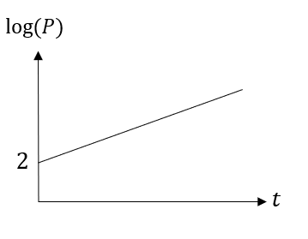

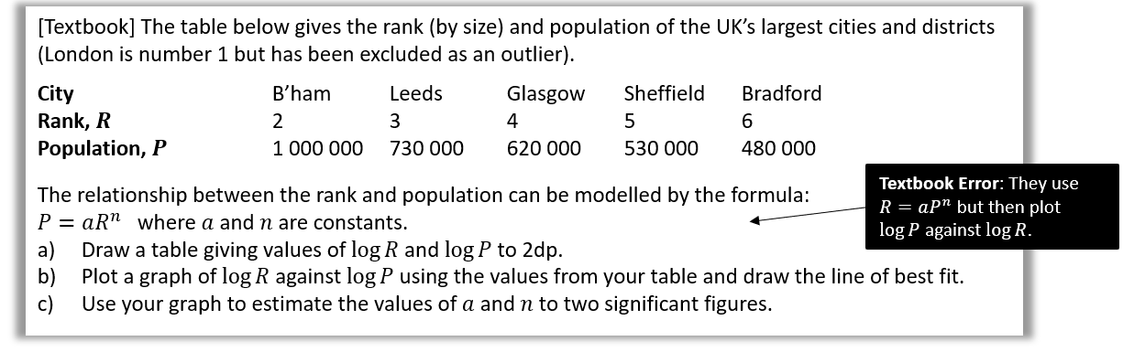

Dr Frost’s wants to predict his number of Twitter followers $P$ (@DrFrostMaths) $t$ years from the start 2015. He predicts that his followers will increase exponentially according to the model $P=ab^{t}$, where $a,b$ are constants that he wishes to find.
He records his followers at certain times. Here is the data:
Years $t$ after 2015: 0.7 1.3 2.2
Followers $P$: 2353 3673 7162
- Draw a table giving values of $t$ and $\log{P}$ (to 3dp).
- A line of best fit is drawn for the data in your new table, and it happens to go through the first data point above (where $t=0.7$) and last (where $t=2.2$).
Determine the equation of this line of best fit. (The $y$-intercept is 3.147)
- Hence, determine the values of $a$ and $b$ in the model.
- Estimate how many followers Dr Frost will have at the start of 2020 (when $t=5$).

Exercise 14H Pg 331-333

AD Page 11

