Laws of logs
Three main laws:
$$\log_{a}{x}+\log_{a}{y}=\log_{a}{xy}$$
$$\log_{a}{x}-\log_{a}{y}=\log_{a}\left(\frac{x}{y}\right)$$
$$\log_{a}\left(x^{k}\right)=k\log_{a}{x}$$
Special cases:
$$\log_{a}{a}=1 \left(a>0, a≠1\right)$$
$$\log_{a}{1}=0 \left(a>0, a≠1\right)$$
$$\log\left(\frac{1}{x}\right)=\log\left(x^{-1}\right)=-\log\left(x\right)$$
Not in syllabus (but in MAT/PAT):
$$\log_{a}{b}=\frac{\log_{c}{b}}{\log_{c}{a}}$$

Examples
Write as a single logarithm:
- $\log_{3}{6}+\log_{3}{7}$

- $\log_{2}{15}-\log_{2}{3}$

- $2\log_{5}{3}+3\log_{5}{2}$

- $\log_{10}{3}-4\log_{10}\left(\frac{1}{2}\right)$

Write in terms of $\log_{a}{x}$, $\log_{a}{y}$ and $\log_{a}{z}$
- $\log_{a}{(x^{2}yz^{3}})$

- $\log_{a}\left(\frac{x}{y^{3}}\right)$
- $\log_{a}\left(\frac{x\sqrt{y}}{z}\right)$

- $\log_{a}\left(\frac{x}{a^{4}}\right)$

Solving equations with logs
Solve the equation $\log_{10}{4}+2\log_{10}{x}=2$

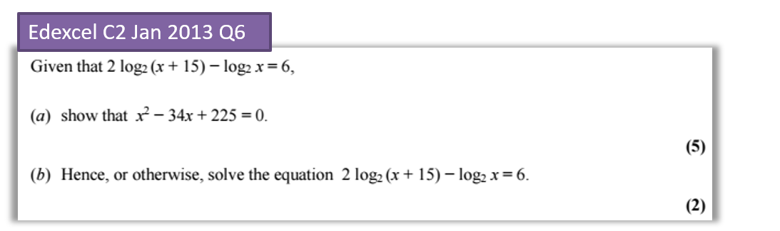

Exercise 14E Pg 323-324

AD Page 11
