Logarithms
$\log_{a}{n}$ (“said log base $a$ of $n$”) is equivalent to $a^{x}=n$.
The log function outputs the missing power.

Examples
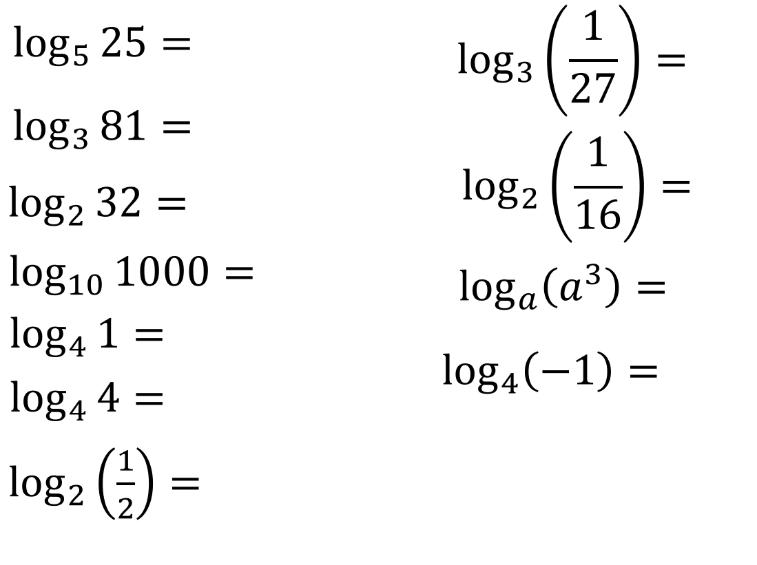
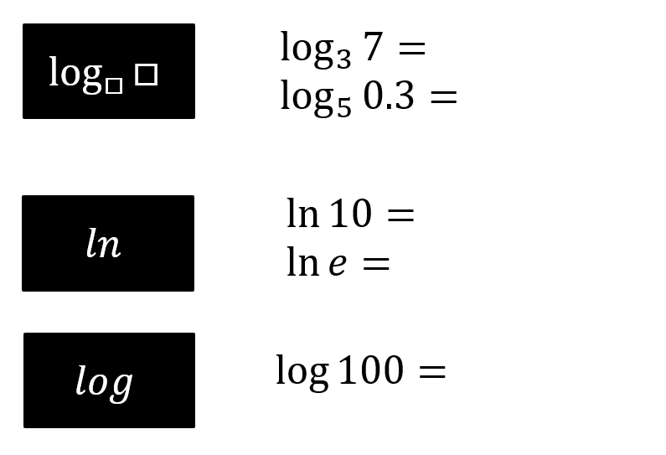
With your calculator…

Exercise 14D Pg 320-321

AD Page 11
