Lower 6 Chapter 14
Exponentials and logarithms

Chapter Overview
- Sketch exponential graphs.
- Use and interpret models that use exponential functions.
- Be able to differentiate $e^{kx}$.
- Understand the log function and use laws of logs.
- Use logarithms to estimate values of constants in non-linear models.

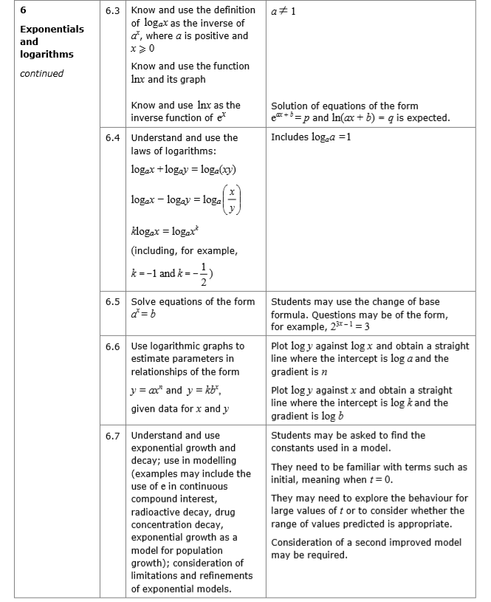
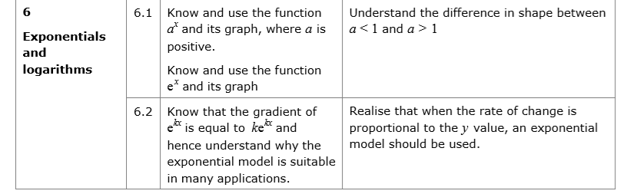

Contrasting exponential graphs
On the same axes sketch $y=3^{x}, y=2^{x}$, $y={1.5}^{x}$

On the same axes sketch $y=2^{x}$ and $y={\left(\frac{1}{2}\right)}^{x}$

Graph Transformations
Sketch $y=2^{x+3}$

Exercise 14A Pg 313-314

AD Page 11

