14A Drawing Exponential Graphs

1) Draw the graph of y = 2^{x}
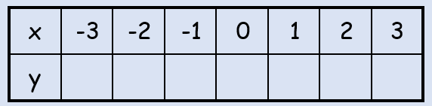
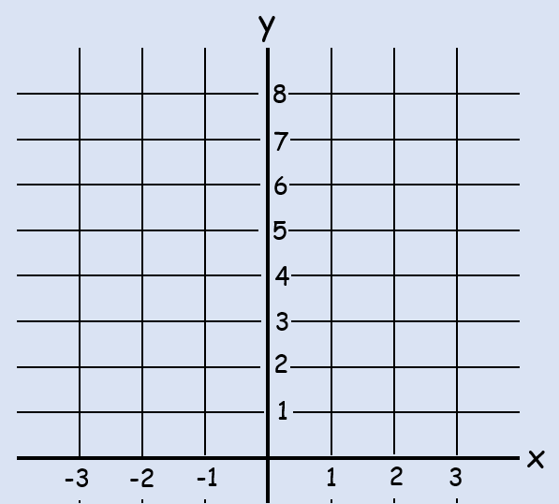

14B Euler’s Number ‘e’

y = 3^{x}
y = 3^{x}ln3
y = 2^{x}ln2
y = 2^{x}

1) Differentiate the following with respect to x:
a) $y=e^{2x}$

b) $y=e^{-\frac{1}{2}x}$

c) $y=3e^{2x}$

2. a) Sketch y = 2e^{x}
y = e^{x}
(0,1)

b) Sketch y = e^{x} + 2
y = e^{x}
(0,1)

c) Sketch y = -e^{x}
y = e^{x}
(0,1)

d) Sketch y = e^{2x}
y = e^{x}
(0,1)

e) Sketch y = e^{x + 1}
y = e^{x}
(0,1)

f) Sketch y = 10e^{-x}
y = e^{x}
(0,1)

g) Sketch y = 3 + 4e^{0.5x}
y = e^{x}
(0,1)

y = e^{x}
(0,1)

y = e^{x}
(0,1)

14C Modelling with e

- The density of a pesticide in a section of field, $P mg/m^{2}$, can be modelled by the equation:
$$P=160e^{-0.006t}$$
In this case, $t$ is the time in days since the pesticide was first applied.
- Estimate the density of the pesticide after 15 days

- Interpret the meaning of the 160 in this model

- Find $\frac{dP}{dt}$

- Interpret the significance of the sign of your answer to part c

- Sketch the graph of $P$ against $t$.

14D Introducing Logorithms

- Write 2⁵ = 32 as a logarithm

- Write as a logarithm:
- 10³ = 1000

- 5⁴ = 625

- 2¹⁰ = 1024

- Find the value of:
- log ₃ (81)

- log ₄ (0.25)

- log _{0.5} (4)

- log _{a} (a⁵)

14E Laws of Logs

- Write each of these as a single logarithm:
- log ₃ (6) + log ₃ (7)

- log ₂ (15) - log ₂ (3)

- 2log ₅ (3) + 3log ₅ (2)

- log ₁₀ (3) - log ₁₀ ($\frac{1}{2}$)

- Write in terms of log_{a}x, log_{a}y and log_{a}z
- log _{a} (x²yz³)

- log _{a} ($\frac{x}{y^{3}}$)

- log _{a} ($\frac{x\sqrt{y}}{z}$)

- log _{a} ($\frac{x}{a^{4}}$)

- Solve the equation:
$$2\log_{2}x=8$$

- Solve the equation:
$$\log_{10}4+2\log_{10}x=2$$

- Solve the equation:
$$\log_{3}\left(x+11\right)-\log_{3}\left(x-5\right)=2$$

14F Solving Equations with Logs
- 3^{x} = 20

- 7^{x+1} = 3^{x+2}

- 5^{2x} + 7 (5^{x}) – 30 = 0

14G ln, the ‘Natural log’

- Solve the equation $e^{x}=5$

- Solve the equation $lnx=3$

- Solve the equation $e^{2x+3}=7$

- Solve the equation $2lnx+1=5$

- Solve the equation $e^{2x}+{5e}^{x}=14$

14H Exponentials in Data

$$y={ax}^{n}$$

$$y={ab}^{x}$$

- The data shows the rank (by size) and population of some UK cities.
The relationship between $P$ and $R$ can be modelled by the formula:
$$P=aR^{n}$$
Where $a$ and $n$ are constants.

- Draw a table giving values of $logR$ and $logP$ to 2 decimal places
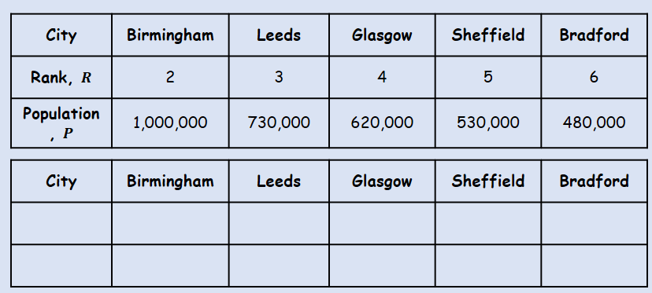
- Plot a graph of $logR$ against $logP$ using the values from your table, and draw a line of best fit

- Use your graph to estimate the values of $a$ and $n$ to two significant figures

- The graph shown represents the growth of a population of bacteria, $P$ over a period of $t$ hours. The graph has a gradient of 0.6 and meets the vertical axis at (0,2) as shown.
A scientist suggests that this growth can be modelled by the equation $P={ab}^{t}$, where a and b are constants to be found.
- Write down an equation for the line
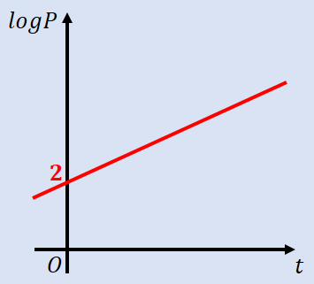

- Using your answer to part a or otherwise, find the values of $a$ and $b$, giving them to 3sf where necessary

- Interpret the meaning of the constant $a$ in this model

