Using Integration
If we know the acceleration, we can integrate to find expressions for velocity and displacement. Recall that the area under a velocity-time graph gives the displacement. Be careful if the velocity (and hence the area) falls under the t-axis as this will give negative displacement.

Example
A particle P, moves in a straight line. At t seconds its acceleration is $\left(6t + 12\right)ms^{-1}$. When t = 0, P is at the point A and its velocity is 3ms⁻¹.
a) Find an expression for the velocity of P in terms of t
b) Find the distance travelled between times t = 3 and t = 5

Example (Textbook Page 189 Example 7)
A particle travels in a straight line. After $t$ seconds its velocity, $v$ ms⁻¹, is given by
$v=5-3t^{2}$, $t≥0$. Find the distance travelled by the particle in the third second of its motion.

Test Your Understanding (EdExcel M2 June 2015 Q6)
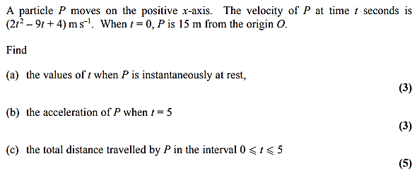

Exercise 11D Page 189

