Maxima and Minima Problems
Recall from Pure that at minimum/maximum points, the gradient is 0. We could therefore for example find where the velocity is minimum/maximum by finding when $\frac{dv}{dt}=0$ (i.e. when the acceleration is 0). Similarly, we can find the maximum and minimum values for displacement and acceleration.

Example
A particle P, moves in a straight line such that its velocity, $v ms^{-1}$ at time $t s$, is given by:
$v = 5 - 9t + 6t^{2} - t^{3}$ where $0≤t≤4$

a) Find the difference between the maximum and minimum velocities over this time interval
b) Sketch a velocity-time graph for the motion of P
c) Find the maximum acceleration over this time interval

Test Your Understanding
A dolphin escapes from Seaworld and its velocity as it speeds away from the park, is
$t^{3}-9t^{2}-48t+500$ (in ms⁻¹), until it reaches its maximum velocity, and then subsequently remains at this velocity.
- When does the dolphin reach its maximum velocity?
- What is this maximum velocity?

Test Your Understanding (EdExcel M2 June 2013 Q3a and b)
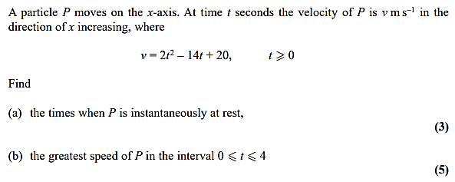

Test Your Understanding
A particle P, moves in a straight line. After t seconds, its distance, s m from its starting point A, when t = 0, is given by:
$s = 2t^{3} - 9t^{2} + 12t$ where $t≥0$
a) Show that the particle never returns to its starting point
b) Find the distances from A at which the particle is instantaneously at rest
c) Find the acceleration of the particle at time t = 3s

Exercise 11C Page 187

