11B Differentiating between x, v, a
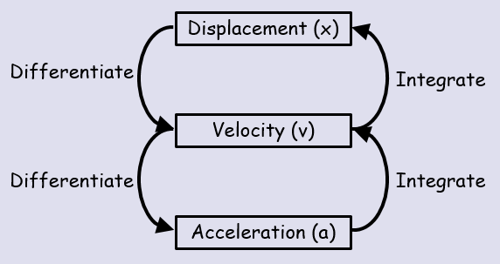

- A particle P is moving along the x-axis. At time t seconds, the displacement x metres from O is given by:
$$x=t^{4}-32t+12$$
Find:
- The speed of P when t = 3

- The value of t for which P is instantaneously at rest

- The magnitude of acceleration when t = 1.5

