11A Functions of Time
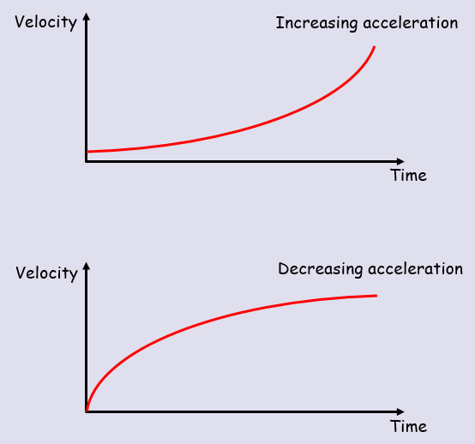

- A body moves in a straight line, such that its displacement, $s$ metres, from a point O at time $t$ seconds is given by $s={2t}^{3}-3t$ for $t>0$
- Find the value of $s$ when $t=2$

- Find the time taken for the body to return to O.

- A toy train travels along a straight track, leaving the start of the track at time $t=0$. It then returns to the start of the track. The distance, $s$ metres, from the start of the track at time $t$ seconds is modelled by:
$s={4t}^{2}-t^{3}$ where $0≤t≤4$
Explain why there is a time restriction on this model

- A body moves in a straight line such that its velocity, $v ms^{-1}$, at time $t$ seconds is given by:
$v={2t}^{2}-16t+24$ for $t≥0$
Find:
- The initial velocity

- The values of t when the body is instantaneously at rest

- The value of t when the velocity is 64ms⁻¹

- The greatest speed of the body in the interval $0≤t≤5$

