A Level Mathematics
Chapter 11 - Mechanics
Variable Acceleration
Chapter Overview
1. Functions of Time
2. Using Differentiation
3. Maxima and Minima Problems
4. Using Integration
5. Constant Acceleration Formulae

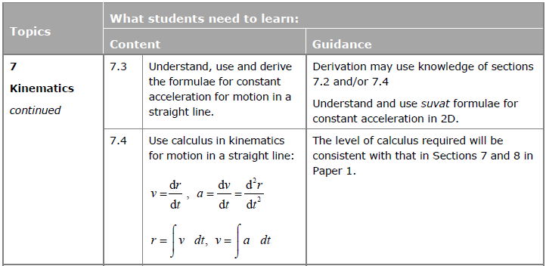

- Functions of Time
Up to now, the acceleration has always been constant in any particular period of time. However, it’s possible to specify either the displacement, velocity or acceleration as any function of time (i.e. an expression in terms of $t$). This allows the acceleration to constantly change.

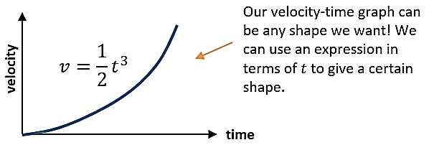
Example
The velocity-time graph of a body is shown above, where $v=\frac{1}{2}t^{3}$.
- What is the velocity after 4 seconds have elapsed?
- How many seconds have elapsed when the velocity of the body is $108$ ms⁻¹?

Example (Textbook)
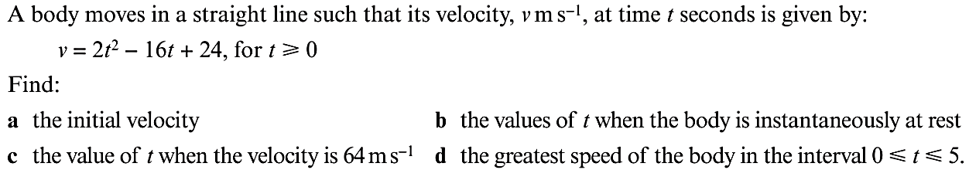

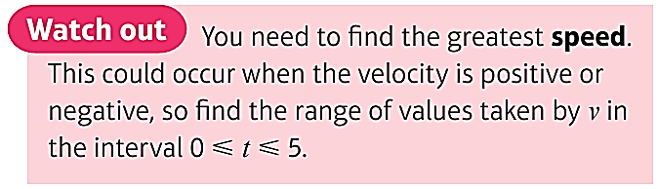
Exercise 11A Page 184

