11A Functions of Time
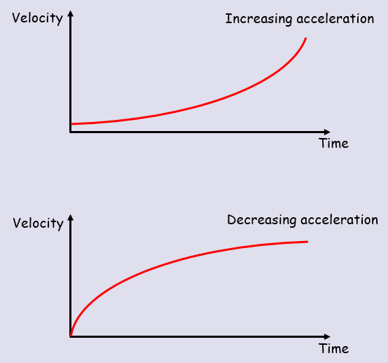

- A body moves in a straight line, such that its displacement, $s$ metres, from a point O at time $t$ seconds is given by $s={2t}^{3}-3t$ for $t>0$
- Find the value of $s$ when $t=2$

- Find the time taken for the body to return to O.

- A toy train travels along a straight track, leaving the start of the track at time $t=0$. It then returns to the start of the track. The distance, $s$ metres, from the start of the track at time $t$ seconds is modelled by:
$s={4t}^{2}-t^{3}$ where $0≤t≤4$
Explain why there is a time restriction on this model

- A body moves in a straight line such that its velocity, $v ms^{-1}$, at time $t$ seconds is given by:
$v={2t}^{2}-16t+24$ for $t≥0$
Find:
- The initial velocity

- The values of t when the body is instantaneously at rest

- The value of t when the velocity is 64ms⁻¹

- The greatest speed of the body in the interval $0≤t≤5$

11B Differentiating between x, v, a
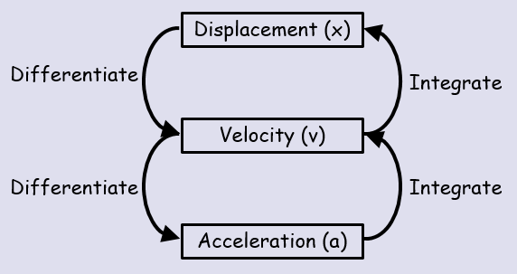

- A particle P is moving along the x-axis. At time t seconds, the displacement x metres from O is given by:
$$x=t^{4}-32t+12$$
Find:
- The speed of P when t = 3

- The value of t for which P is instantaneously at rest

- The magnitude of acceleration when t = 1.5

11C Maxima & Minima

- A child is playing with a yo-yo. The yo-yo leaves the child’s hand at time $t=0$ and travels vertically in a straight line before returning to the child’s hand. The distance in metres, $s$ of the yo-yo from the child’s hand after time $t$ seconds is given by:

$s=0.6t+0.4t^{2}-0.2t^{3},$ $0≤t≤3$

- Justify the restriction $0≤t≤3$

- Find the maximum distance of the yo-yo from the child’s hand, to 3sf

11D Integrating between x, v, a

- A particle is moving on the x-axis. At time $t=0$, the particle is at the point where $x=5$. The velocity of the particle at time t seconds ($t≥0$) is $\left(6t-t^{2}\right) ms^{-1}$. Find:
- An expression for the displacement of the particle from O at time t seconds

- The distance of the particle from its starting point when $t=6$

- A particle travels in a straight line. After $t$ seconds its velocity, ${v ms}^{-1}$, is given by $v=5-3t^{2}, t≥0$. Find the distance travelled by the particle in the third second of its motion.

11E Deriving SUVAT

- A particle moves in a straight line with constant acceleration, $a {ms}^{-2}$. Given that its initial velocity is $u {ms}^{-1}$ and its initial displacement is 0m, prove that:
- The particle’s velocity at time $t$ seconds is given by $v=u+at$

- The particle’s displacement, $s$, at time t is given by $s=ut+\frac{1}{2}at^{2}$

