Pulleys
A pulley is a wheel on which a rope/string/cable passes.
What modelling assumptions are made?

Example
Particles of mass 4kg and 2kg are connected by a light string passing over a smooth, fixed pulley. The particles hang freely and are released from rest.
i) Find the acceleration of the two particles and the tension in the string. Let the acceleration be a and the tension in the string be T
ii) Find the force exerted on the pulley by the string

Example – Horizontal and Vertical String
(Take g = 10ms⁻² in this question)
The diagram shows a particle, P, of mass 0.5kg on a smooth horizontal table. P is connected to another particle, Q, of mass 1.5kg, by a taut, light, inextensible string which passes over a small, fixed, smooth pulley at the edge of the table, Q hanging vertically below the pulley.
A horizontal force of magnitude XN acts on P as shown.
a) Given the system is in equilibrium, find X
b) Given that X = 12, find the distance travelled by Q in the first two seconds of its motion, following the release of the system from rest. You may assume that P does not reach the pulley in this time.

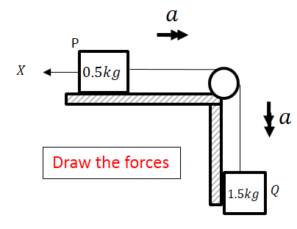

Test Your Understanding (EdExcel M1 Jan 2010 Q6)
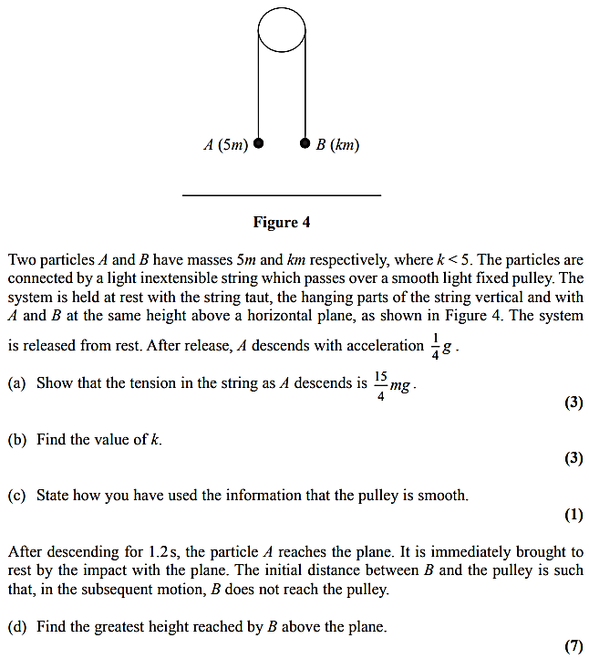

Exercise 10F Page 175
Mixed Exercise 10 Page 177

