Connected Particles
When we have multiple connected objects moving in the same straight line, they can be considered either as two separate particles, or as a single particle, but all forces acting on the particle must be considered.

What assumptions are made?

Example (EdExcel M1 June 2009 Q6)
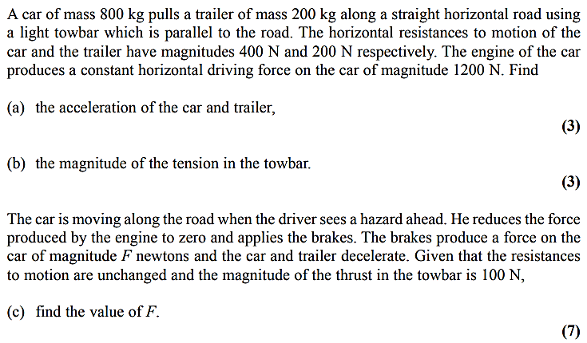

Test Your Understanding

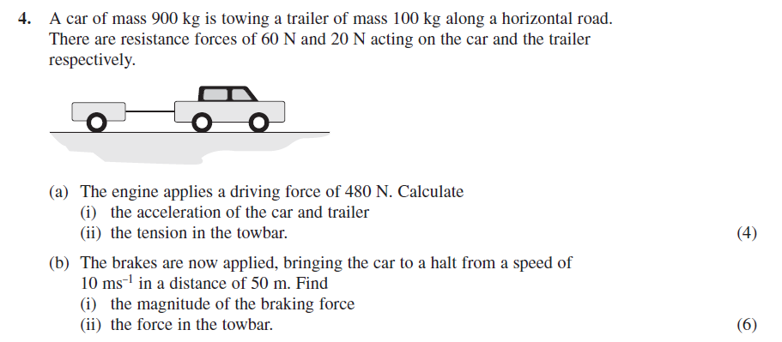

Vertical Example

