- Connected Particles
When we have multiple connected objects moving in the same straight line, they can be considered either as two separate particles, or as a single particle, but all forces acting on the particle must be considered.

What assumptions are made?

Example (EdExcel M1 June 2009 Q6)
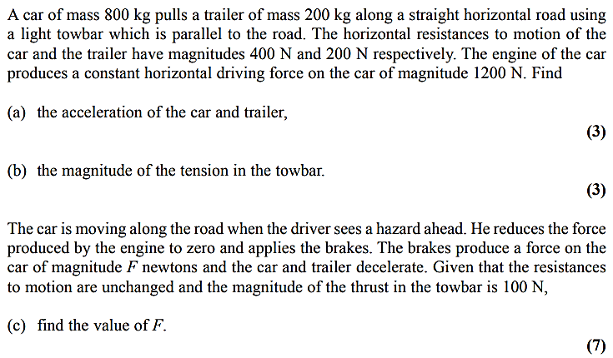

Test Your Understanding

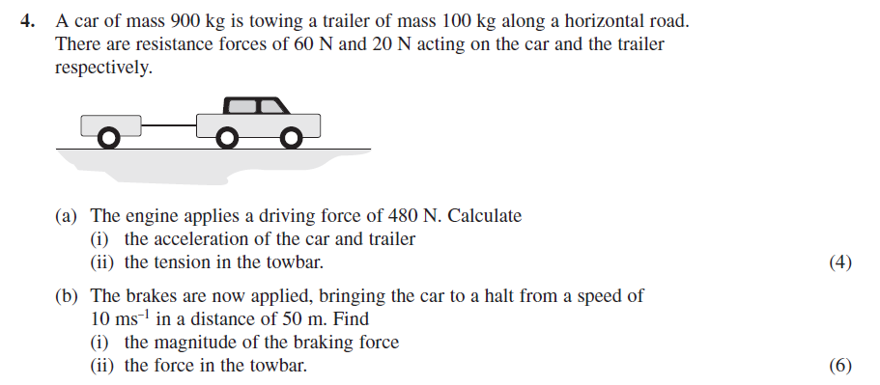

Vertical Example

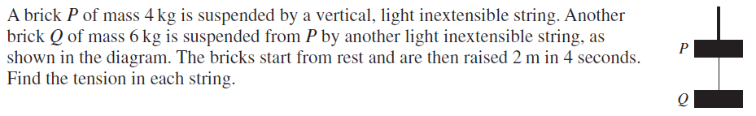

Example – Using Newton’s 3rd Law for Stacked Objects

Newton’s 3rd Law: For every action there is an equal and opposite reaction
Therefore when two bodies $A$ and $B$ are in contact, if body $A$ exerts a force on body $B$, then body $B$ exerts a force on body $A$ that is equal in magnitude and acts in the opposite direction.
[Textbook] A light scale-pan is attached to a vertical light inextensible string. The scale-pan carries two masses $A$ and $B$. The mass of $A$ is 400g and the mass of $B$ is 600g. $A$ rests on top of $B$, as shown in the diagram.
The scale-pan is raised vertically, using the string, with acceleration 0.5 ms⁻².
- Find the tension in the string.
- Find the force exerted on mass $B$ by mass $A$.
- Find the force exerted on mass $B$ by the scale-pan.

Test Your Understanding – Motion of a Lift (EdExcel M1 May 2013 Q2)
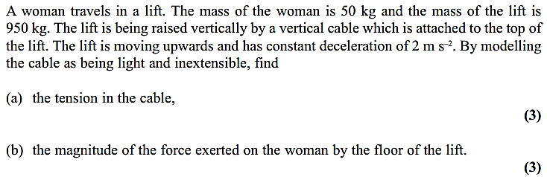

Exercise 10E Page 171

