10C F=ma

- Find the weight in Newtons, of a particle of mass 12kg.

- Find the acceleration when a particle of mass 1.5kg is acted on by a force of 6N

- Find the values of the missing forces acting on the object in the diagram below
a)
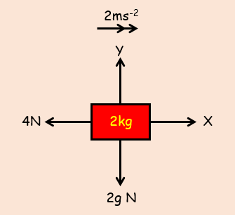

b)
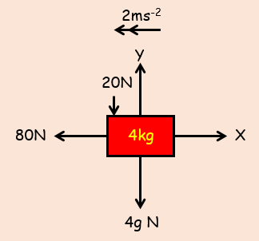

- A particle of mass 5kg is pulled along a rough horizontal table by a force of 20N, with a frictional force of 4N acting against it. Given that the particle is initially at rest, find:

- The acceleration of the particle

- The distance travelled by the particle in the first 4 seconds

- The magnitude of the normal reaction between the particle and the table

