Forces and Acceleration
Newton’s 2nd Law of Motion: $F=ma$
(where the force $F$ and acceleration $a$ are in the same direction)

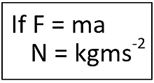
- Force is measured in Newtons (N)
- Mass is measured in kg
- Acceleration is measured in ms⁻²

Examples
- A car of 2000kg has a driving force of 800N and forces of 200N resisting its motion. Determine its acceleration.

- A child has a mass of 50kg. What is the gravitational force acting on the child? (i.e. its weight)

Combining F = ma with SUVAT equations
We can use SUVAT equations and Newton 1 and 2 to solve problems. We resolve forces which are parallel in one or more directions to do this.
Forces acting in a perpendicular direction do not affect the motion of a body.

NB: Remember SUVAT is for constant acceleration only.

Example
The forces acting on a body cause it to accelerate as indicated.
a) Find the values of X and Y
b) Find the distance travelled in the first 4 seconds if the object starts at rest.

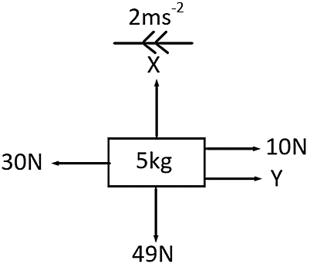
(Indicate which direction is positive vertically and horizontally)

Forces Acting Under Gravity

Acceleration due to gravity is $g=9.8$ ms⁻²

Example
A lift of mass 600kg is raised or lowered by means of a cable attached to its top. When carrying passengers whose total mass is 400kg, the lift accelerates uniformly from rest to 2ms⁻¹ over a distance of 5m. Find:
a) The magnitude of the acceleration
b) The tension in the cable if the motion takes place vertically upwards
c) The tension in the cable if the motion takes place vertically downwards

Test Your Understanding (EdExcel M1 May 2012 Q5 abridged)
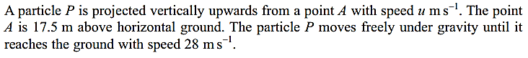
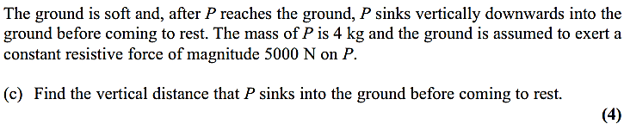

Exercise 10C Page 164

