Forces as Vectors
Forces have direction, and therefore we can naturally write them as vectors, either in $i$-$j$ notation or as column vectors.
Add the vectors of two or more forces to find the resultant force.
Example
The forces (3i - 4j), (2i + 5j) and (ai + bj) act on a particle in equilibrium. Find the values of a and b.
If the particle is in equilibrium, what is the value of the resultant force?

We can use Pythagoras and trignometry to find the magnitude and bearing of a force when it is in vector form.
Example
The vector $i$ is due east and $j$ due north. A particle begins at rest at the origin. It is acted on by three forces $\left(2i+j\right)$ N, $\left(3i-2j\right)$ N and $\left(-i+4j\right)$ N.
- Find the resultant force in the form $pi+qj$.
- Work out the magnitude and bearing of the resultant force.

Test Your Understanding (EdExcel M1 Jan 2012 Q3)
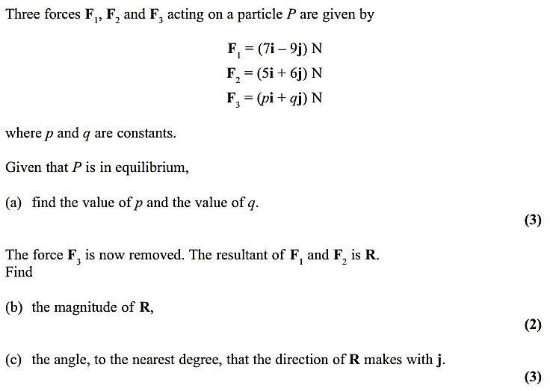

Test Your Understanding (EdExcel M1 May 2009 Q2)
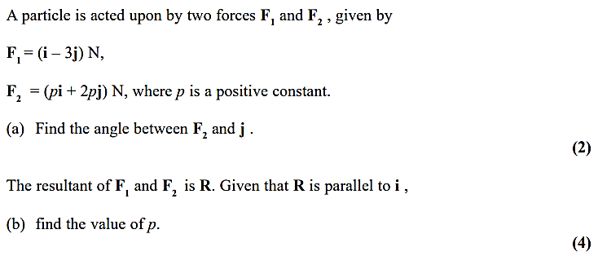

Exercise 10B Page 161

