10A Diagrams & Resultant Forces

- The diagram shows the forces acting on a particle.
- Calculate the resultant force
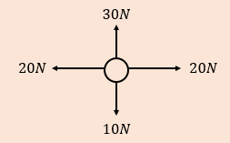

- Describe the motion of the particle

