A Level Mathematics
Chapter 10 - Mechanics
Forces and Motion
Chapter Overview
1. Force Diagrams
2. Forces as Vectors
3. Forces and Acceleration
4. Motion in 2 Dimensions
5. Connected Particles
6. Pulleys
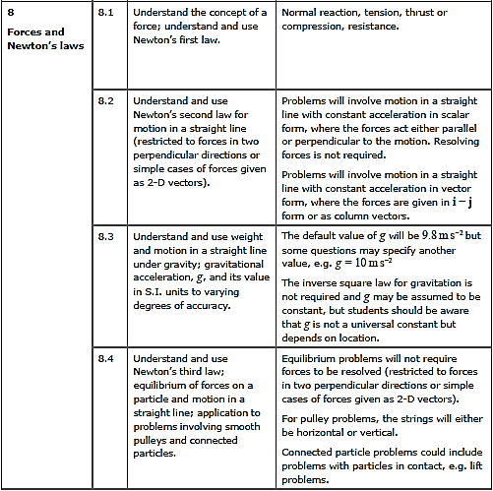
- Force Diagrams
Recall Newton’s laws of motion:

- An object will remain at rest or continue to move in a straight line at a constant speed unless it is acted upon by a resultant force
- The force needed to accelerate a particle is equal to the product of its mass and the acceleration of the particle: F = ma
- Every action has an equal and opposite reaction

When drawing a force diagram, make sure you include all of the forces which might be acting on an object (see Chapter 8). Consider the forces acting on each object, one at a time. You can draw the resultant force and describe the motion of the object.

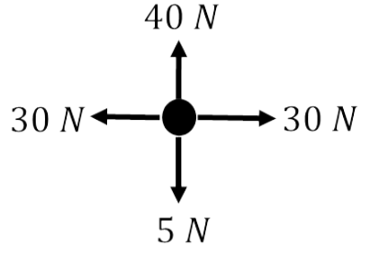
$$R\left(↑\right):$$
$$R\left(→\right):$$

Exercise 10A Page 158

