10A Diagrams & Resultant Forces

- The diagram shows the forces acting on a particle.
- Calculate the resultant force
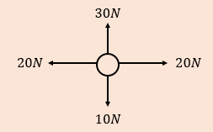

- Describe the motion of the particle

10B Forces as Vectors

- The forces $2i+3j,$ $4i-j$, $-3i+2j$ and $xi+yj$ act on an object which is in equilibrium. Find the values of x and y.

- In this question i represents the unit vector due east, and j represents the unit vector due north. A particle begins at rest at the origin. It is acted on by three forces $\left(2i+j\right)N,$ $\left(3i-2j\right)N$ and $\left(-i+4j\right)N$.

- Find the resultant force in the form $pi+qj$

- Work out the magnitude and bearing of the resultant force

- Describe the motion of the particle

10C F=ma

- Find the weight in Newtons, of a particle of mass 12kg.

- Find the acceleration when a particle of mass 1.5kg is acted on by a force of 6N

- Find the values of the missing forces acting on the object in the diagram below
a)
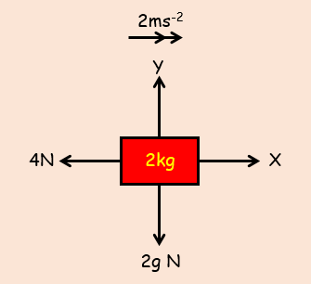

b)
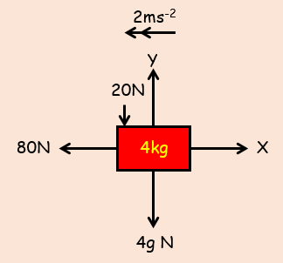

- A particle of mass 5kg is pulled along a rough horizontal table by a force of 20N, with a frictional force of 4N acting against it. Given that the particle is initially at rest, find:

- The acceleration of the particle

- The distance travelled by the particle in the first 4 seconds

- The magnitude of the normal reaction between the particle and the table

10D F=ma with Vectors
- A force of$\left(3i+8j\right) N$ acts upon a particle of mass 0.5kg.

- Find the acceleration of the particle in the form $\left(pi+qj\right) {ms}^{-2}$.

- Find the magnitude and bearing of the acceleration of the particle

- The following forces:

F₁ = (2i + 4j) N

F₂ = (-5i + 4j) N

F₃ = (6i – 5j) N
all act on a particle of mass 3kg. Find the acceleration of the particle.

- A boat is modelled as a particle of mass 60kg being acted on by 3 forces:
$$F_{3}=\left(\begin{matrix}-75 \\ 100\end{matrix}\right)N$$
$$F_{2}=\left(\begin{matrix}10p \\ 20q\end{matrix}\right)N$$
$$F_{1}=\left(\begin{matrix}80 \\ 50\end{matrix}\right)N$$

Given that the boat is accelerating at a rate of $\left(\begin{matrix}0.8 \\ -1.5\end{matrix}\right) {ms}^{-2}$, find the values of $p$ and $q$

- Given that:
a = 3i - j
b = i + j
Find µ if a + µb is parallel to 3i + j

10E Connected Particles

- Two particles, P and Q, of masses 5kg and 3kg respectively, are connected by a light inextensible string. Particle P is pulled by a horizontal force of magnitude 40N along a rough horizontal plane. Particle P experiences a frictional force of 10N and particle Q experiences a frictional force of 6N.

- Find the acceleration of the particles

- Find the tension in the string

- Explain how the modelling assumptions that the string is light and inextensible have been used

- A light scale-pan is attached to a vertical light inextensible string. The scale pan carries two masses, A and B. The mass of A is 400g and the mass of B is 600g. A rests on top of B.
The scale pan is raised vertically with an acceleration of 0.5ms⁻².
- Find the Tension in the string

- Find the force exerted on mass B by mass A

- Find the force exerted on mass B by the scale pan

C Alt (Consider particles as one)

10F Pulleys

- Particles P and Q, of masses 2m and 3m, are attached to the ends of a light inextensible string. The string passes over a small, smooth, fixed pulley and the masses hang with the string taut. The system is released from rest.
- Find the acceleration of each mass

- Find the tension in the string, in terms of m

- Find the force exerted on the pulley by the string, in terms of m

- Find the distance travelled by Q in the first 4 seconds, assuming that P does not reach the pulley

- Comment on any modelling assumptions used

- Two particles A and B of masses 0.4kg and 0.8kg respectively are connected by a light inextensible string. Particle A lies on a rough horizontal table 4.5m from a small smooth fixed pulley which is attached to the end of the table. The string passes over the pulley and B hangs freely, with the string taut, 0.5m above the ground. The frictional force has a magnitude 0.08g.The system is released from rest. Find:
- The acceleration of the system

- The velocity at which B hits the ground

- The total distance travelled by A before it comes to rest

- (Bonus Question) The Force exerted on the pulley and the direction the force is in.

