The Robin Hood Bandits
  - Grade I clearance only
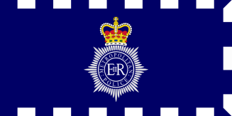
  - 12/2/2018
New Scotland Yard
35 Victoria Embankment,
Westminster,
London
SW1A 2JL
9/12/2020
Briefing document

In the early hours of Tuesday Morning on 08/12/2020 the crown jewels were stolen from the tower of London by a group known only as ‘the Robin Hood bandits.

We have currently arrested 16 individuals from across the country that had on their person the equipment that we understand could have been used to carry out the heist. We are, however, still unsure of the identity of the true culprit and can only hold these members of the public in custody for 24 hours before they can be released again. We must find enough evidence to charge them before that happens.

Each individual was found with a batman-style grappling hook, many of which have been circulating the criminal underworld recently, which was similar to that used to scale the white tower during the heist. These have been tested for their power of projection with these statistics placed alongside each suspect’s details in the documents enclosed.

Each individual was also found with a length of rope and driving a recently leased white van, again similar to that which was being used for the heist. We have provided you with details of each van’s braking distance (distance to come to a complete stop from travelling at 50 miles per hour) as well as other key statistics, such as their acceleration from 0-60 miles per hour.

Also attached is a map of the tower and newspaper front page from this morning.

Before any individual can be charged, all other suspects must be cleared of any suspicion.

Good luck with you Investigation.

