U6 Chapter 3

Sequences and Series

Chapter Overview

1. Sequences

2. Arithmetic Series

3. Geometric Series

4. Sigma Notation

5. Recurrence Relations

6. Combined Sequences

7. Classifying Sequences



Sequences

A sequence is an ordered set of mathematical objects. Each element in the sequence is called a term.

$u_{n}=$

$$n=$$

Arithmetic Sequences

Examples

1. The th term of an arithmetic sequence is $u_{n}=55-2n$.

1. Write down the first 3 terms of the sequence.
2. Find the first term in the sequence that is negative.

2. Find the $n$ th term of each arithmetic sequence.

1. 6, 20, 34, 48, 62
2. 101, 94, 87, 80, 73

3. A sequence is generated by the formula $u_{n}=an+b$ where $a$ and $b$ are constants to be found. Given that $u_{3}=5$ and $u_{8}=20$, find the values of the constants and .

4. For which values of $x$ would the expression $-8, x^{2}$ and $17x$ form the first three terms of an arithmetic sequence.

Test Your Understanding

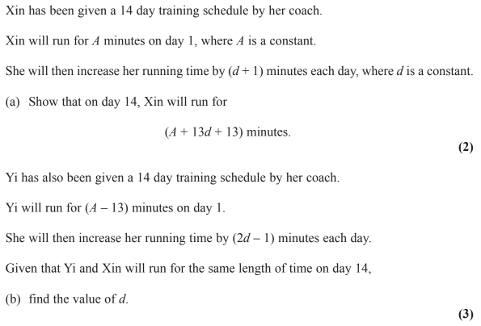

Extension

[STEP I 2004 Q5] The positive integers can be split into five distinct arithmetic progressions, as shown:

A: 1, 6, 11, 16, …

B: 2, 7, 12, 17, …

C: 3, 8, 13, 18, …

D: 4, 9, 14, 19, …

E: 5, 10, 15, 20, …

Write down an expression for the value of the general term in each of the five progressions. Hence prove that the sum of any term in B and any term in C is a term in E.

Prove also that the square of every term in B is a term in D. State and prove a similar claim about the square of every term in C.

1. Prove that there are no positive integers $x$ and $y$ such that $x^{2}+5y=243723$
2. Prove also that there are no positive integers $x$ and $y$ such $x^{4}+2y^{4}=26081974$

Ex 3A Pg 61

Arithmetic Series

Proof of summation (required for exam):

Examples

1. Find the sum of the first 30 terms of the following arithmetic sequences

2. Find the greatest number of terms for the sum of $4+9+14+…$ to exceed 2000

Test Your Understanding

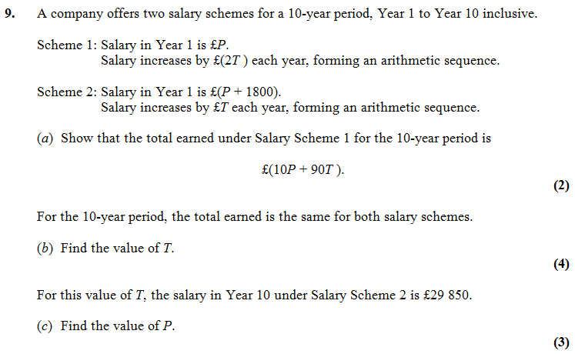

Extension

[MAT 2007 1J]

The inequality

$$\left(n+1\right)+\left(n^{4}+2\right)+\left(n^{9}+3\right)+… +\left(n^{10000}+100\right)>k$$

Is true for all $n≥1$. It follows that



$k<1300$

$k^{2}<101$

$k≥{101}^{10000}$

$k<5150$

[AEA 2010 Q2]

The sum of the first $p$ terms of an arithmetic series is $q$ and the sum of the first $q$ terms of the same arithmetic series is $p$, where $p$ and $q$ are positive integers and $p≠q$.

Giving simplified answers in terms of $p$ and $q$, find

1. The common difference of the terms in this series,
2. The first term of the series,
3. The sum of the first $\left(p+q\right)$ terms of the series.

[MAT 2008 1I]

The function $S\left(n\right)$ is defined for positive integers $n$ by

$S\left(n\right)=$ sum of digits of $n$

For example, $S\left(723\right)=7+2+3=12$.

The sum

$S\left(1\right)+S\left(2\right)+S\left(3\right)+…+S\left(99\right)$

equals what?

Ex 3B Pg 64

Geometric Series

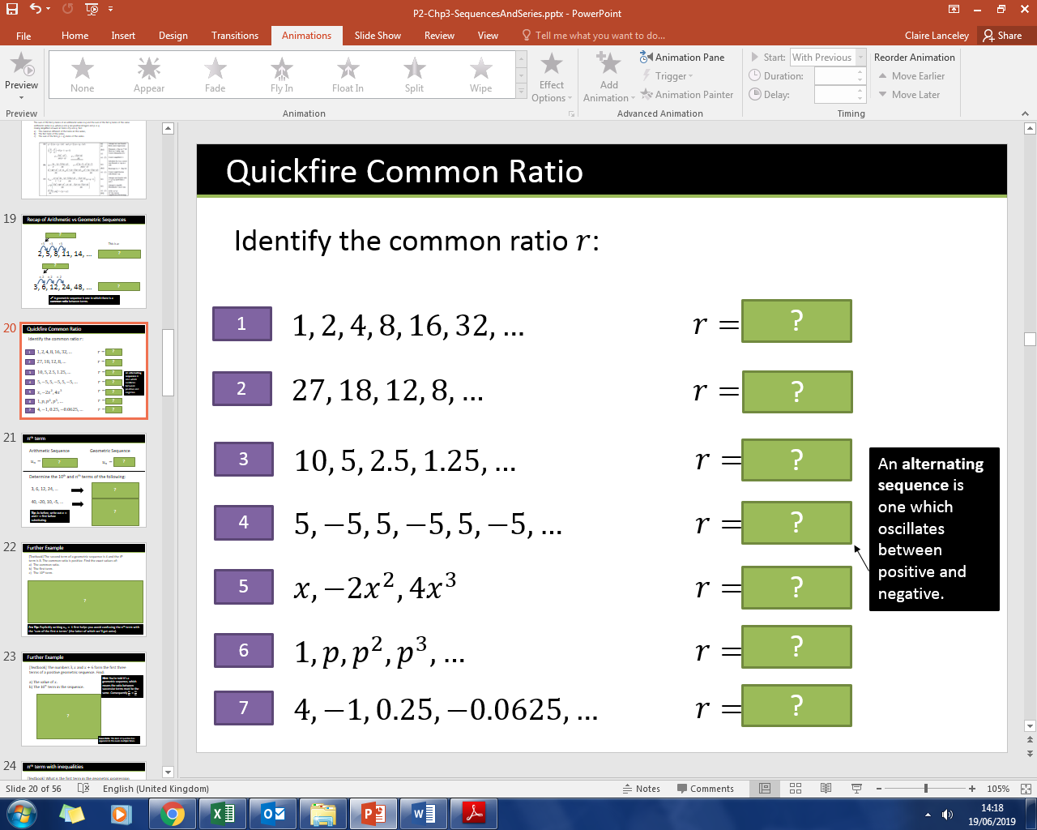

Examples

1. Determine the 10th and th terms of the following:

a) 3, 6, 12, 24, …

b) 40, -20, 10, -5, …

2. The second term of a geometric sequence is 4 and the 4th term is 8. The common ratio is positive. Find the exact values of:

1. The common ratio.
2. The first term.
3. The 10th term.

3. The numbers $3, x$ and $x+6$ form the first three terms of a positive geometric sequence. Find:

a) The value of $x$.

b) The 10th term in the sequence.

Inequalities Example

What is the first term in the geometric progression $3, 6, 12, 24, …$ to exceed 1 million?

Test Your Understanding

1. All the terms in a geometric sequence are positive.

The third term of the sequence is 20 and the fifth term 80. What is the 20th term?

2. The second, third and fourth term of a geometric sequence are the following:

$$x, x+6, 5x-6$$

a) Determine the possible values of $x$.

b) Given the common ratio is positive, find the common ratio.

c) Hence determine the possible values for the first term of the sequence.

Ex 3c Pg 69

Sum of terms of Geometric Series

Proof:

Examples

1. Find the sum of the first 10 terms of the following sequences

a)

$$3, 6, 12, 24, 48, …$$

b) $$4, 2,1, \frac{1}{2},\frac{1}{4},\frac{1}{8}, …$$

Example

Find the least value of $n$ such that the sum of $1+2+4+8+…$ to $n$ terms would exceed 2 000 000.

Test Your Understanding

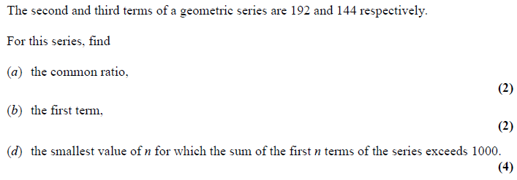

Extension

MAT 2010 1B]

The sum of the first $2n$ terms of

$$1, 1, 2,\frac{1}{2}, 4,\frac{1}{4},8,\frac{1}{8},16,\frac{1}{16},…$$

is



$2^{n}+1-2^{1-n}$

$2^{n}+2^{-n}$

$2^{2n}-2^{3-2n}$

$\frac{2^{n}-2^{-n}}{3}$

Ex 3D Pg 72

Divergence and Convergence

Sum to Infinity

Quickfire Examples: Calculate a, r and $S_{∞}$ for the following sequences

1. $1,\frac{1}{2},\frac{1}{4},\frac{1}{8},…$

2. $27,-9,3,-1,…$

3. $p, p^{2},p^{3},p^{4},…$ $where -1<p<1$

4. $p, 1,\frac{1}{p},\frac{1}{p^{2}},…$

Examples

1. The fourth term of a geometric series is 1.08 and the seventh term is 0.23328.

1. Show that this series is convergent.
2. Find the sum to infinity of this series.

2. For a geometric series with first term $a$ and common ratio $r$, $S_{4}=15$ and $S_{∞}=16$.

a) Find the possible values of $r$.

b) Given that all the terms in the series are positive, find the value of $a$.

Test Your Understanding

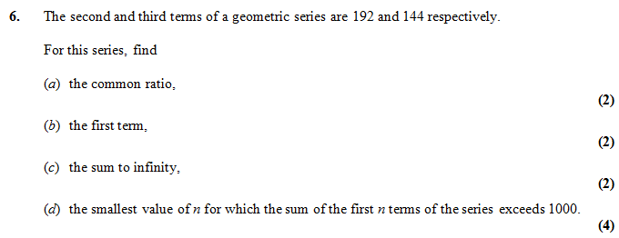

Extension

1. [MAT 2006 1H] How many solutions does the equation

$$2=\sin{x}+\sin^{2}{x}+\sin^{3}{x}+\sin^{4}{x}+…$$

have in the range

2. [MAT 2003 1F] Two players take turns to throw a fair six-sided die until one of them scores a six. What is the probability that the first player to throw the die is the first to score a six?

3. [Frost] Determine the value of $x$ where:

$$x=\frac{1}{1}+\frac{2}{2}+\frac{3}{4}+\frac{4}{8}+\frac{5}{16}+\frac{6}{32}+…$$

(Hint: Use an approach similar to proof of geometric $S_{n}$ formula)

Ex 3E Pg 75

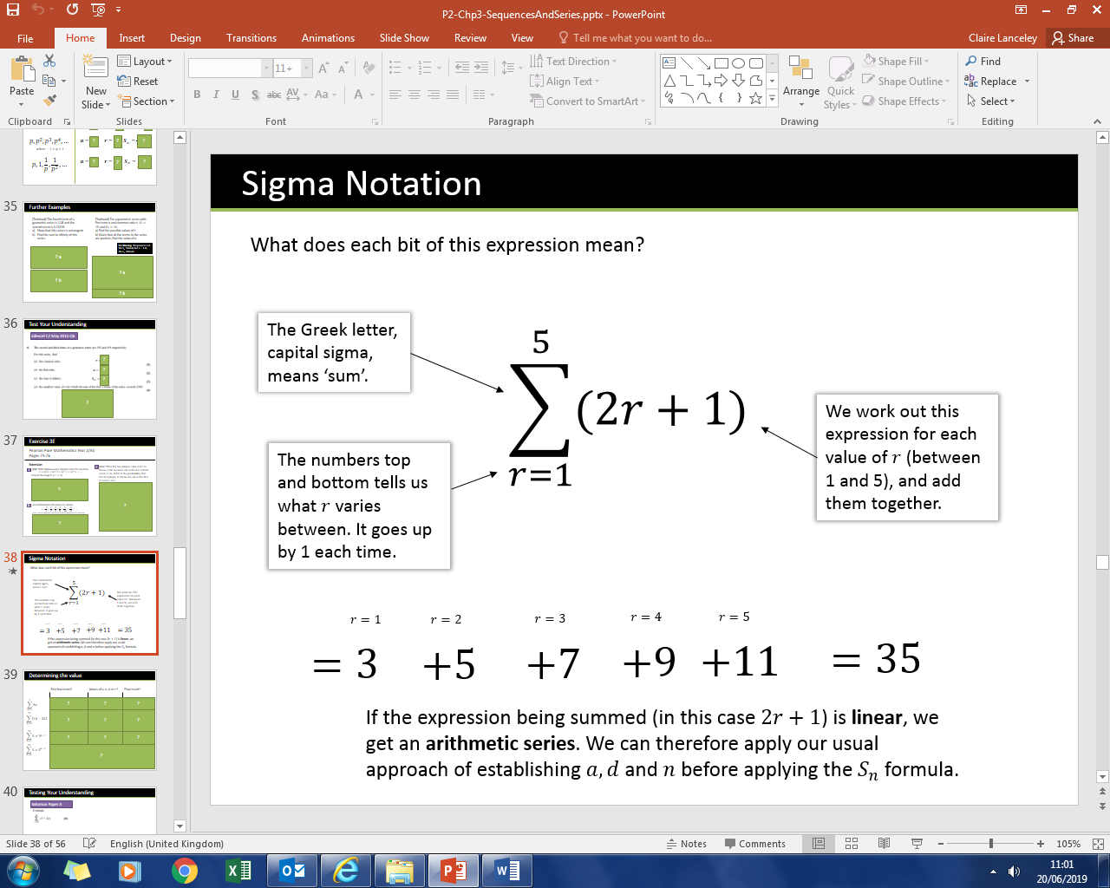Sigma Notation

|  |  |  |  |
| --- | --- | --- | --- |
|  | First few terms? | Values of $a, n, d or r$? | Final result? |
| $$\sum_{n=1}^{7}{3n}$$ |  |  |  |
| $$\sum_{k=5}^{15}{\left(10-2k\right)}$$ |  |  |  |
| $$\sum_{k=1}^{12}{5×3^{k-1}}$$ |  |  |  |
| $$\sum_{k=5}^{12}{5×3^{k-1}}$$ |  |  |  |

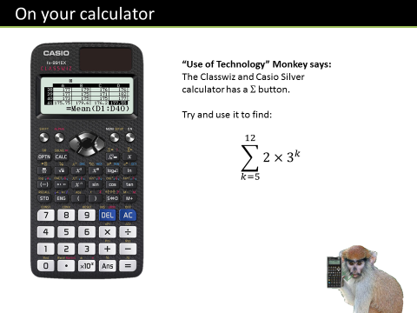Test Your Understanding

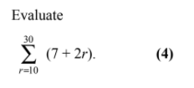

Ex 3F Pg 77

Recurrence Relations

Example

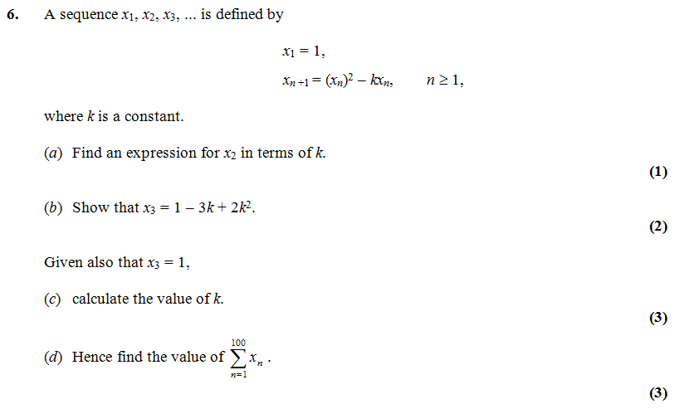

Test Your Understanding

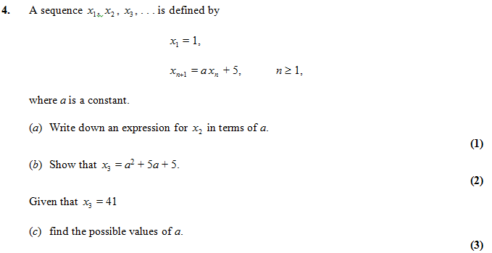

Combined Sequences

Sequences (or series) can be generated from a combination of both an arithmetic and a geometric sequence.

Example



Extension

1. *[AEA 2011 Q3]* A sequence $\{u_{n}\}$ is given by

$$u_{1}=ku_{2n}=u_{2n-1}×p, n≥1u_{2n+1}=u_{2n}×q n≥1$$

1. Write down the first 6 terms in the sequence.
2. Show that $\sum_{r=1}^{2n}{u_{r}}=\frac{k\left(1+p\right)\left(1-{\left(pq\right)}^{n}\right)}{1-pq}$

$[x]$ means the integer part of $x$, for example .  
Find

2. [MAT 2014 1H] The function $F\left(n\right)$ is defined for all positive integers as follows: $F\left(1\right)=0$ and for all $n≥2$,

$F\left(n\right)=F\left(n-1\right)+2$ if 2 divides $n$ but 3 does not divide $,$

$F\left(n\right)=F\left(n-1\right)+3$ if 3 divides $n$ but 2 does not divide $n,$

$F\left(n\right)=F\left(n-1\right)+4$ if 2 and 3 both divide $n$

$F\left(n\right)=F\left(n-1\right)$ if neither 2 nor 3 divides $n$.

Then the value of $F\left(6000\right)$ equals what?

3. [MAT 2016 1G] The sequence $\left(x_{n}\right)$, where $n≥0$, is defined by $x_{0}=1$ and

$x_{n}=\sum_{k=0}^{n-1}{\left(x_{k}\right)}$ for $n≥1$

Determine the value of the sum $\sum_{k=0}^{∞}{\frac{1}{x_{k}}}$

Ex 3G Pg 80

Classifying Sequences

A sequence is **strictly increasing** if the terms are always increasing, i.e.

$u_{n+1}>u_{n}$ for all $n∈N$.

*e.g. $1, 2, 4, 8, 16, …$*

Similarly a sequence is **strictly decreasing** if $u_{n+1}<u_{n}$ for   
all $n∈N$

A sequence is **periodic** if the terms repeat in a cycle. The **order $k$** of a sequence is **how often it repeats**, i.e. $u_{n+k}=u_{n}$ for all $n$.

*e.g. 2, 3, 0, 2, 3, 0, 2, 3, 0, 2, … is periodic and has order 3.*

Examples

For each sequence:

1. State whether the sequence is increasing, decreasing or periodic.
2. If the sequence is periodic, write down its order.

$u_{n+1}=u_{n}+3, u_{1}=7$

$u_{n+1}={\left(u_{n}\right)}^{2}, u_{1}=\frac{1}{2}$

$u_{n+1}=\sin\left(90n°\right)$

Ex 3H Pg 82

Modelling

Examples

1. Bruce starts a new company. In year 1 his profits will be £20 000. He predicts his profits to increase by £5000 each year, so that his profits in year 2 are modelled to be £25 000, in year 3, £30 000 and so on. He predicts this will continue until he reaches annual profits of £100 000. He then models his annual profits to remain at £100 000.

1. Calculate the profits for Bruce’s business in the first 20 years.
2. State one reason why this may not be a suitable model.
3. Bruce’s financial advisor says the yearly profits are likely to increase by 5% per annum. Using this model, calculate the profits for Bruce’s business in the first 20 years.

2. A piece of A4 paper is folded in half repeatedly. The thickness of the A4 paper is 0.5 mm.

1. Work out the thickness of the paper after four folds.
2. Work out the thickness of the paper after 20 folds.
3. State one reason why this might be an unrealistic model.

Test Your Understanding

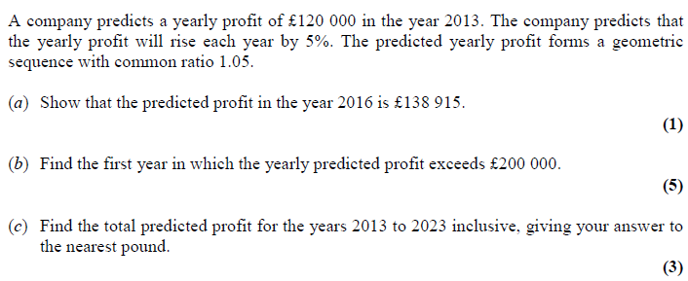

Extension

*AEA 2007 Q5*

The figure shows part of a sequence $S_{1}, S_{2}, S_{3},…$, of model snowflakes. The first term $S_{1}$ consist of a single square of side $a$. To obtain $S_{2}$, the middle third of each edge is replaced with a new square, of side $\frac{a}{3}$, as shown. Subsequent terms are added by replacing the middle third of each external edge of a new square formed in the previous snowflake, by a square $\frac{1}{3}$ of the size, as illustrated by $S_{3}$.

a) Deduce that to form $S_{4}$, 36 new squares of side $\frac{a}{27}$ must be added to $S_{3}$.

b) Show that the perimeters of $S_{2}$ and $S_{3}$ are $\frac{20a}{3}$ and $\frac{28a}{3}$ respectively.

c) Find the perimeter of $S_{n}$.

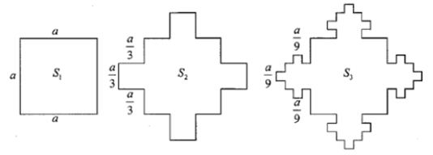

Ex 3I Pg 84