**Pure 2**

**Vectors**

Chapter Overview

1:: Distance between two points.

2:: $i,j,k$ notation for vectors

3:: Magnitude of a 3D vector and using it to find angle between vector and a coordinate axis.

4:: Solving Geometric Problems

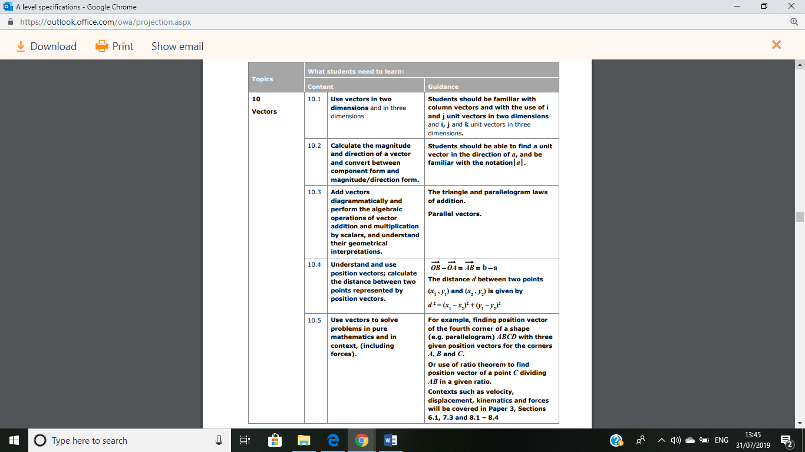5:: Application to Mechanics

**Distance from the origin and magnitude of a vector**

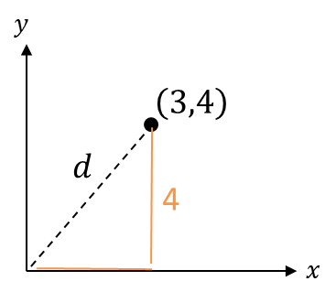 In 2D, how did we find the distance from a point to the origin?

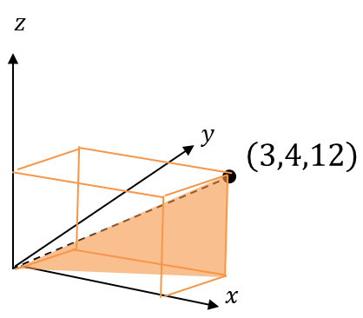



**The magnitude of a vector $a=\left(\begin{matrix}x \\ y \\ z\end{matrix}\right)$:**

$$\left|a\right|=\sqrt{x^{2}+y^{2}+z^{2}}$$

**And the distance of $(x,y,z)$ from the origin is $\sqrt{x^{2}+y^{2}+z^{2}}$**

**Distance between two 3D points**

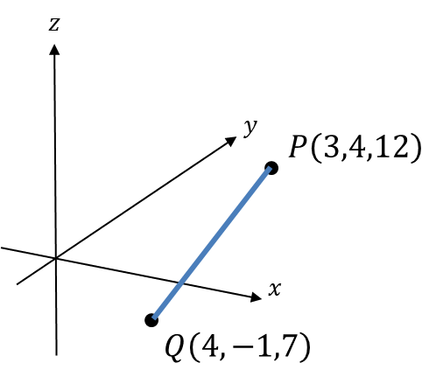

How do we find the distance between $P$ and $Q$?

**The distance between two points is:**

$$d=\sqrt{{\left(Δx\right)}^{2}+{\left(Δy\right)}^{2}+{\left(Δz\right)}^{2}}$$

$Δx$**means “change in $x$”**

**Quickfire Questions:**

Distance of $(4,0,-2)$ from the origin:

$$\left|\left(\begin{matrix}5 \\ 4 \\ -1\end{matrix}\right)\right|=$$

Distance between $(0,4,3)$ and $\left(5,2,3\right).$

Distance between $(1,1,1)$ and $\left(2,1,0\right).$

Distance between $(-5,2,0)$ and $\left(-2,-3,-3\right).$

**Tip**: Because we’re squaring, it doesn’t matter whether the change is negative or positive.

***Test Your Understanding So Far…***

[Textbook] **Find the distance from the origin to the point $P(7,7,7)$.**

[Textbook] **The coordinates of $A$ and $B$ are $(5,3,-8)$ and $\left(1,k,-3\right)$ respectively. Given that the distance from $A$ to $B$ is $3\sqrt{10}$ units, find the possible values of $k$.**

Ex 12A p.338

$i$**, $j$ and $k$ notation**

In 2D you were previously introduced to $i=\left(\begin{matrix}1 \\ 0 \end{matrix}\right)$ and $j=\left(\begin{matrix}0 \\ 1\end{matrix}\right)$ as unit vectors in each of the $x$ and $y$ directions.

It meant for example that $\left(\begin{matrix}8 \\ -2\end{matrix}\right)$ could be written as $8i-2j$ since $8\left(\begin{matrix}1 \\ 0 \end{matrix}\right)-2\left(\begin{matrix}0 \\ 1\end{matrix}\right)=\left(\begin{matrix}8 \\ -2\end{matrix}\right)$

Unsurprisingly, **in 3D:**

$$i=\left(\begin{matrix}1 \\ 0 \\ 0\end{matrix}\right), j=\left(\begin{matrix}0 \\ 1 \\ 0\end{matrix}\right), k=\left(\begin{matrix}0 \\ 0 \\ 1\end{matrix}\right)$$

**Quickfire Questions**

1. Put in $i,j,k$ notation:
$$\left(\begin{matrix}1 \\ 2 \\ 3\end{matrix}\right)=$$

$$\left(\begin{matrix}3 \\ 0 \\ -1\end{matrix}\right)=$$

2. Write as a column vector:
$$4j+k=$$

$$i-j=$$

3. If $A\left(1,2,3\right), B\left(4,0,-1\right)$ then
$$\vec{AB}=$$

4. If $a=\left(\begin{matrix}2 \\ 3 \\ 4\end{matrix}\right)$ and $b=\left(\begin{matrix}0 \\ -1 \\ 3\end{matrix}\right)$ then $3a+2b=$

**Examples**

1. Find the magnitude of $a=2i-j+4k$ and hence find $\hat{a}$, the unit vector in the direction of $a$.
2. If $a=\left(\begin{matrix}2 \\ -3 \\ 5\end{matrix}\right)$ and $b=\left(\begin{matrix}4 \\ -2 \\ 0 \end{matrix}\right)$ is $2a-3b$ parallel to $4i-5k$?

**Angles between vectors and an axis**

How could you work out the angle between a vector and the $x$-axis?

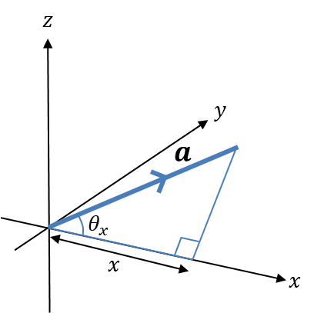

* **The angle between $a=\left(\begin{matrix}x \\ y \\ z\end{matrix}\right)$ and the $x$-axis is:**

$$\cos{θ_{x}}=\frac{x}{\left|a\right|}$$

**and similarly for the $y$ and $z$ axes.**

[Textbook] **Find the angles that the vector $a=2i-3j-k$ makes with each of the positive coordinate axis.**

***Test Your Understanding***

[Textbook] **The points $A$ and $B$ have position vectors $4i+2j+7k$ and**

$3i+4j-k$**relative to a fixed origin, $O$. Find $\vec{AB}$ and show that $ΔOAB$ is isosceles.**

**(a) Find the angle that the vector $a=2i+j+k$ makes with the $x$-axis.**

**(b) By similarly considering the angle that $b=i+3j+2k$ makes with the $x$-axis, determine the area of $OAB$ where $\vec{OA}=a$ and $\vec{OB}=b$. (Hint: draw a diagram)**

Ex 12B p.341-343

**Solving geometric problems**

For more general problems involving vectors, often **drawing a diagram** helps!

[Textbook] $A, B, C$ **and $D$ are the points $\left(2,-5,-8\right)$, $\left(1,-7,-3\right), (0,15,-10)$ and $\left(2,19,-20\right)$ respectively.**

1. **Find $\vec{AB}$ and $\vec{DC}$, giving your answers in the form $pi+qj+rk$  
   .**
2. **Show that the lines $AB$ and $DC$ are parallel and that $\vec{DC}=2\vec{AB}$.**
3. **Hence describe the quadrilateral $ABCD$.**

[Textbook] $P, Q$ **and $R$ are the points $\left(4,-9,-3\right),(7,-7,-7)$ and $\left(8,-2,0\right)$ respectively. Find the coordinates of the point $S$ so that $PQRS$ forms a parallelogram.**

There are many contexts in maths where we can ‘compare coefficients’, e.g.

$3x^{2}+5x≡A\left(x^{2}+1\right)+Bx+C$

Comparing $x^{2}$ terms: $3=A$

We can do the same with vectors:

[Textbook] **Given that $3i+\left(p+2\right)j+120k=pi-qj+4pqrk$  
, find the values of $p, q$ and $r$.**

[Textbook] **The diagram shows a cuboid whose vertices are $O,A,B,C,D,E,F$ and $G$. Vectors $a, b$ and $c$ are the position vectors of the vertices $A, B$ and $C$ respectively. Prove that the diagonals $OE$ and $BG$ bisect each other.**

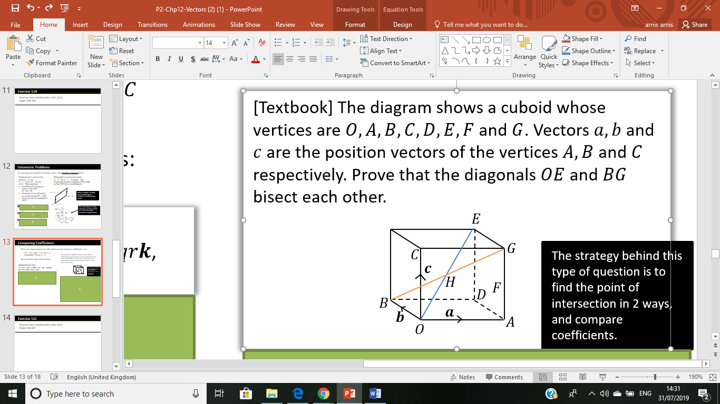

F

The strategy behind this type of question is to find the point of intersection in 2 ways, and compare coefficients.

Ex 12C p.346-347

**Application to Mechanics**

Out of displacement, speed, acceleration, force, mass and time, all but mass and time are vectors. Clearly these can act in 3D space.

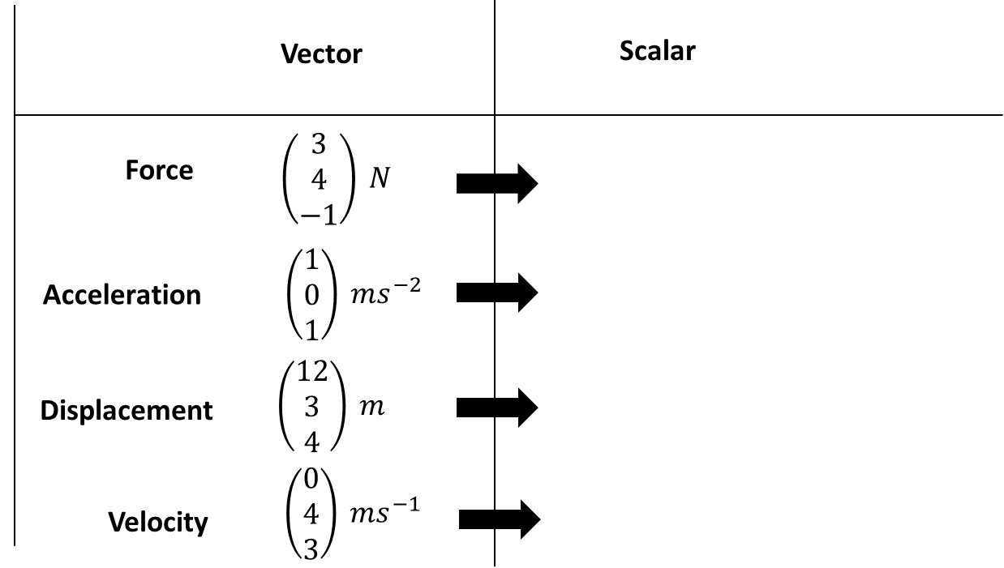

**Example**

[Textbook] **A particle of mass 0.5 kg is acted on by three forces.**

$$F_{1}=\left(2i-j+2k\right) NF_{2}=\left(-i+3j-3k\right) NF_{3}=\left(4i-3j-2k\right) N$$

1. **Find the resultant force $R$ acting on the particle.**
2. **Find the acceleration of the particle, giving your answer in the form ms-2.**
3. **Find the magnitude of the acceleration.**

**Given that the particle starts at rest,**

**d. Find the distance travelled by the particle in the first 6 seconds of its motion.**

Ex 12D p.348-349