A Level Mathematics
Chapter 8 - Mechanics
Further Kinematics
Chapter Overview
1. Vectors in Kinematics
2. Vector Methods with Projectiles
3. Variable Acceleration in One Dimension
4. Differentiating Vectors
5. Integrating Vectors
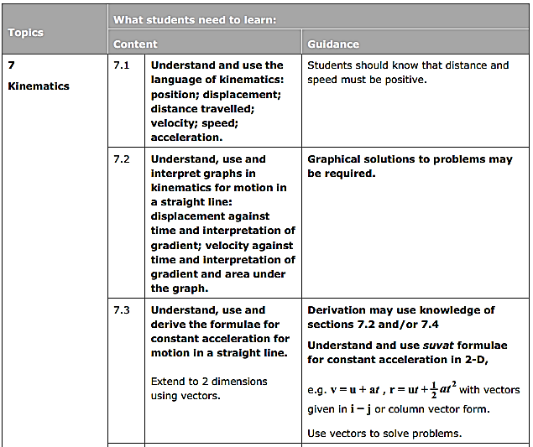
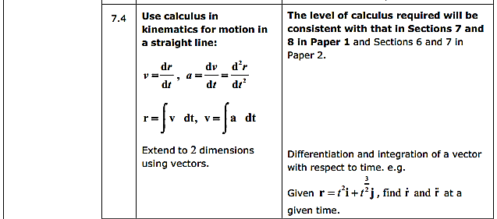

- Vectors in Kinematics
If a particle starts from the point with position vector r₀, and moves with constant velocity v, its displacement from its initial position at time t is given by vt and it position vector r is given by:

Example
At time $t = 0$, where $t$ is the time (in seconds), a particle is at the point with position vector $(4i - j)$m and travels with velocity $(-2i + 2j)$ms⁻¹. Find:
a) The position vector of the particle after $t$ seconds
b) The distance the particle is from the origin, O, after 3 seconds.

Example
A particle starts at a point 8m from O at an angle of 45^{O} anti-clockwise from east and travels with a velocity $(-2i - 3j)$ ms⁻¹, where $i$ and $j$ are unit vectors due east and north respectively.
Find the position vector of the particle after t seconds in the form $r = r_{0} + tv$.

Example – Using SUVAT with Vectors
A particle is initially travelling with velocity $(-2i - 9j)$ ms⁻¹ and 2 seconds later it has a velocity of$(6i - 11j)$ ms⁻¹, where $i$ and $j$ are unit vectors in the directions of the positive x- and y- axes respectively. Given that the acceleration of the particle is constant, find:
a) The acceleration
b) The magnitude of the acceleration
c) The angle that the acceleration makes with the vector $j$

Example (Textbook p161 Example 3)
An ice skater is skating on a large flat ice rink. At time $t=0$ the skater is at a fixed point $O$ and is travelling with velocity $\left(2.4i-0.6j\right)$ ms⁻¹.
At time $t=20$ s the skater is travelling with velocity $\left(-5.6i+3.4j\right)$ ms⁻¹.
Relative to $O$, the skater has position vector $s$ at time $t$ seconds.
Modelling the ice skater as a particle with constant acceleration, find:
- The acceleration of the ice skater
- An expression for $s$ in terms of $t$
- The time at which the skater is directly north-east of $O$.
A second skater travels so that she has position vector $r=\left(1.1t-6\right)j$ m relative to $O$ at time $t$.
- Show that the two skaters will meet.

Test Your Understanding (EdExcel M1 May 2013(R) Q6)
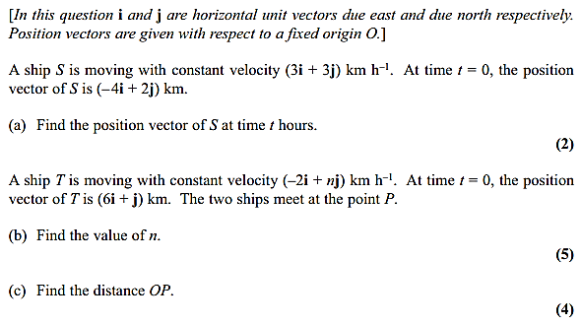
Exercise 7A Page 162

- Vector Methods with Projectiles
Previously we considered the initial speed of the projectile and the angle of projection. But we could also use a velocity vector to represent the initial projection (vectors have both direction and magnitude) and subsequent motion.

Example
A ball is projected from the origin with velocity $(12i + 24j)$ms⁻¹ where $i$ and $j$ are horizontal and vertical unit vectors respectively. The particle moves freely under gravity. Find:
a) The position vector of the ball after 3s
b) The speed of the ball after 3s
c) The ball strikes the ground at point B. Determine the distance OB
Example
A particle P is projected with velocity $(4pi + 5pj)$ms⁻¹ from a point O on a horizontal plane, where $i$ and$j$ are horizontal and vertical unit vectors respectively.
The particle P strikes the plane at the point A, which is 800 m from O.
a) Show that $p = 14$.
b) Find the time of flight from O to A.

The particle P passes through a point B with speed 60 m s⁻¹.
c) Find the height of B above the horizontal plane.

Test Your Understanding (EdExcel M2 Jan 2012 Q7)
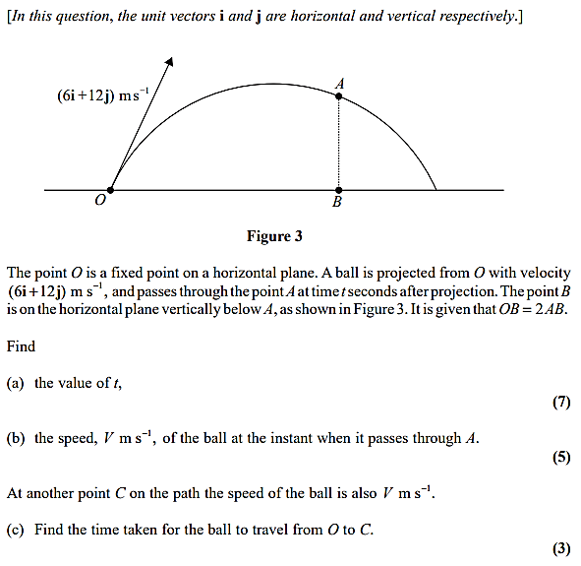
Exercise 8B Page 166

- Variable Acceleration in One Dimension

Displacement ($s$)
Velocity ($v$)
Acceleration ($a$)
Differentiate
Integrate

Don’t forget the constant of integration for indefinite integrals

Example
A particle is moving in a straight line with acceleration at time $t$ seconds given by
$$a=\cos{2πt ms^{-2}, t≥0}$$
The velocity of the particle at time $t=0$ is $\frac{1}{2π}$ ms⁻¹. Find:
- an expression for the velocity at time $t$ seconds
- the maximum speed
- the distance travelled in the first 3 seconds.

Test Your Understanding (Textbook p168 Example 6)
Exercise 8C Page 168

A particle of mass 6kg is moving on the positive $x$-axis. At time $t$ seconds the displacement, $s$, of the particle from the origin is given by
$$s=2t^{\frac{3}{2}}+\frac{e^{-2t}}{3} m, t≥0$$
- Find the velocity of the particle when $t=1.5$.
- Given that the particle is acted on by a single force of variable magnitude $F$ N which acts in the direction of the positive $x$-axis,
- Find the value of $F$ when $t=2$

- Differentiating Vectors
We use calculus with 2-d (and 3-d) vectors by differentiating and integrating each function of time separately:

If $r=xi+yj$, then

Example
A particle $P$ of mass 0.8kg is acted on by a single force $F$ N. Relative to a fixed origin $O$, the position vector of $P$ at time $t$ seconds is $r$ metres, where
$$r=2t^{3}i+50t^{-\frac{1}{2}}j, t≥0$$
Find:
- the speed of $P$ when $t=4$
- the acceleration of $P$ as a vector when $t=2$
- $F$ when $t=2$.
Exercise 8D Page 171

- Integrating Vectors
We can integrate vectors by integrating each function of time separately.

Remember each component will have a constant of integration, $C=(pi + qj)$.

Example
A force $F$ acts on a body of mass 250g which is initially at rest at a fixed point O. If $F = ((5t - 2)i + 4tj)$N, where$t$ is the time for which the force has been acting on the body, find expressions for:

a) The velocity vector of the body at time $t$.
b) The position vector of the body at time $t$.

Example (Textbook)
A particle $P$ is moving in a plane so that, at time $t$ seconds, its acceleration is $(4i-2tj)$ms⁻². When $t=3$, the velocity of $P$ is $6i$ ms⁻¹ and the position vector of $P$ is $(20i+3j)$ m with respect to a fixed origin $O$. Find:
- the angle between the direction of motion of $P$ and $i$ when $t=2$
- the distance of $P$ from $O$ when $t=0$.

Test Your Understanding (EdExcel M2 Jan 2013 Q4)
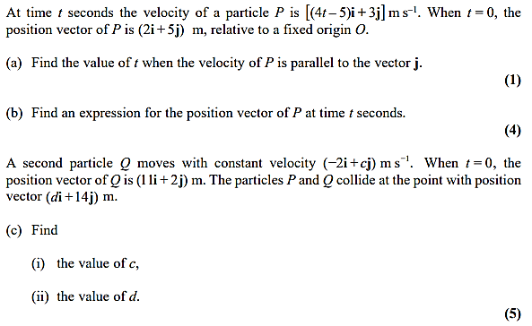

Exercise 8E Page 175
Mixed Exercise 8 Page 177

