A Level Mathematics
Chapter 7 - Mechanics
Applications of Forces
Chapter Overview
1. Static Particles
2. Modelling with Statics
3. Friction and Static Particles
4. Static Rigid Bodies
5. Dynamics and Inclined Planes
6. Connected Particles
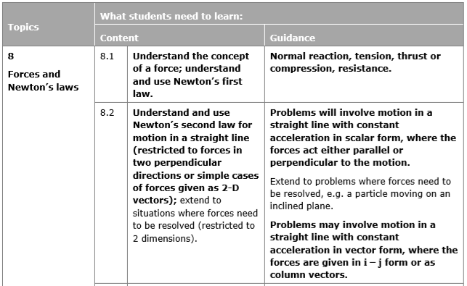
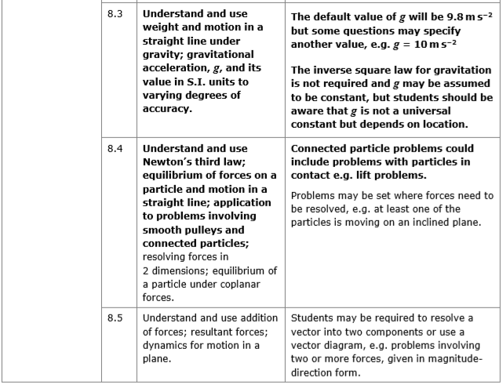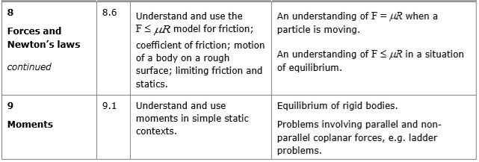
In this chapter, we will bring together everything that we have learned about forces: friction, resolving forces into components, Newton's 2nd law, inclined planes and connected particles, for different, common types of problems.

- Static Particles
If a particle is in equilibrium, the resultant of all forces is 0 and the particle remains at rest.

- Always draw a diagram
- Resolve the forces, horizontal and vertical, or parallel and perpendicular if on an inclined plane
- In each direction, sum of components = 0
- Solve the resulting equations to find unknown forces

For particles in equilibrium, you can also use a triangle of forces.

Example
The diagram shows a particle in equilibrium under the action of four forces as shown in the diagram below. The particle rests on an inclined plane which is set at an angle of 30° to the horizontal.

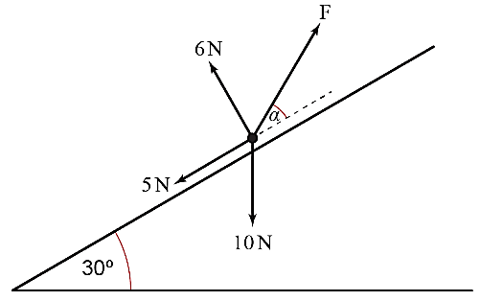
Find the magnitude of force F and the size of the angle, α, in degrees giving both answers to two significant figures.

Test Your Understanding
The diagram shows a particle in equilibrium on an inclined plane under the forces shown. Find the magnitude of the force $Q$ and the size of the angle $β$.
Exercise 7A Page 130

$$Q N$$
$$14 N$$
$$30°$$
$$6 N$$
$$5 N$$
$$β$$

Hint: Redraw the Q N force

- Modelling with Statics
Remember to include additional forces such as weight, tension, thrust, normal reaction, friction etc.

Example
A light, inextensible string of length 50cm has its upper end fixed at a point A and comes with a particle of mass 8kg at its lower end. A horizontal force P applied to the particle keeps it in equilibrium 30cm from the vertical through A.

By resolving horizontally and vertically, find the magnitude of P and the tension in the string.

Example
A light, inextensible string passes over a smooth pulley fixed at the top of a smooth plane inclined at 30^{O} to the horizontal. A particle of mass 2kg is attached to one end of the string and hangs freely. A mass m is attached to the other end of the string and rests in equilibrium on the surface of the plane.
Calculate the normal reaction between the mass m and the plane, the tension in the string and the value of m.

Test Your Understanding (EdExcel M1 May 2013(R) Q2)
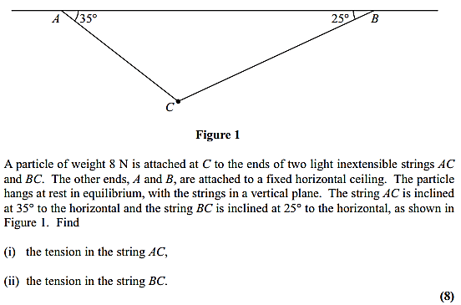
Exercise 7B Page 134

- Friction and Static Particles
If there is no motion, the maximum frictional force, F_{max}, has not yet been reached.
When F_{max} = μR, the body is on the point of moving. This is called limiting equilibrium.
In Statics, the force of friction, F, is such that $≤μR$ , and the direction of the friction force is opposite to the direction in which the body would move if the friction force were absent.

Example
A 10kg truck lies on a horizontal rough floor. The coefficient of friction between the trunk and the floor is $\frac{\sqrt{3}}{4}$.

Calculate the magnitude of the force, P, which is necessary to pull the trunk horizontally if P is applied:
a) horizontally
b) at 30^{O} above the horizontal

Example – Rough Inclined Plane
A mass of 6kg rests in limiting equilibrium on a rough plane inclined at 30^{O} to the horizontal.
a) Find the coefficient of friction between the mass and the plane.
b) A horizontal force of magnitude P N is applied to the box. Given that the box remains in equilibrium, find the maximum possible value of P.

Exercise 7C Page 139

- Static Rigid Bodies
Recall from the chapter on moments that for a stationary rigid body:
- The resultant force is 0.
- The resultant moment is 0.
The problems are the same as in the moments chapter, except now we may need to consider frictional forces.

Example
A uniform rod $AB$ of mass 45kg and length 12m rests with the end $A$ on rough horizontal ground. The rod rests against a smooth peg $C$ where $AC=8$ m. The rod is in limiting equilibrium at an angle of $15°$ to the horizontal. Find:
- the magnitude of the reaction of $C$
- the coefficient of friction between the rod and the ground.

Example (EdExcel M2 Jan 2012 Q5)
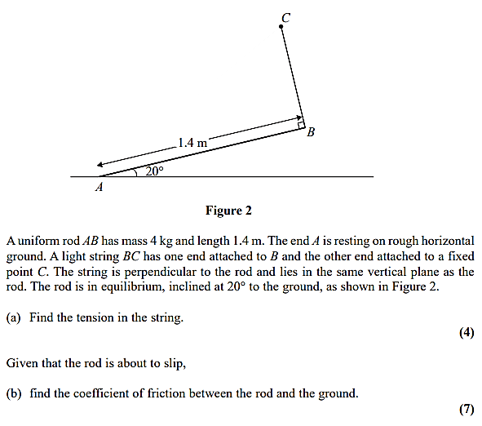

Test Your Understanding (EdExcel M2 Jan 2013 Q3)
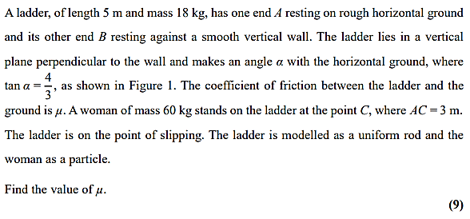
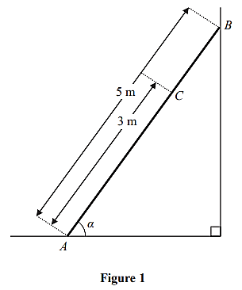

Exercise 7D Page 144
- Dynamics and Inclined Planes
If a particle is in motion, $F = F_{max} = μR$, and $F$ opposes the direction of motion.
- Draw a force diagram
- Use Newton's 2nd law to resolve parallel and perpendicular to the plane
- Use SUVAT to solve problems if $F$ (and therefore $a$) are constant

Example (EdExcel M1 Jan 2010 Q5)
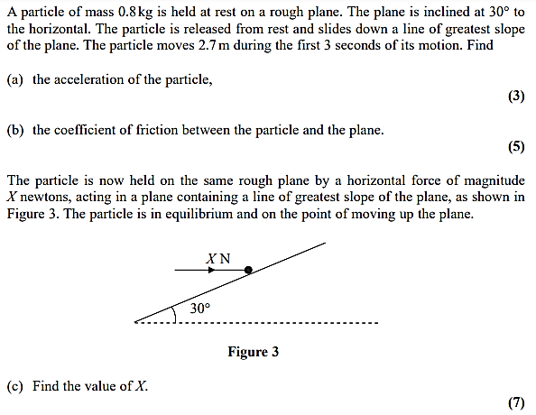

Test Your Understanding (EdExcel M1 May 2013(R) Q5)
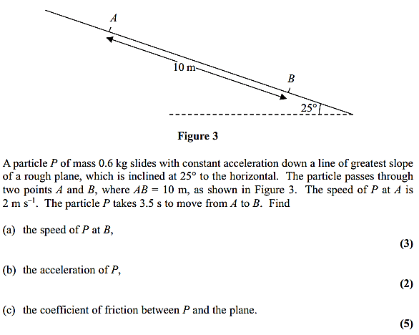

Exercise 7E Page 148
- Connected Particles
Use Newton's 2nd law, SUVAT and F_{max} = μR to solve problems about connected particles on rough and inclined surfaces.

Example
Two particles P and Q, of mass 2kg and 3kg respectively, are connected by a light, inextensible string. The string passes over a small smooth pulley which is fixed at the top of a rough inclined plane. The plane is inclined to the horizontal at an angle of 30⁰. Particle P is held at rest on the inclined plane and Q hangs freely on the edge of the plane with the string vertical and taut. Particle P is released and it accelerates up the plane at 2.5ms⁻². Find:
- The tension in the string
- The coefficient of friction between P and the plane
- The force exerted by the string on the pulley

Example (EdExcel M1 Jan 2006 Q7)
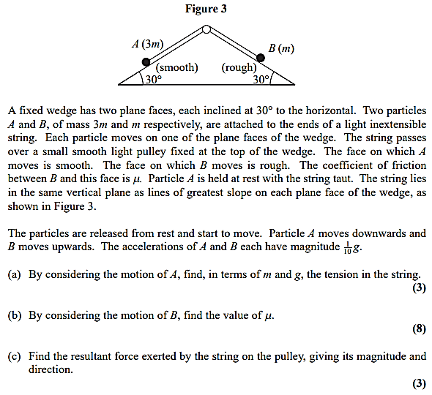

Additional Question (Connected Particles)
EdExcel M1 (Old) Jan 2013 Q7
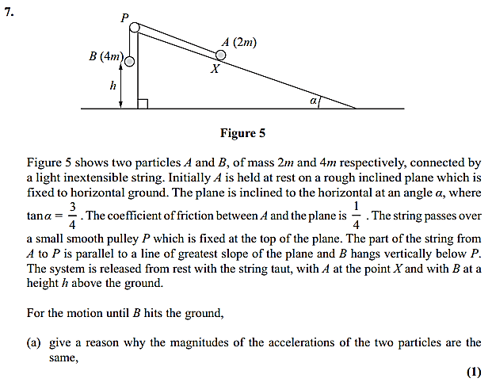
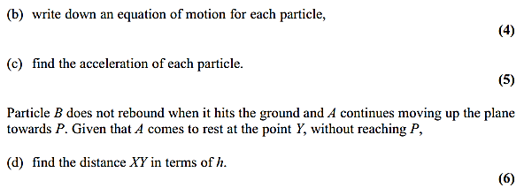

Test Your Understanding (EdExcel M1 May 2013(R) Q3)
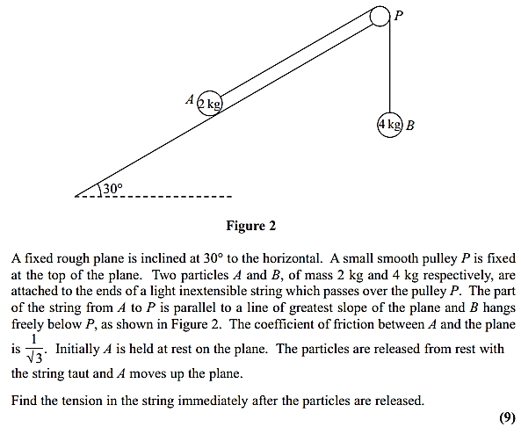

Exercise 7F Page 152
Mixed Exercise 7 Page 154

