A Level Mathematics
Chapter 6 - Mechanics
Projectiles
Chapter Overview
1. Horizontal Projection
2. Horizontal and Vertical Components
3. Projection at any Angle
4. Projectile Motion Formulae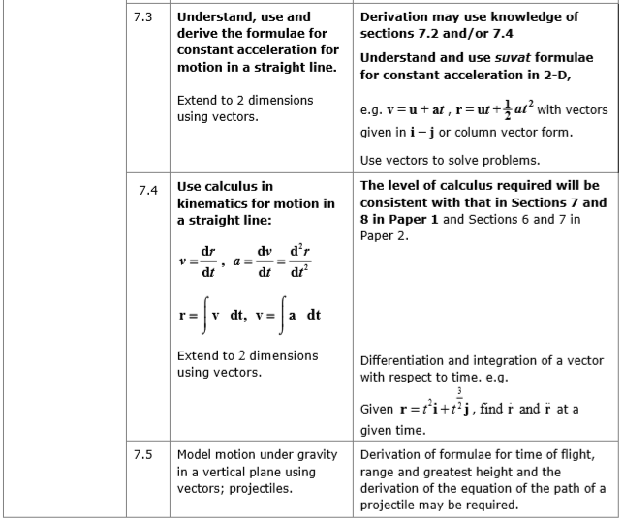

A particle moving in a vertical plane under gravity is sometimes called a projectile. You can use projectile motion to model the flight of e.g. a golf ball.

- Horizontal Motion
The horizontal motion of a projectile is modelled as having constant velocity ($a = 0$), so $s = vt$. Use $u_{x}$ and $v_{x}$ to denote horizontal velocity components.

The vertical motion of a projectile is modelled as having constant acceleration due to gravity ($a = g$). Use SUVAT - careful with directions! Use $u_{y}$ and $v_{y}$ to denote vertical velocity components.

Example
A ball is thrown horizontally with speed 20ms⁻¹, from the top of a building, which is 30m high. Find:
a) The time the ball takes to reach the ground.
b) The distance between the bottom of the building and the point where the ball hits the ground.

Example
A particle is projected horizontally with a velocity of 39.2ms⁻¹. Find the horizontal and vertical components of the velocity of the particle 3s after projection. Find also the speed and direction of the motion of the particle.
Exercise 6A Page 110

- Horizontal and Vertical Components of Velocity
When a particle is projected with initial velocity U at an angle α above the horizontal:
- The horizontal component of the initial velocity is Ucosα
- The vertical component of the initial velocity is Usinα
- When the particle is at its highest point, the vertical velocity = 0.
- The speed of the object is the magnitude of the velocity vector.

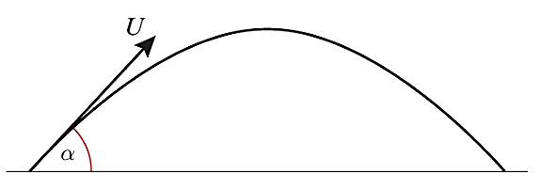
Example (Textbook Exercise 6B Q4)
A particle is projected from the top of a building with initial velocity of 28ms⁻¹ at an angle θ below the horizontal, where $\tan{θ}=\frac{7}{24}$.
a) Find the horizontal and vertical components of the initial velocity
b) Express the initial velocity as a vector in terms of i and j.

Exercise 6B Page 112

- Projection at Any Angle
We can solve problems with particles projected at any angle by resolving the initial velocity into horizontal and vertical components.

Range = distance from point at which the particle was projected to the point where it strikes the horizontal plane

Time of Flight = time taken by particle to move from its point of projection to the point where it strikes the horizontal plane

A projectile reaches its point of greatest height when the vertical component of its velocity, $u_{y} = 0$.

Example
A particle is projected from a point on a horizontal plane and has an initial velocity of $28\sqrt{3}ms^{-1}$ at an angle of elevation of 60^{O}. Find the greatest height reached by the particle and the time taken to reach this point. Also find the range of the particle.

Example
A golfer hits a ball with a velocity of 52ms⁻¹, at an angle α above the horizontal where $\tan{α} =\frac{5}{12}.$

a) Set up a mathematical model, stating any assumptions made
b) Determine the time for which the ball is at least 15m above the ground (take g = 10ms⁻²)

Test Your Understanding (EdExcel M2 May 2012 Q7)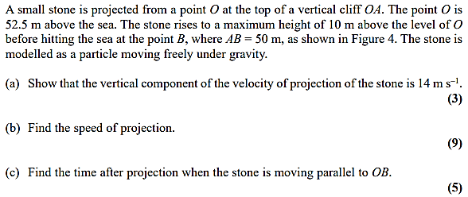
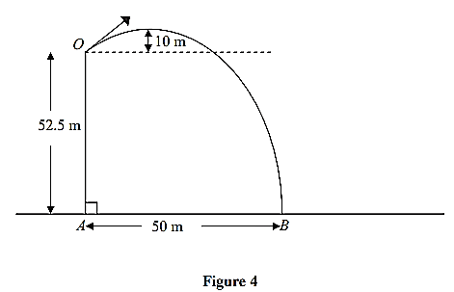

Exercise 6C Page 117

Extension Question:
A ball is projected from ground level at an angle of $θ$. Prove that when the ball hits the ground, the distance the ball has travelled along the ground is maximised when $θ=45°$.
(Year 2 differentiation knowledge required)

- Projection motion Formulae
You must be able to derive general formulae related to the motion of a particle which is projected from a point on a horizontal plane and moves freely under gravity.

Deriving the Time of Flight (T) and the Range (R)

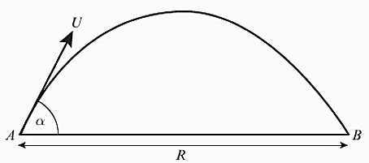

A particle is projected from a point on a horizontal plane with an initial velocity $U$ at an angle $α$ above the horizontal and moves freely under gravity until it hits the plane at point $B$.
Given that that acceleration due to gravity is $g$, find expressions for:
- the time of flight, $T$
- the range, $R$, on the horizontal plane.

Deriving the Equation of the Trajectory
When a particle is projected from a point O, on a horizontal plane, the equation of the trajectory may be obtained by taking x and y axes through the point of projection, O, as shown on the diagram.

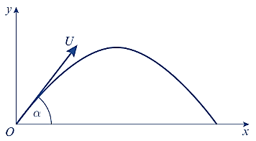

A particle is projected from a point with speed $U$ at an angle of elevation $α$ and moves freely under gravity. When the particle has moved a horizontal distance $x$, its height above the point of projection is $y$.
- Show that $y=x\tan{α -\frac{gx^{2}}{2u^{2}}\left(1+\tan^{2}{α}\right)}$
A particle is projected from a point $O$ on a horizontal plane, with speed 28 ms⁻¹ at an angle of elevation $α$. The particle passes through a point $B$, which is at a horizontal distance of 32m from $O$ and at a height of 8m above the plane.

(b) Find the two possible values of $α$, giving your answers to the nearest degree.

Exam Note: You may be asked to derive these. But don’t attempt to memorise them or actually use them to solve exam problems – instead use the techniques used earlier in the chapter.
For a particle projected with initial velocity $U$ at angle $α$ above horizontal and moving freely under gravity:
- Time of flight $=\frac{2U\sin{α}}{g}$
- Time to reach greatest height $=\frac{U\sin{α}}{g}$
- Range on horizontal plane $=\frac{U^{2}\sin{2α}}{g}$
- Equation of trajectory: $y=x\tan{α -\frac{gx^{2}}{2U^{2}}\left(1+\tan^{2}{α}\right)}$
where $y$ is vertical height of particle and $x$ horizontal distance.

Exercise 6D Page 123
Mixed Exercise 6 Page 125

