A Level Mathematics
Chapter 5 - Mechanics
Forces and Friction
Chapter Overview
1. Resolving Forces
2. Inclined Planes
3. Friction

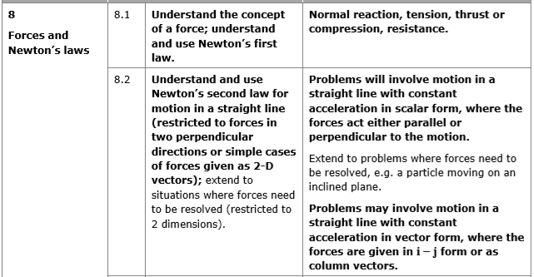
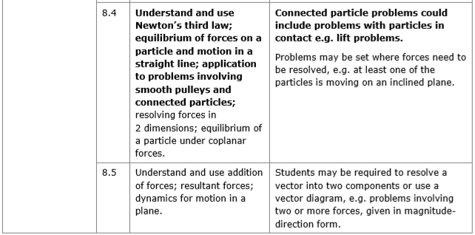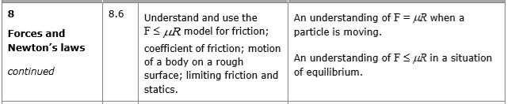

- Resolving Forces
If a force is applied at an angle to the direction of motion you can resolve it to find the component of the force that acts in the direction of motion.

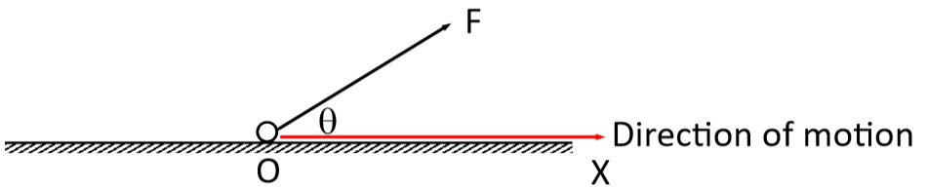

The component of a force, F, in any given direction is the measure of the effect of the force in that direction.
In the diagram above, the magnitude of the force in the horizontal and vertical direction can be calculated using trigonometry:

Rule of thumb:
Pull a force THROUGH an angle $⟹$ cos θ
Pull a force AWAY from an angle $⟹$ sin θ

Example
Find the sum of the components of the given forces in the direction of:
a) the x-direction
b) the y-direction

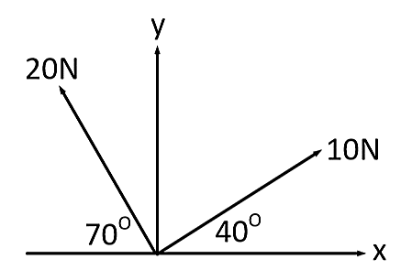

We can also draw a triangle of forces to solve problems for particles in equilibrium.

Example (Textbook Page 94 Example 4)
Three forces act on a particle as shown.
Given that the particle is in equilibrium, calculate the magnitude of P.

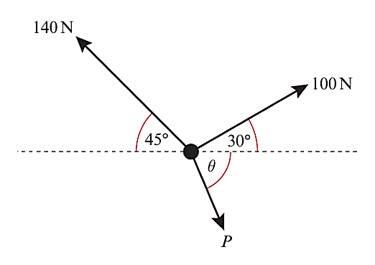

Applied Example
A force P is applied to a box of mass 5 kg, causing the box to accelerate at 2 m s⁻² along a smooth, horizontal plane. Given that the force causing the acceleration is applied at 30º to the plane, work out the value of P.

Exercise 5A Page 94

- Inclined Planes
For problems involving inclined planes, we usually resolve forces parallel and perpendicular to the plane.
(For some problems where a particle is in equilibrium, it may be easier to resolve horizontally and vertically)

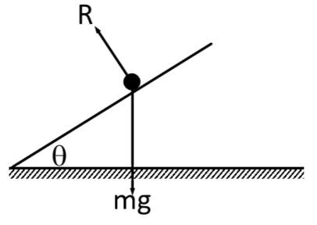
Smooth Plane
If there is no friction, the particle will slide down the slope.

Rough Plane
If rough enough, the force of friction might be enough to prevent the particle from moving.

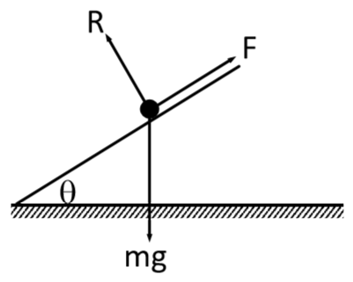

Remember:
- Weight always acts vertically downwards
- The normal reaction always acts perpendicular to the plane
- Friction always opposes the direction of motion

We have to resolve the weight into its components parallel and perpendicular to the plane.

Example
A block of mass 25kg slides down a smooth slope angled at 20° to the horizontal.
- Draw a force diagram to show all the forces acting on the block
- Calculate the magnitude of the normal reaction of the slope on the block.
- Find the acceleration.

Test your understanding
A block of mass 10kg slides down a smooth slope angled at 15° to the horizontal.
- Draw a force diagram to show all the forces acting on the block
- Calculate the magnitude of the normal reaction of the slope on the block.
- Find the acceleration.

Inclined Plane with an Additional Force
Example
A small parcel of mass 2 kg is held in equilibrium on a rough plane by a horizontal force of magnitude 20 N, acting in a vertical plane through a line of greatest slope. The plane is inclined at an angle of 20° to the horizontal. The parcel is modelled as a particle. The parcel is on the point of moving up the slope.
- Draw a force diagram to show all the forces acting on the parcel.
- Calculate the magnitude of the normal reaction of the slope on the parcel.

We can use Pythagoras to work out values for sin θ and cos θ if given tan θ.
Example (Textbook Page 98 Exercise 5B Question 3)
A particle of mass 0.5kg is held at rest on a smooth slope that is inclined at an angle of a to the horizontal. The particle is released. Given that $\tan{∝}=\frac{3}{4}$, calculate:
- The normal reaction between the particle and the plane
- The acceleration of the particle

Test Your Understanding (Textbook p97 Example 6)
A particle of mass $m$ is pushed up a smooth slope, inclined at $30°$ by a force of magnitude $5g$ N acting at angle of $60°$ to the slope, causing the particle to accelerate up the slope at 0.5 ms⁻². Show that the mass of the particle is $\left(\frac{5g}{1+g}\right)$ kg.

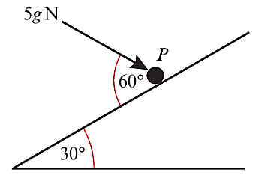

Hint: Redraw the 5g force

Exercise 5B Page 98

- Friction
Friction is a force which opposes motion between two rough surfaces.

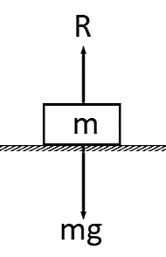
Scenario 1: A block is on a horizontal rough surface with no forces (other than gravity) acting on it.

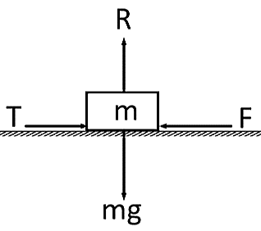
Scenario 2: A horizontal force is applied but it is not enough to move the block.

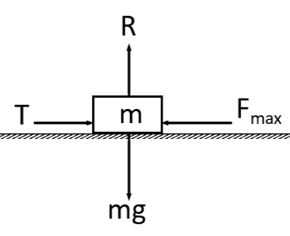

Scenario 3: T has reached or exceeded F_{max}, the maximum or limiting value for the friction.

Two things determine the maximum or limiting value, F_{max} between two surfaces:
$$F_{max}=μR$$

Example
A block of mass 5kg rests on a rough horizontal plane. The coefficient of friction between the block and the plane is 0.6.
Calculate the frictional force acting on the block when a horizontal force, P, is applied to the block and the magnitude of P is:
a) 12N
b) 29.4N
c) 36N

Also calculate the magnitude of any acceleration that may occur.

Example (Inclined Plane)
A particle is held at rest on a rough plane, which is inclined to the horizontal at an angle α, where tan α = 0.75. The coefficient of friction between the particle and the plane is 0.5. The particle is released and slides down the plane. Find:
a) The acceleration of the particle
b) The distance it slides in the first two seconds

Test Your Understanding
1. A particle P of mass 3 kg is held at rest in equilibrium on a rough plane that is inclined to the horizontal at an angle of 30° by a constant force of magnitude $x$N acting up the plane.
The coefficient of friction between P and the plane is 0.5. Find the magnitude of $x$ if:
- The particle is on the point of slipping up the plane
- The particle is on the point of slipping down the plane

2. A particle P of mass 3 kg is held at rest in equilibrium on a rough plane that is inclined to the horizontal at an angle of 30° by a constant force of magnitude 30 N. The direction of the force is inclined to the plane at an angle of 40°, and its line of action lies in the vertical plane containing P and a line of greatest slope of the plane.
The coefficient of friction between P and the plane is μ.

Given that P is on the point of sliding up the plane, find the value of μ.

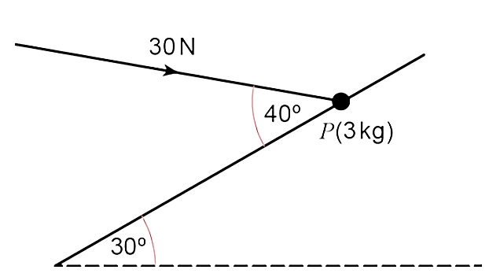

Exercise 5C Page 103
Mixed Exercise 5 Page 105

