A Level Mathematics
Chapter 4 - Mechanics
Moments
Chapter Overview
1. Moments
2. Resultant Moments
3. Equilibrium
4. Centres of Mass
5. Tilting

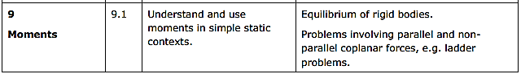

- Moments
The moment of a force is the turning effect of the force on the body on which it is acting.

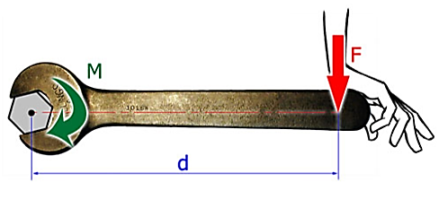
The moment is dependent on:
- The magnitude of the force
- The distance of the force from the axis of rotation

Moment of force =

You must also give the direction of the force.
Example
In each diagram, find the moment of the force, F, about the point P.

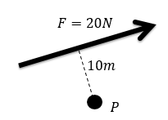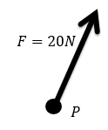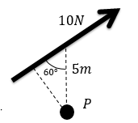

Test Your Understanding (Textbook))
The diagram shows two forces acting on a lamina. Find the moment of each of the forces about P.

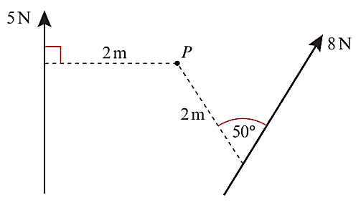

Exercise 4A Page 72

- Resultant Moments
If several coplanar forces act on a body, you can add the moments about a point. Choose a positive direction (clockwise or anti-clockwise) and consider the sense of rotation of each moment.

Example
Find the sum of moments about the point O, of the forces acting in each diagram:

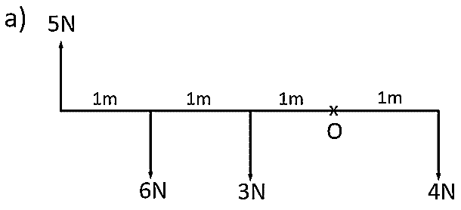

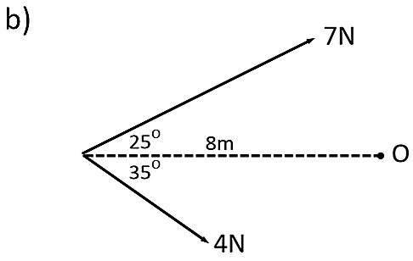

Resolving a Force into its Parallel and Perpendicular Components to Find its Moment
This can be a useful technique for harder problems. We can use trig to find the perpendicular distance of a force from a point of rotation, but we can also split the force into its parallel and perpendicular components.

Example
Find the moment of the force about point P.

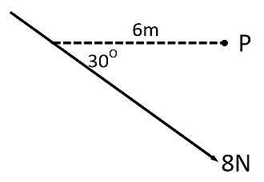

Exercise 4B Page 74

- Equilibrium
If a rigid body is in equilibrium:

1.

2.

Example
AB is a uniform rod of length 5m and weight 20N. AB is resting in a horizontal position on supports at C and D. Find the magnitude of the reactions at C and D.

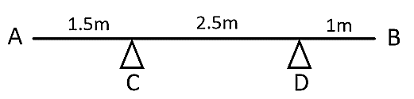

Example
A uniform beam AB, of length 2m and mass 4kg, has a mass of 3kg attached to one end and a mass of 1kg attached at the other end. Find the position of the support C, if the beam rests in a horizontal position.

Remember to include all forces on your force diagram.
There are two ways to solve this problem:

1) Take moments about C
2) Resolve forces to find the reaction at C, then take moments about one end

Test Your Understanding (Textbook)
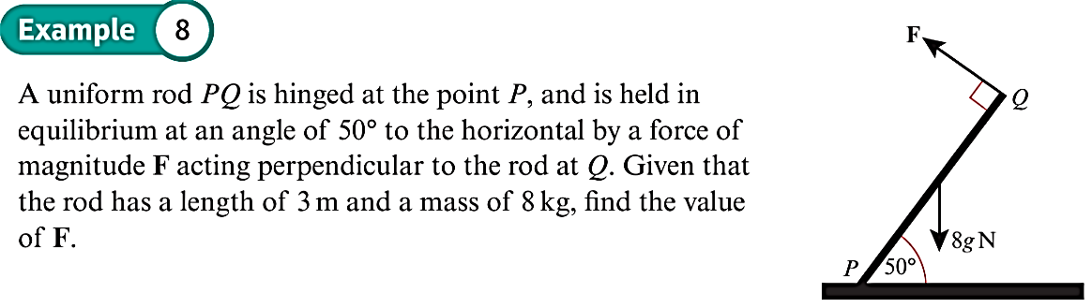

Test Your Understanding (EdExcel M1 May 2013 (R) Q8)
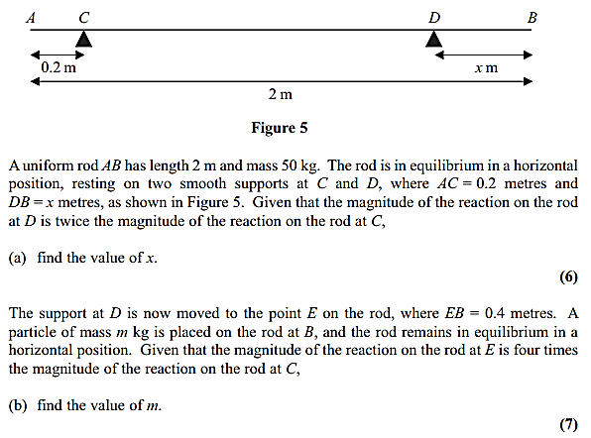

Exercise 4C Page 78

- Centres of Mass (Non-Uniform Bodies)
The mass of a non-uniform rigid body can be modelled as acting at its centre of mass.

Example
Sam and Tasmin are sitting on a non-uniform plank AB, of mass 28kg and length 5m. The plank is pivoted at M, the midpoint of AB. The centre of mass of AB is at C, where AC is 2.2m. Sam has mass 40kg. Tasmin has mass 35kg and sits at A. Where must Sam sit for the plank to be horizontal?

Make sure that you put all the forces on the diagram.

Example
Two sand bags of masses 7kg and 3kg are placed on the ends of a non-uniform rod PQ, of mass 8kg and length 4m, with the 7kg mass placed at P.
The rod rests in equilibrium on the edge of a smooth table, with half of the rod lying on the table's surface. Find the distance of the centre of mass from the edge of the table and the reaction force of the table on the rod.
If the rod were to tilt, where would it pivot? This will be where the reaction of the table on the rod is positioned.

Test Your Understanding (EdExcel M1 May 2012 Q2)

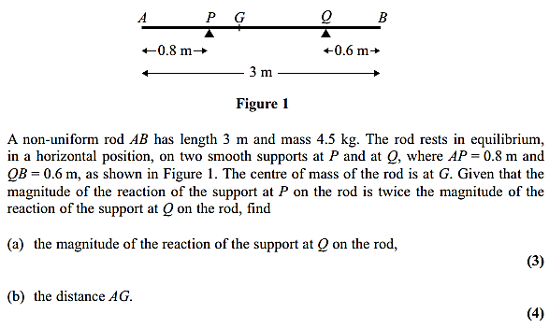

Exercise 4D Page 81

- Tilting

When a rigid body is on the point of tilting about a pivot, the reaction
at any other support (or tension in any other wire/string) is zero.

Example
A uniform beam AB, of mass 12kg and length 6m rests on two pivots at P and Q, where AP = 1m and QB = 1.5m.
A particle of M kg is placed at A and the beam is about to tilt about the pivot at P. Find the mass of the particle and the reaction force at P.

Test Your Understanding – Suspended System (Textbook)
A non-uniform rod $AB$, of length 10 m and weight 40 N, is suspended from a pair of light cables attached to $C$ and $D$ where $AC=3$ m and $BD=2$ m.
When a weight of 25 N is hung from $A$ the rod is on the point of rotating.
Find the distance of the centre of mass of the rod from $A$.

Test Your Understanding (EdExcel M1 May 2013 Q6)
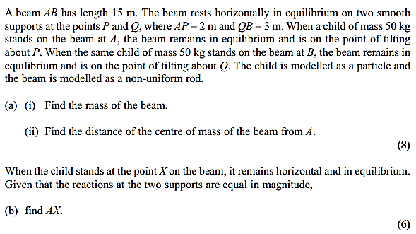

Exercise 4E Page 84
Mixed Exercise 4 Page 85

