Lower 6 Chapter 13
Integration

Course Structure
- Find $y$ given $\frac{dy}{dx}$
- Evaluate definite integrals, and hence the area under a curve.
- Find areas bound between two different lines.

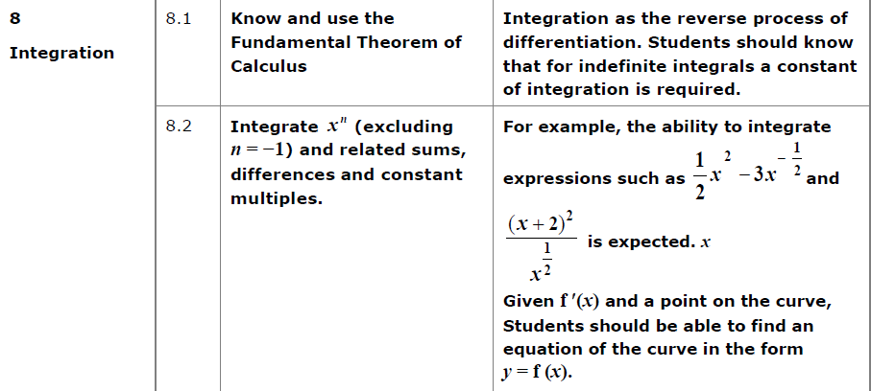
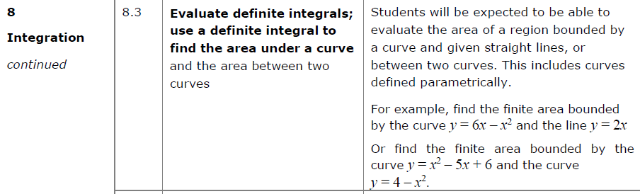

Integrating $x^{n}$ terms

Integration is the opposite of differentiation.

Consider:
If $\frac{dy}{dx}=3x^{2}$, what could $f(x)$?

Examples
Find $y$ when:
- $\frac{dy}{dx}=4x^{3} 2. \frac{dy}{dx}=x^{5}$

$3. \frac{dy}{dx}=3x^{\frac{1}{2}}$ 4. $\frac{dy}{dx}=\frac{4}{\sqrt{x}}$

$5. \frac{dy}{dx}=5x^{-2}$ 6. $\frac{dy}{dx}=4x^{\frac{2}{3}}$

7. $\frac{dy}{dx}=10x^{-\frac{2}{7}}$

Test Your Understanding

Find $f(x)$ when:

$f^{'}\left(x\right)=2x+7$ $f^{'}\left(x\right)=x^{2}-1$

$f^{'}\left(x\right)=\frac{2}{x^{7}}$ $f^{'}\left(x\right)=\sqrt[3]{x}=$

$f^{'}\left(x\right)=33x^{\frac{5}{6}}$

Ex 13A pg 289
Integration Notation

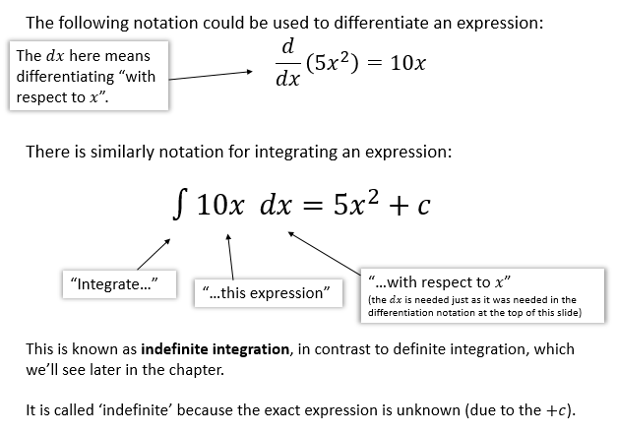

Examples
- Find $\int{(x^{-\frac{3}{2}}+2) dx}$ 2. Find $\int{(6t^{2}-1) dt}$

3. Find $\int{(px^{3}+q) dx}$ where $p$ and $q$ are constants.

Test Your Understanding

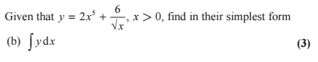

Ex 13B pg 291
Finding the Constant of Integration

Recall that when we integrate, we get a constant of integration, which could be any real value. This means we don’t know what the exact original function was.

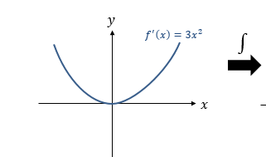
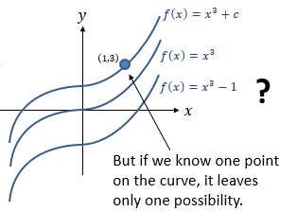

Example
The curve with equation $y=f(x)$ passes through $\left(1,3\right)$. Given that $f^{'}\left(x\right)=3x^{2}$, find the equation of the curve.

Test Your Understanding
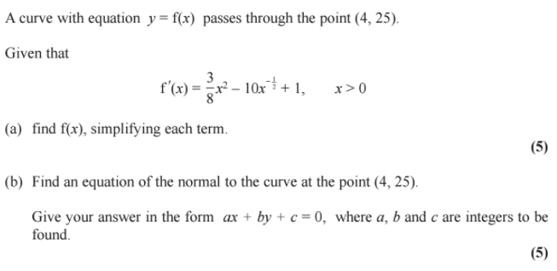

Ex 13C pg 294

Definite Integral
The most useful use of integration is that it finds the area under a graph. Before we do this, we need to understand how to find a definite integral.
Examples

- $f\left(x\right)=4x^{3}$

- $\int_{-3}^{3}{x^{2}+1 dx}=$

- Given that $P$ is a constant and $\int_{1}^{5}{\left(2Px+7\right) dx}=4P^{2}$, show that there are two possible values for $P$ and find these values.

Extension
- [MAT 2009 1A] The smallest value of
$$I\left(a\right)=\int_{0}^{1}{{\left(x^{2}-a\right)}^{2} dx}$$
as $a$ varies, is what?

- [MAT 2015 1D] Let
$f\left(x\right)=\int_{0}^{1}{{\left(xt\right)}^{2} dt}$ and $g\left(x\right)=\int_{0}^{x}{t^{2} dt}$
Let $A>0$. Which of the following statements are true?
- $g\left(f\left(A\right)\right)$ is always bigger than $f\left(g\left(A\right)\right)$
- $f\left(g\left(A\right)\right)$ is always bigger than $g\left(f\left(A\right)\right)$
- They are always equal.
- $f\left(g\left(A\right)\right)$ is bigger if $A<1$, and $g\left(f\left(A\right)\right)$ is bigger if $A>1$.
- $g\left(f\left(A\right)\right)$ is bigger if $A<1$, and $f\left(g\left(A\right)\right)$ is bigger if $A>1$.

Ex 13D pg 297
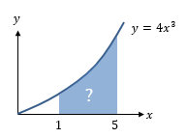
Areas Under Curves
Consider our previous example $\int_{1}^{5}{4x^{3} dx}$. This definite integral gives the area bounded by the curve and the lines x = 1 and x = 5.

The definite integral $\int_{b}^{a}{f(x)} dx$ gives the area between a positive curve $y=f(x)$, the $x$-axis, and the lines $x=a$ and $x=b$.

Example
Find the area of the finite region between the curve with equation $y=20-x-x^{2}$ and the $x$-axis.

Test Your Understanding
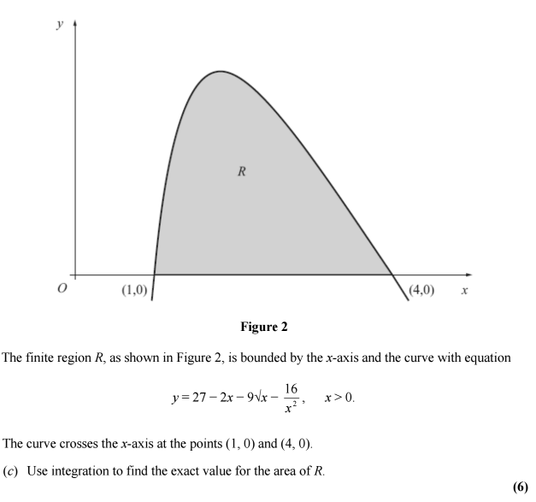

Extension
[MAT 2007 1H] Given a function $f(x)$, you are told that
$$\int_{0}^{1}{3f\left(x\right) dx}+\int_{1}^{2}{2f\left(x\right) dx}=7\int_{0}^{2}{f\left(x\right) dx}+\int_{1}^{2}{f\left(x\right) dx}=1$$
It follows that $\int_{0}^{2}{f(x)} dx$ equals what?

[MAT 2011 1G]
A graph of the function $y=f\left(x\right)$ is sketched on the axes below:
What is the value of $\int_{-1}^{1}{f(x^{2}-1)} dx$?

Ex 13E pg 299
Negative Areas

Sketch the curve $y=x(x-1)(x-2)$.

Now calculate $\int_{0}^{2}{x\left(x-1\right)\left(x-2\right)} dx$.

Why is this result surprising?

Integration $∫f\left(x\right) dx$ is just the sum of areas of infinitely thin rectangles, where the current $y$ value (i.e. $f(x)$) is each height, and the widths are $dx$.
i.e. The area of each is $f\left(x\right)×dx$
The problem is, when $f(x)$ is negative, then $f\left(x\right)×dx$ is negative, i.e. a negative area!
The result is that the ‘positive area’ from 0 to 1 is cancelled out by the ‘negative area’ from 1 to 2, giving an overall ‘area’ of 0.
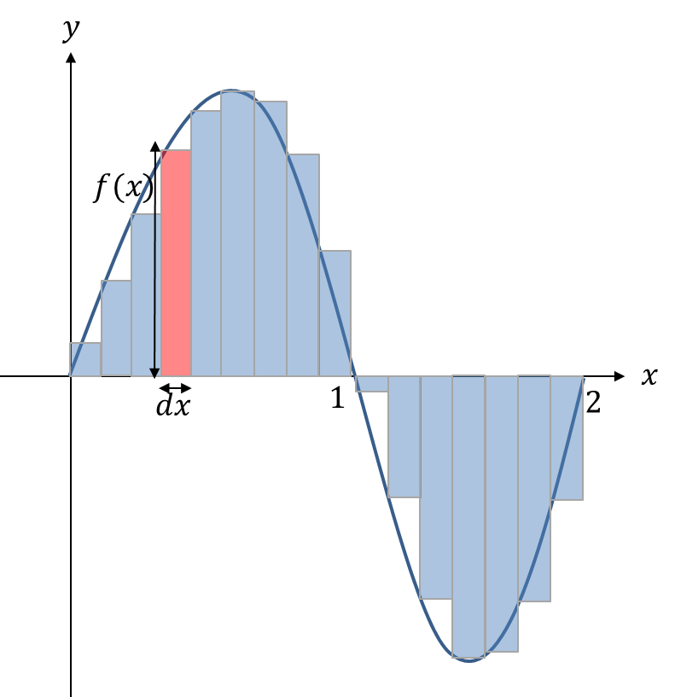
So how do we resolve this?

This explains the $dx$ in the $\int{f\left(x\right) dx}$, which effectively means “the sum of the areas of strips, each of area $f\left(x\right)×dx$. So the $dx$ is not just part of the $∫$ notation, it’s behaving as a physical quantity! (i.e. length

Example
Find the total area bound between the curve $y=x(x-1)(x-2)$ and the $x$-axis.
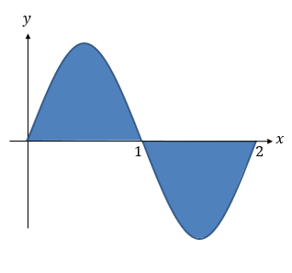

Test Your Understanding

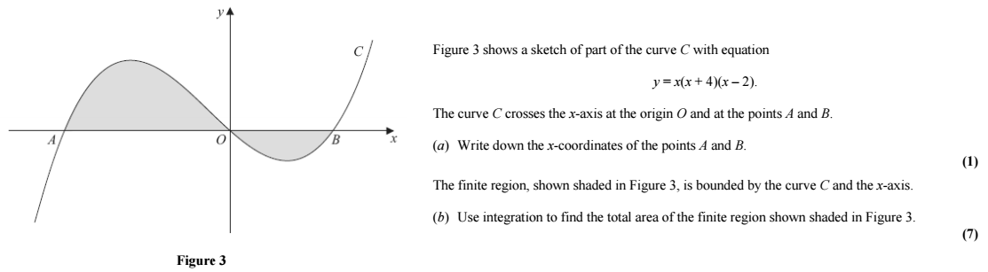

Extension
[MAT 2010 1I] For a positive number $a$, let
$$I\left(a\right)=\int_{0}^{a}{\left(4-2^{x^{2}}\right)dx}$$
Then $\frac{dI}{da}=0$ when $a$ is what value?

[STEP I 2014 Q3]
The numbers $a$ and $b$, where $b>a≥0$, are such that
$$\int_{a}^{b}{x^{2} dx}={\left(\int_{a}^{b}{x dx}\right)}^{2}$$
- In the case $a=0$ and $b>0$, find the value of $b$.
- In the case $a=1$, show that $b$ satisfies
$$3b^{3}-b^{2}-7b-7=0$$Show further, with the help of a sketch, that there is only one (real) value of $b$ that satisfies the equation and that it lies between 2 and 3.
- Show that $3p^{2}+q^{2}=3p^{2}q$, where $p=b+a$ and $q=b-a$, and express $p^{2}$ in terms of $q$. Deduce that $1<b-a≤\frac{4}{3}$

Ex 13F pg 301
Areas Between Curves and Lines

We are often interested in areas formed between curves and lines. It is important to sketch the graph to consider which areas we need to calculate.

Example
Determine the area between the lines with equations $y=x\left(4-x\right)$ and $y=x$
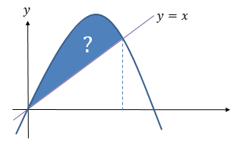

Example
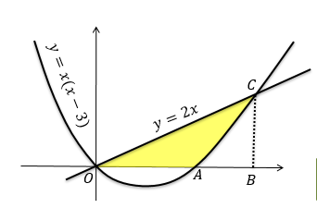
The diagram shows a sketch of the curve with equation $y=x\left(x-3\right)$ and the line with equation $y=2x$.
Find the area of the shaded region $OAC$.

Test Your Understanding

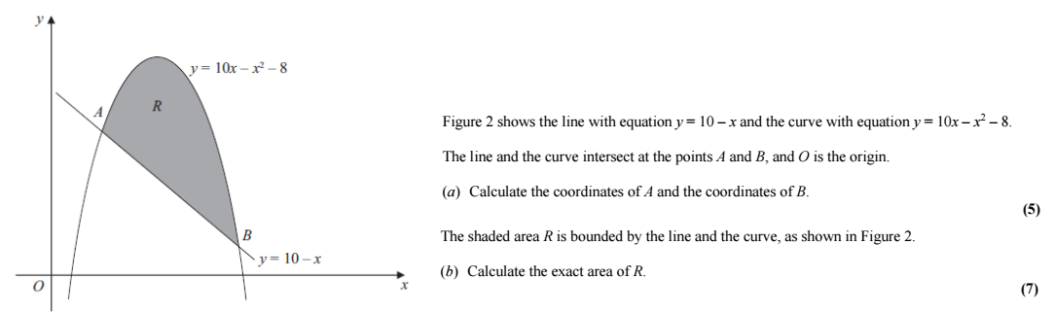

If the top curve has equation $y=f\left(x\right)$ and the bottom curve $y=g\left(x\right)$, the area between them is:
$$\int_{b}^{a}{\left(f\left(x\right)-g\left(x\right)\right) dx}$$
This means you can integrate a single expression to get the final area,
Alternative Method:
If the top curve has equation $y=f\left(x\right)$ and the bottom curve $y=g\left(x\right)$, the area between them is:
$$\int_{b}^{a}{\left(f\left(x\right)-g\left(x\right)\right) dx}$$
This means you can integrate a single expression to get the final area, without any adjustment required after.

Extension
[MAT 2005 1A] What is the area of the region bounded by the curves $y=x^{2}$ and $y=x+2$?

[MAT 2016 1H] Consider two functions
$$f\left(x\right)=a-x^{2}g\left(x\right)=x^{4}-a$$
For precisely which values of $a>0$ is the area of the region bounded by the $x$-axis and the curve $y=f\left(x\right)$ bigger than the area of the region bounded by the $x$-axis and the curve $y=g\left(x\right)$?
(Your answer should be an inequality in terms of $a$)

Ex 13G pg 304

