Lower 6 Chapter 11
Vectors

Chapter Overview
- Add/scale factors and show vectors are parallel.
- Calculate magnitude and direction of a vector.
- Understand and use position vectors.
- Solve geometric problems.
- Understand speed vs velocity.

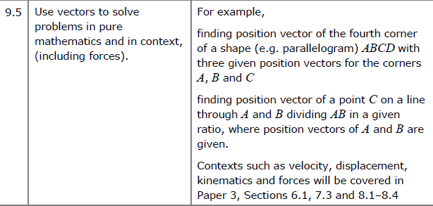
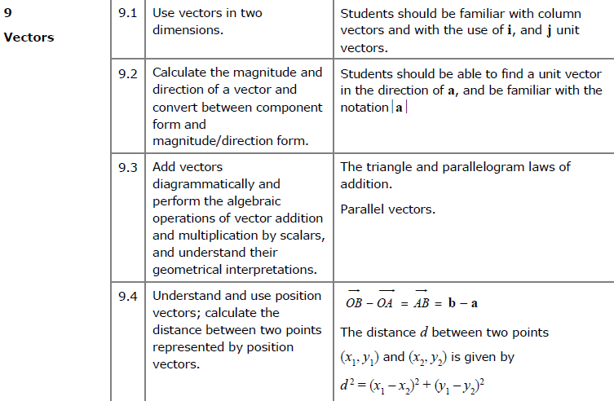

Vector basics

Whereas a coordinate represents a position in space, a vector represents a displacement in space.

- A vector has 2 properties:
- Direction
- Magnitude (i.e. length)

If $P$ and $Q$ are points then $\vec{PQ}$ is the vector between them.

- If two vectors $\vec{PQ}$ and $\vec{RS}$ have the same magnitude and direction, they’re the same vector and are parallel.

- $\vec{AB}=-\vec{BA}$ and the two vectors are parallel, equal in magnitude but in opposite directions.

- Triangle Law for vector addition:

$$\vec{AB}+\vec{BC}=\vec{AC}$$

The vector of multiple vectors is known as the resultant vector. (you will encounter this term in Mechanics)

- Vector subtraction is defined using vector addition and negation:
$$a-b=a+\left(-b\right)$$

- The zero vector $0$ (a bold 0), represents no movement.

$$\vec{PQ}+\vec{QP}=0$$

In 2D: $0=\left(\begin{matrix}0 \\ 0\end{matrix}\right)$

- A scalar is a normal number, which can be used to ‘scale’ a vector.
- The direction will be the same.
- But the magnitude will be different (unless the scalar is 1).

- Any vector parallel to the vector $a$ can be written as $λa$, where $λ$ is a scalar.

The implication is that if we can write one vector as a multiple of another, then we can show they are parallel.

Example
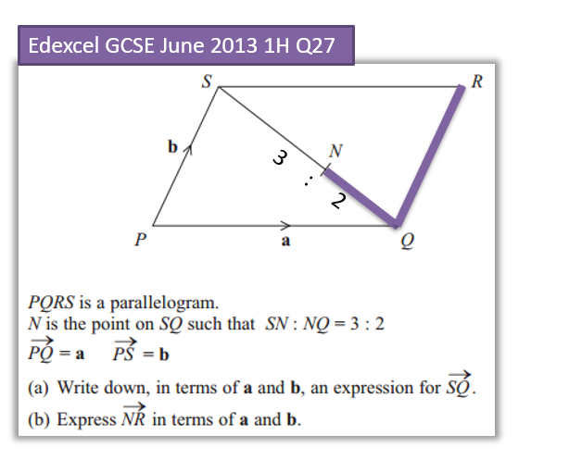

Test your understanding
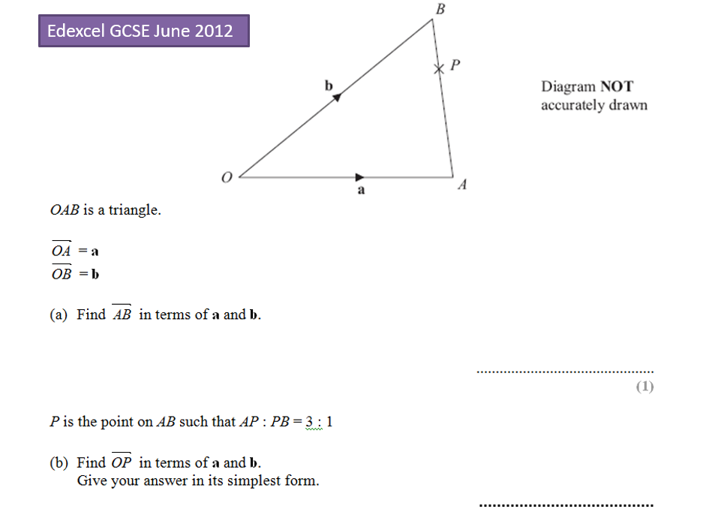

Exercise 11A Pg 234/235

AD Page 11

Representing vectors

A unit vector is a vector of magnitude 1.

$i$ and $j$ are unit vectors in the $x$-axis and $y$-axis respectively. We can write all vectors in terms of $i$ and $j$.

Example
If $a=3i, b=i+j, c=i-2j$ then:
- Write $a$ in vector form.
- Find $b+2c$ in $i,j$ form.

Exercise 11B Pg 237/238

AD Page 11
Magnitude of a vector
The magnitude $|a|$ of a vector $a$ is its length.
If $aIf a=\left(\begin{matrix}x \\ y\end{matrix}\right) \left|a\right|=\sqrt{x^{2}+y^{2}}$
Examples:

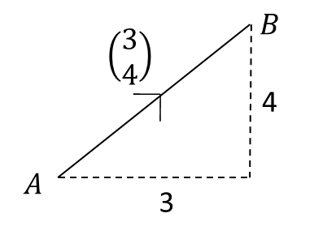

$2. a=\left(\begin{matrix}4 \\ -1\end{matrix}\right)$ $3. b=\left(\begin{matrix}2 \\ 0\end{matrix}\right)$

Direction of a Vector
The direction of a vector can be found using basic trigonometry.

Examples
1. Find the angle that vector$a=\left(\begin{matrix}4 \\ -1\end{matrix}\right)$ makes with the positive x axis.

2. Find the angle that vector$b=\left(\begin{matrix}-5 \\ -12\end{matrix}\right)$ makes with j.

Unit vector
A unit vector is a vector whose magnitude is 1.
If $a$ is a vector, then the unit vector $\hat{a}$in the same direction is

$$\hat{a}=\frac{a}{\left|a\right|}$$
Example:

Find a unit vector in the direction of $a=\left(\begin{matrix}3 \\ 4\end{matrix}\right)$

Test Your Understanding: Convert the following vectors to unit vectors.

$a=\left(\begin{matrix}12 \\ -5\end{matrix}\right)$ $b=\left(\begin{matrix}1 \\ 1\end{matrix}\right)$

Exercise 11C Pg 240/241

AD Page 11

Position vectors
A vector used to represent a position is unsurprisingly known as a position vector.

A position can be thought of as a translation from the origin.

The position vector of a point $A$ is the vector$\vec{OA}$, where $O$ is the origin. $\vec{OA}$ is usually written as $a$.
Examples
1. The points $A$ and $B$ have coordinates $\left(3,4\right)$ and $(11,2)$ respectively.
Find, in terms of $i$ and $j$:
- The position vector of $A$
- The position vector of $B$
- The vector $\vec{AB}$

2. $\vec{OA}=5i-2j$ and $\vec{AB}=3i+4j$. Find:
a) The position vector of $B$.
b) The exact value of $\left|\vec{OB}\right|$ in simplified surd form.

Exercise 11D Pg 243/244

AD Page 11

Solving Geometric Problems

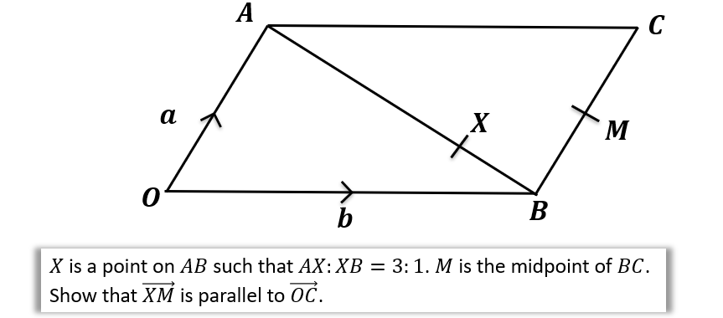

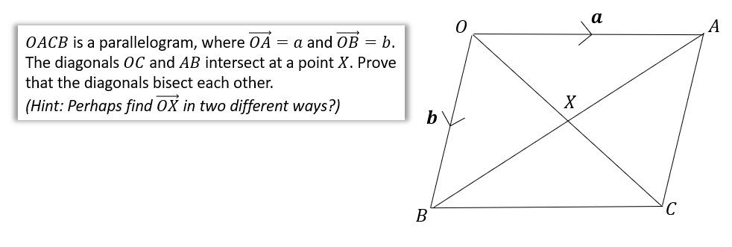

Test your understanding
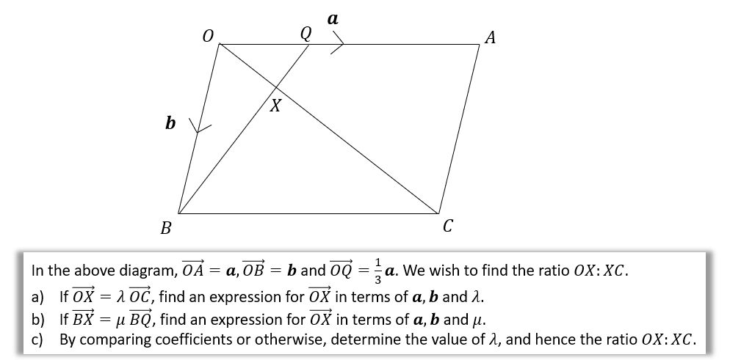

Area of a triangle example
If $\vec{AB}=3i-2j$ and $\vec{AC}=i-5j$. Determine $∠BAC$.

Extension
[STEP 2010 Q7]
Relative to a fixed origin $O$, the points $A$ and $B$ have position vectors $a$ and $b$, respectively. (The points $O, A$ and $B$ are not collinear.) The point $C$ has position vector $c$ given by
$$c=αa+βb,$$
where $α$ and $β$ are positive constants with $α+β<1$. The lines $OA$ and $BC$ meet at the point $P$ with position vector $p$ and the lines $OB$ and $AC$ meet at the point $Q$ with position vector $q$. Show that
$$p=\frac{αa}{1-β}$$
and write down $q$ in terms of $α, β$ and $b$.
Show further that the point $R$ with position vector $r$ given by
$$r=\frac{αa+βb}{α+β},$$
lies on the lines $OC$ and $AB$.
The lines $OB$ and $PR$ intersect at the point $S$. Prove that $\frac{OQ}{BQ}=\frac{OS}{BS}$.

Exercise 11E Pg 246/247

AD Page 11
Modelling with vectors

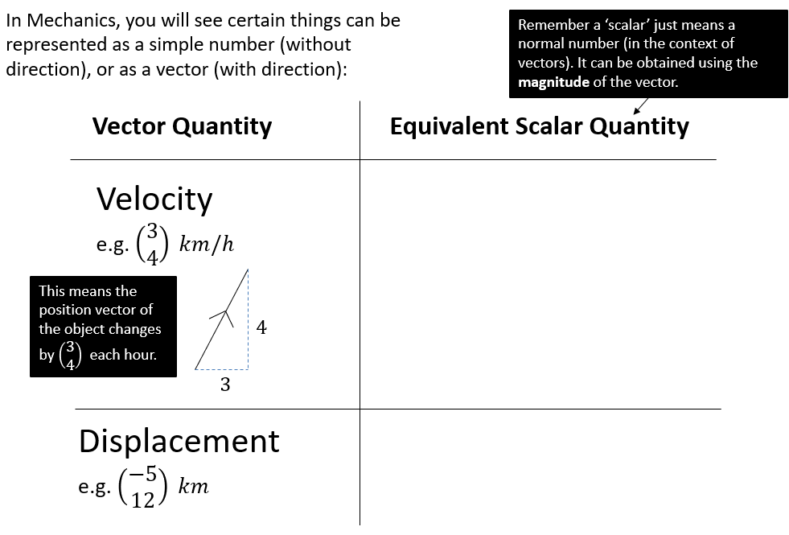

Examples
- A girl walks 2 km due east from a fixed point $O$ to $A$, and then 3 km due south from $A$ to $B$. Find
- the total distance travelled
- the position vector of $B$ relative to $O$
- $\left|\vec{OB}\right|$
- The bearing of $B$ from $O$.

- In an orienteering exercise, a cadet leaves the starting point $O$ and walks 15 km on a bearing of $120°$ to reach $A$, the first checkpoint. From $A$ he walks 9 km on a bearing of $240°$ to the second checkpoint, at $B$. From $B$ he returns directly to $O$.

Find:
- the position vector of $A$ relative to $O$
- $\left|\vec{OB}\right|$
- the bearing of $B$ from $O$
- the position vector of $B$ relative $O$.

Exercise 11F Pg 250/251

AD Page 11

