**9H Implicit Differentiation**

1. Differentiate the following equation implicitly:
$$y^{3}=3x^{2}$$

2. Below is a sketch of the circle with equation $x^{2}+y^{2}=25$, $-5≤x≤5$, $-5≤y≤5$.

Find the gradient of the curve where $x=4$

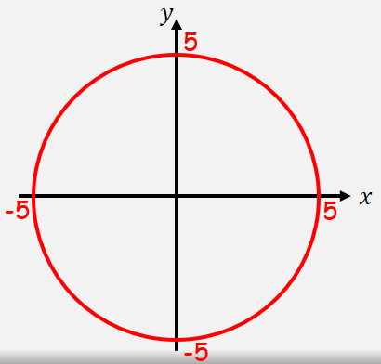

1. Find $\frac{dy}{dx}$ in terms of $x$ and $y$ when:
$$x^{3}+x+y^{3}+3y=6$$

2. Given that ${4xy}^{2}+\frac{{6x}^{2}}{y}=10$, find the value of $\frac{dy}{dx}$ at the point (1,1)
3. Find the value of $\frac{dy}{dx}$ at the point (1,1), when:

$$e^{2x}lny=x+y+2$$