**Parametric Differentiation**

Recall from the previous chapter that parametric equations are when we define each of $x$ and $y$ (and possibly $z$) in terms of some separate parameter, e.g. $t$.

**If $x$ and $y$ are given as functions of a parameter $t$, then**

$$\frac{dy}{dx}=\frac{dy/dt}{dx/dt}$$

1. Find the gradient at the point $P$ where $t=2$, on the curve given parametrically by
$$x=t^{3}+t, y=t^{2}+1, t∈R$$

2. Find the equation of the normal at the point $P$ where $θ=\frac{π}{6}$, to the curve with parametric equations

$x=3\sin{θ}, y=5\cos{θ}$

**Test Your Understanding**

C4 June 2012 Q6

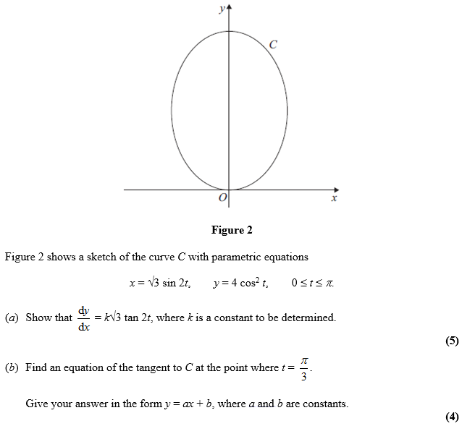

Exercise 9G Page 252-254