**Differentiating other trigonometric functions**

**Differentiate $y=\tan{x}$**

**More generally: $\frac{d}{dx}\left(\tan{kx}\right)=k\sec^{2}{kx}$**

**Differentiate $y=\sec{x}$**

**More generally: $\frac{d}{dx}\left(\sec{kx}\right)=k\sec{kx}\tan{kx}$**

$$\frac{d}{dx}\left(\tan{x}\right)=\sec^{2}{x}$$

$$\frac{d}{dx}\left(\sec{x}\right)=\sec{x}\tan{x}$$

$$\frac{d}{dx}\left(\cot{x}\right)={-cosec}^{2}{x}$$

$$\frac{d}{dx}\left(\operatorname{cosec}{x}\right)=-\operatorname{cosec}{x}\cot{x}$$

**Differentiate**



$y=\frac{cosec 2x}{x^{2}}$

$y=\sec^{3}{x}$

**Test Your Understanding So Far**

Edexcel C3 June 2013(R) Q5b

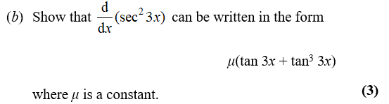

**Making use of $1÷dx/dy$**

Often in exam questions, you will be given $x$ in terms of $y$, but want to find $\frac{dy}{dx}$ in terms of $x$.

**The key is to make use of an appropriate trig identity, e.g:**

$$\sin^{2}{x}+\cos^{2}{x}≡1 1+\tan^{2}{x}≡\sec^{2}{x}$$

**Eg. Given that $x=\tan{y}$, express $\frac{dy}{dx}$ in terms of $x$.**

Exercise 9F Page 249-251

Q1-7 only

**Further examples**

**No Longer in Syllabus**

$$\frac{d}{dx}\left(\arcsin{x}\right)=\frac{1}{\sqrt{1-x^{2}}}$$

$$\frac{d}{dx}\left(\arccos{x}\right)=-\frac{1}{\sqrt{1-x^{2}}}$$

$$\frac{d}{dx}\left(\arctan{x}\right)=\frac{1}{1+x^{2}}$$

1. **Show that if $y=\arcsin{x}$, then $\frac{dy}{dx}=\frac{1}{\sqrt{1-x^{2}}}$**
2. **Given that $y=\arcsin{x^{2}}$ find $\frac{dy}{dx}$**

**Test Your Understanding**

Edexcel C3 Jan 2011 Q8b,c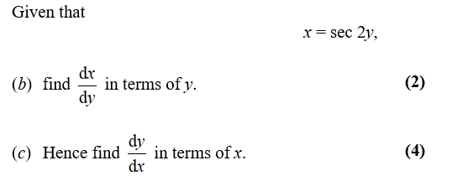

**Eg. Given that $y=\arctan\left(\frac{1-x}{1+x}\right)$, find $\frac{dy}{dx}$**

**No Longer in Syllabus**