**The Quotient Rule**

**Just as we use the ‘product rule’ to differentiate a ‘product’, we use the ‘quotient rule’ to differentiate a ‘quotient’ (i.e. division).**

**The quotient rule:**

**If $y=\frac{u}{v}$ then $\frac{dy}{dx}=\frac{v\frac{du}{dx}-u\frac{dv}{dx}}{v^{2}}$**

**Memorisation Tips**: “Bottoms first!” The denominator ($v$) is the first term seen in the new denominator and numerator. The denominator gets squared. Note that in the numerator, we have $-$ instead of the $+$ seen in the Product Rule.

**1. If $y=\frac{x}{2x+5}$, find $\frac{dy}{dx}$**

**2. Find the stationary point of $y=\frac{\sin{x}}{e^{2x}}$, $0<x<π$**

**Test Your Understanding**

Edexcel C3 Jan 2012 Q1a

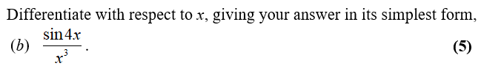

Edexcel C3 June 2012 Q3

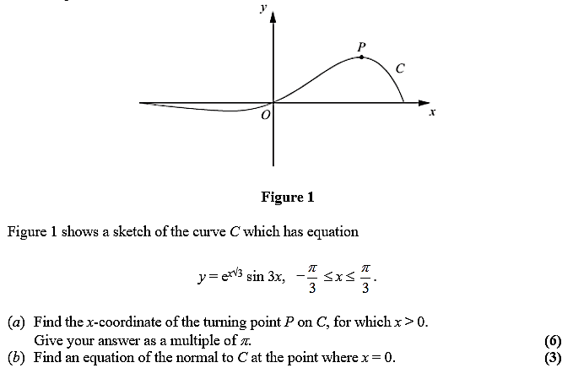

Exercise 9E Page 244-245