**Differentiating combinations of functions**

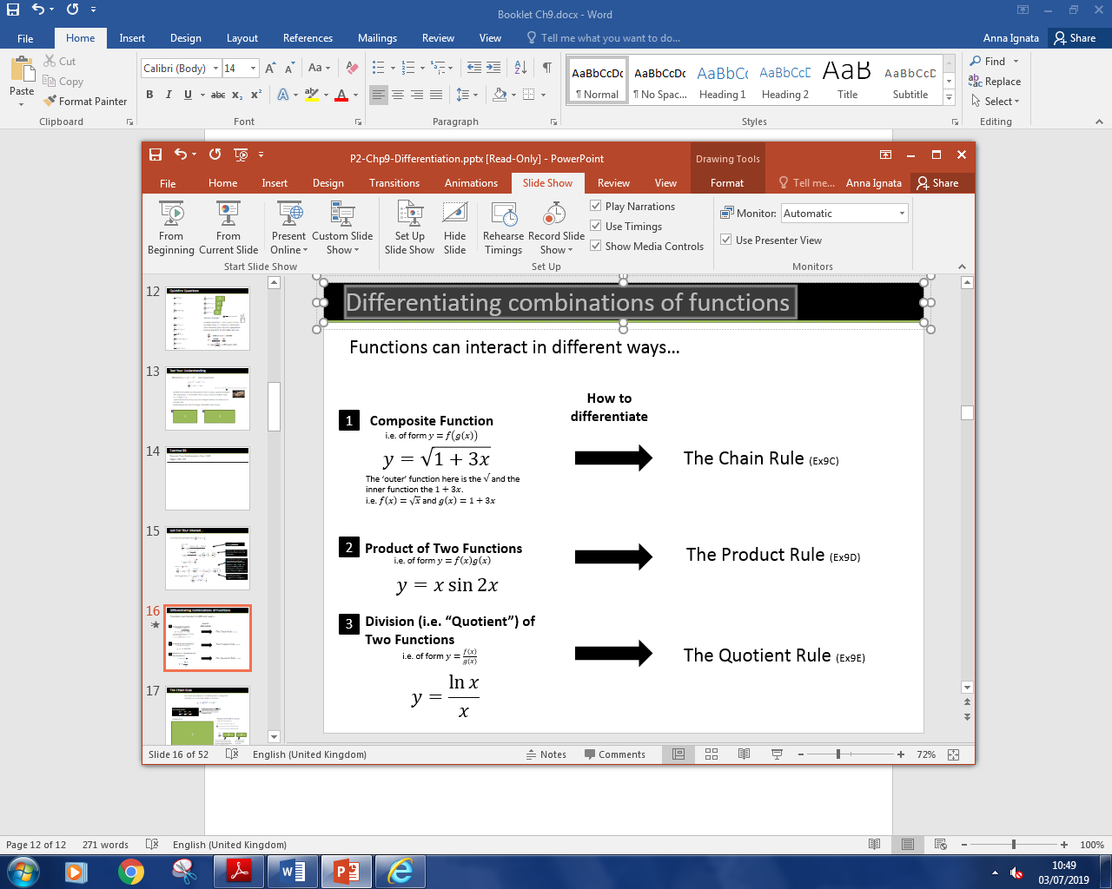

**The Chain Rule**

The Chain Rule:

$$\frac{dy}{dx}=\frac{dy}{du}×\frac{du}{dx}$$

The chain rule allows us to differentiate a composite function, i.e. a function within a function.

$$Eg. y={\left(3x^{4}+x\right)}^{5}$$

Full Method:

Doing it mentally in one go:

(aka the ‘bla method’)

**Further Practice**

$y={\left(x^{2}+1\right)}^{3}$

$y={\left(\ln{x}\right)}^{3}$

$y=e^{x^{2}+x}$

$y={\left(2^{x}+1\right)}^{2}$

$y=\ln\left(\sin{x}\right)$

$y=\sin{5x}$

$y=\sin^{2}{x}=$

$y=\sqrt{x+1}=$

$y=\cos^{3}{2x}=$

$y=e^{e^{x}}$

**Test Your Understanding**

C3 June 2011 Q1a

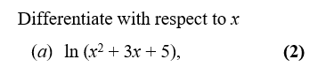

[Textbook] Given that $y=\sqrt{5x^{2}+1}$, find $\frac{dy}{dx}$ at $\left(4,9\right)$

Exercise 9C Page 239-240

Q1-5 & 11-13