U6 Chapter 9

Differentiation

Chapter Overview

1. Differentiate trigonometric, exponential and log functions.

2. Use chain, product and quotient rules.

3. Differentiate parametric equations.

4. Implicit Differentiation

5. Rates of change

 

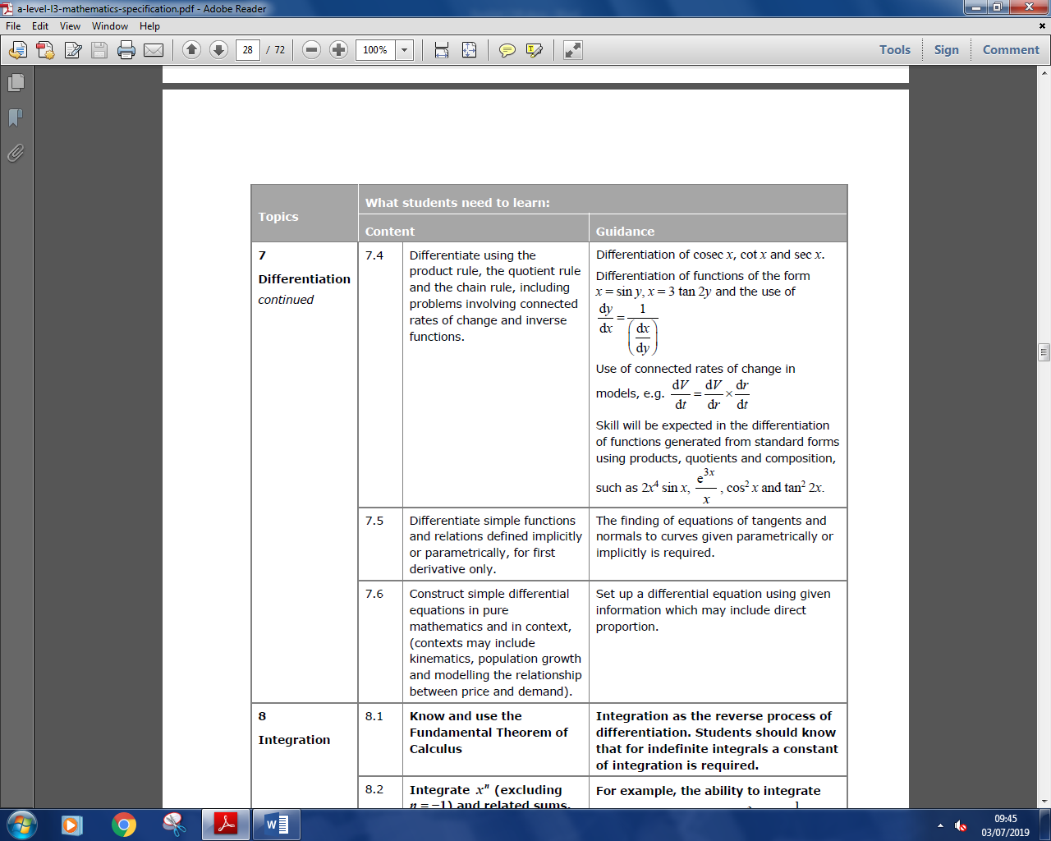

**Differentiating trigonometric functions**

You need to be able to differentiate sin x and cos x from first principles.

**Example 1 Prove, from first principles, that the derivative of sin x is cos x.**

$\frac{d}{dx}\left(\sin{x}\right)=\cos{x}$

Things of helpfulness:

* As $x→0, \sin{x}≈x$ and $\cos{x}≈1-\frac{1}{2}x^{2}$

$\sin\left(a+b\right)=\sin{a}\cos{b}+\cos{a}\sin{b}$

**If $y=f(x)$ then $\frac{dy}{dx}=\lim_{h→0}{\frac{f\left(x+h\right)-f\left(x\right)}{h}}$**

**Why does this result only hold in radians?**

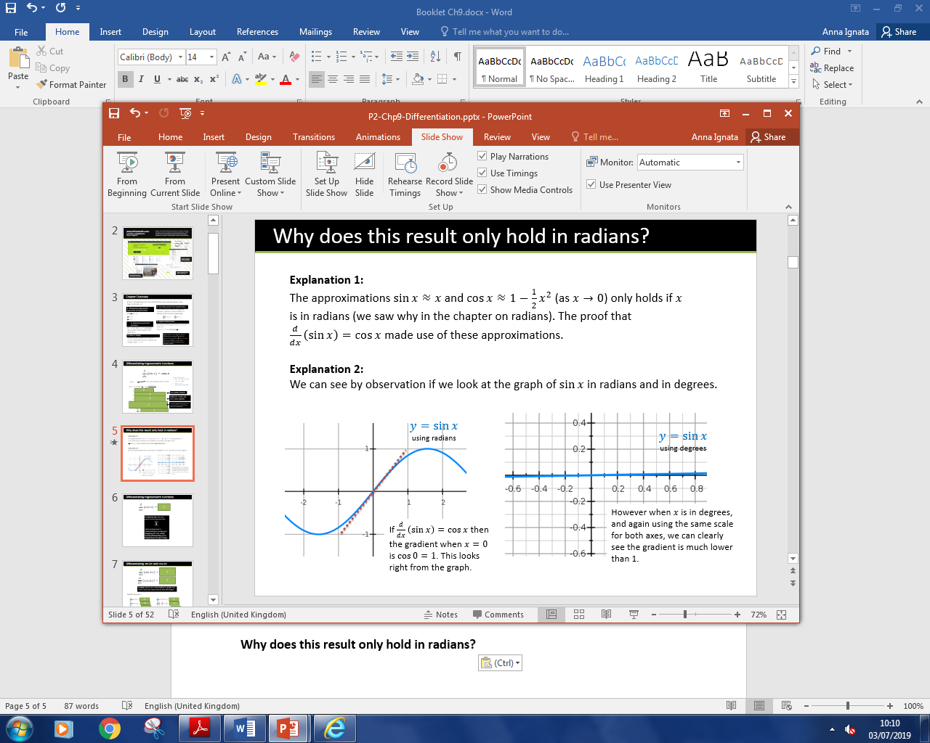

$$\frac{d}{dx}\left(\sin{kx}\right)=k\cos{kx}$$

$$\frac{d}{dx}\left(\cos{kx}\right)=-k\sin{kx}$$

**Quickfire Questions:**

$\frac{d}{dx}\left(\sin{3x}\right)=$

$\frac{d}{dx}\left(\cos{5x}\right)=$

$\frac{d}{dx}\left(3\sin{5x}\right)=$

$\frac{d}{dx}\left(4\cos{3x}\right)=$

$\frac{d}{dx}\left(-\frac{1}{2}\sin{x}\right)=$

$\frac{d}{dx}\left(-\frac{2}{3}\cos{\frac{1}{2}x}\right)$ =

**Example**

[Textbook] A curve has equation $y=\frac{1}{2}x-\cos{2x}$. Find the stationary points on the curve in the interval $0≤x≤π$.

**Test Your Understanding**

A curve has equation $y=\sin{3x}+2x$. Find the stationary points on the curve in the interval $0≤x≤\frac{2}{3}π$.

Exercise 9A Page 234