Integrating Vectors
We can integrate vectors by integrating each function of time separately.

Remember each component will have a constant of integration, $C=(pi + qj)$.

Example
A force $F$ acts on a body of mass 250g which is initially at rest at a fixed point O. If $F = ((5t - 2)i + 4tj)$N, where$t$ is the time for which the force has been acting on the body, find expressions for:

a) The velocity vector of the body at time $t$.
b) The position vector of the body at time $t$.

Example (Textbook)
A particle $P$ is moving in a plane so that, at time $t$ seconds, its acceleration is $(4i-2tj)$ms⁻². When $t=3$, the velocity of $P$ is $6i$ ms⁻¹ and the position vector of $P$ is $(20i+3j)$ m with respect to a fixed origin $O$. Find:
- the angle between the direction of motion of $P$ and $i$ when $t=2$
- the distance of $P$ from $O$ when $t=0$.

Test Your Understanding (EdExcel M2 Jan 2013 Q4)
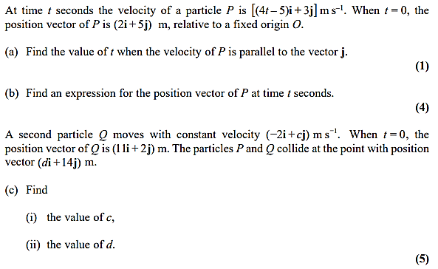

Exercise 8E Page 175
Mixed Exercise 8 Page 177

