Vector Methods with Projectiles
Previously we considered the initial speed of the projectile and the angle of projection. But we could also use a velocity vector to represent the initial projection (vectors have both direction and magnitude) and subsequent motion.

Example
A ball is projected from the origin with velocity $(12i + 24j)$ms⁻¹ where $i$ and $j$ are horizontal and vertical unit vectors respectively. The particle moves freely under gravity. Find:
a) The position vector of the ball after 3s
b) The speed of the ball after 3s
c) The ball strikes the ground at point B. Determine the distance OB
Example
A particle P is projected with velocity $(4pi + 5pj)$ms⁻¹ from a point O on a horizontal plane, where $i$ and$j$ are horizontal and vertical unit vectors respectively.
The particle P strikes the plane at the point A, which is 800 m from O.
a) Show that $p = 14$.
b) Find the time of flight from O to A.

The particle P passes through a point B with speed 60 m s⁻¹.
c) Find the height of B above the horizontal plane.

Test Your Understanding (EdExcel M2 Jan 2012 Q7)
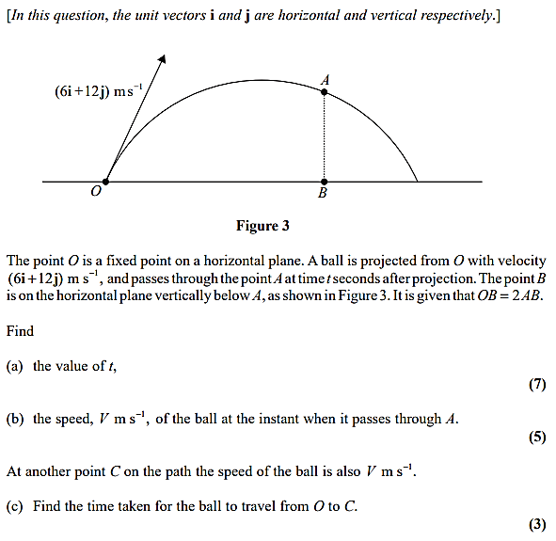
Exercise 8B Page 166

