A Level Mathematics
Chapter 8 - Mechanics
Further Kinematics
Chapter Overview
1. Vectors in Kinematics
2. Vector Methods with Projectiles
3. Variable Acceleration in One Dimension
4. Differentiating Vectors
5. Integrating Vectors
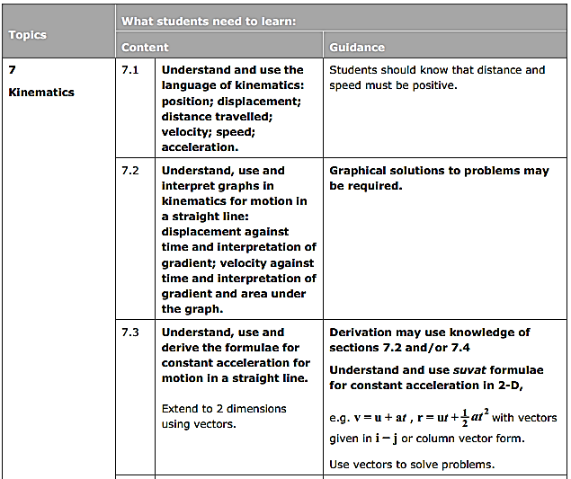
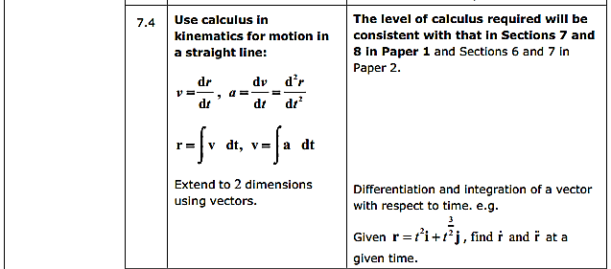

- Vectors in Kinematics
If a particle starts from the point with position vector r₀, and moves with constant velocity v, its displacement from its initial position at time t is given by vt and it position vector r is given by:

Example
At time $t = 0$, where $t$ is the time (in seconds), a particle is at the point with position vector $(4i - j)$m and travels with velocity $(-2i + 2j)$ms⁻¹. Find:
a) The position vector of the particle after $t$ seconds
b) The distance the particle is from the origin, O, after 3 seconds.

Example
A particle starts at a point 8m from O at an angle of 45^{O} anti-clockwise from east and travels with a velocity $(-2i - 3j)$ ms⁻¹, where $i$ and $j$ are unit vectors due east and north respectively.
Find the position vector of the particle after t seconds in the form $r = r_{0} + tv$.

Example – Using SUVAT with Vectors
A particle is initially travelling with velocity $(-2i - 9j)$ ms⁻¹ and 2 seconds later it has a velocity of$(6i - 11j)$ ms⁻¹, where $i$ and $j$ are unit vectors in the directions of the positive x- and y- axes respectively. Given that the acceleration of the particle is constant, find:
a) The acceleration
b) The magnitude of the acceleration
c) The angle that the acceleration makes with the vector $j$

Example (Textbook p161 Example 3)
An ice skater is skating on a large flat ice rink. At time $t=0$ the skater is at a fixed point $O$ and is travelling with velocity $\left(2.4i-0.6j\right)$ ms⁻¹.
At time $t=20$ s the skater is travelling with velocity $\left(-5.6i+3.4j\right)$ ms⁻¹.
Relative to $O$, the skater has position vector $s$ at time $t$ seconds.
Modelling the ice skater as a particle with constant acceleration, find:
- The acceleration of the ice skater
- An expression for $s$ in terms of $t$
- The time at which the skater is directly north-east of $O$.
A second skater travels so that she has position vector $r=\left(1.1t-6\right)j$ m relative to $O$ at time $t$.
- Show that the two skaters will meet.

Test Your Understanding (EdExcel M1 May 2013(R) Q6)
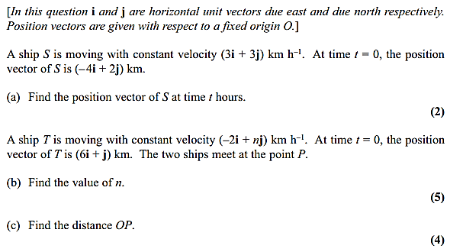
Exercise 7A Page 162

