- Connected Particles
Use Newton's 2nd law, SUVAT and F_{max} = μR to solve problems about connected particles on rough and inclined surfaces.

Example
Two particles P and Q, of mass 2kg and 3kg respectively, are connected by a light, inextensible string. The string passes over a small smooth pulley which is fixed at the top of a rough inclined plane. The plane is inclined to the horizontal at an angle of 30⁰. Particle P is held at rest on the inclined plane and Q hangs freely on the edge of the plane with the string vertical and taut. Particle P is released and it accelerates up the plane at 2.5ms⁻². Find:
- The tension in the string
- The coefficient of friction between P and the plane
- The force exerted by the string on the pulley

Example (EdExcel M1 Jan 2006 Q7)
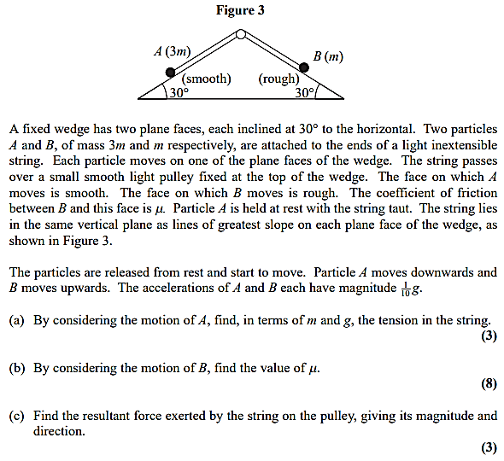

Additional Question (Connected Particles)
EdExcel M1 (Old) Jan 2013 Q7
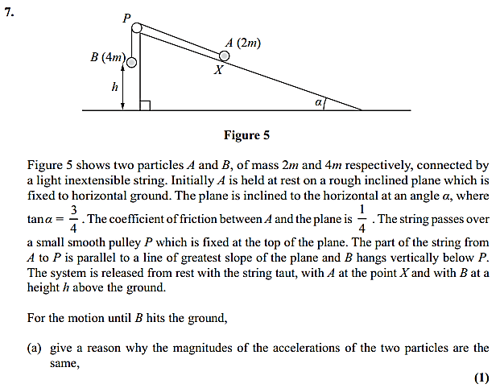
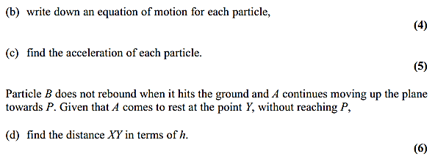

Test Your Understanding (EdExcel M1 May 2013(R) Q3)
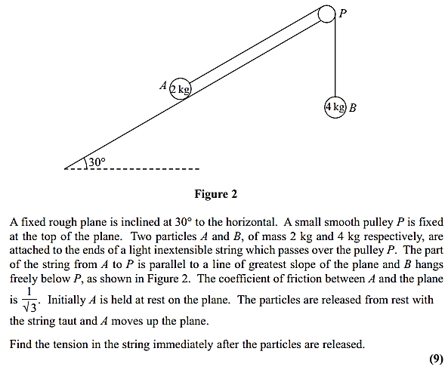

Exercise 7F Page 152
Mixed Exercise 7 Page 154

